**Industry placement models and sequencing**

This example illustrates a ***possible*** model and sequencing for industry placements, as a visual aid to planning. The size of the arrows denotes the significance of the various components at different times throughout the 2 year T Level programme.

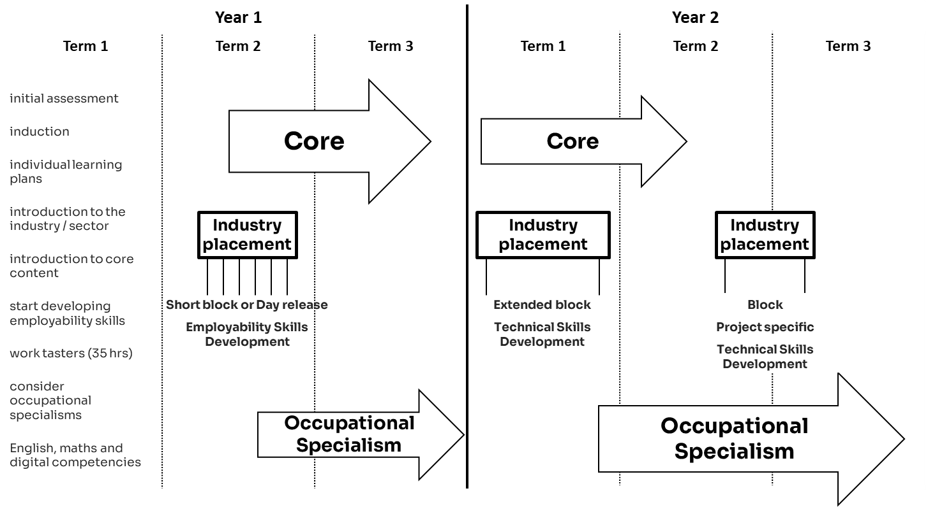As part of your curriculum planning you’ll be considering how different timings and durations for industry placements will work for students and their learning; for employers and their business needs; and for you and your resources.