t level and Industry placement marketing methods
Method / channel | Audience | Example / links | Benefits
Case studies and testimonials | Employers | T Level student testimonials from Weston College:  Weston college student testimonial  Case study of Exeter College working with the Royal Albert Memorial Museum, Exeter on industry placement opportunities  Weston College talk to one of their employers to create a video testimonial.  Cardinal Newman College created a resource quoting students on their T Level experience | - Show what T Levels and industry placements are like in reality  - Display students’ achievements on their T Levels and the success of industry placements.
Websites | Students and parents | Many schools and colleges have created informative pages on their website and some examples are below.  https://sixthform.laretraite.co.uk/The_Offer/T-Levels/  https://www.hsdc.ac.uk/study-with-us/t-levels/  https://www.blackpool.ac.uk/t-levels | - Engage students  - Provide information for their parents, carers or guardians  - Put T Levels in the context of your wider offer  - Demonstrate your teaching expertise in areas of the curriculum e.g. specialist Biology, Psychology and Health teachers for Education and Childcare; or specialist Business, ICT and programming teachers for Digital.
Social media and networks | Students, parents and employers | La Retraite School  twitter https://twitter.com/LaRetraite6  Linkedin https://www.linkedin.com/school/la-retraite-roman-catholic-girls-school/posts/?feedView=all  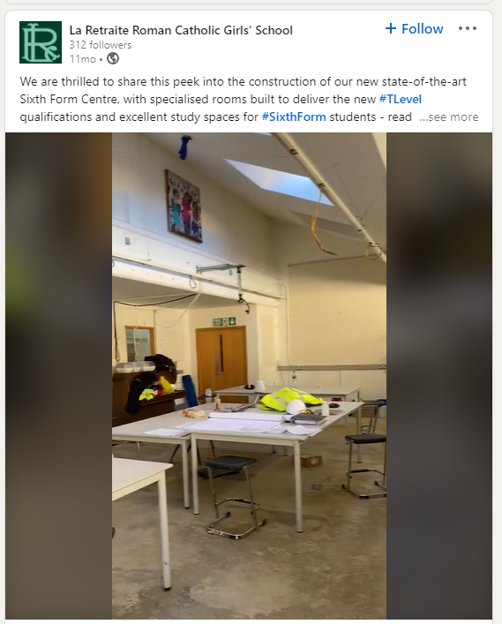  Update on the digital T Level at City College Norwich:  City College Norwich SM post  Cirencester College example of a social media advert:  Cirencester Social media  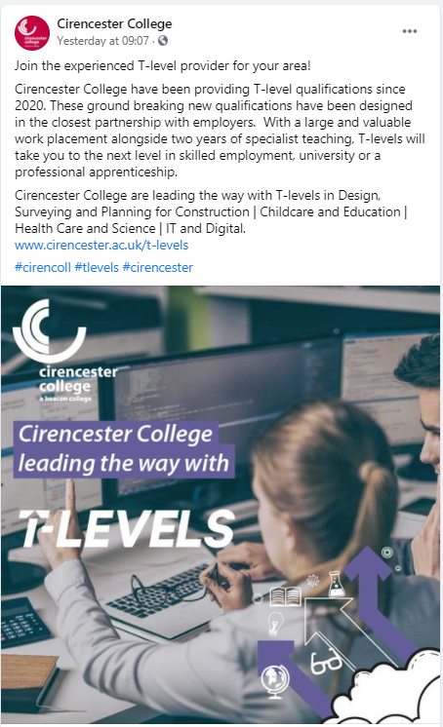  Short social media post created by Bishop Burton College to raise the profile of the T Level offer:  Bishop Burton LinkedIn post  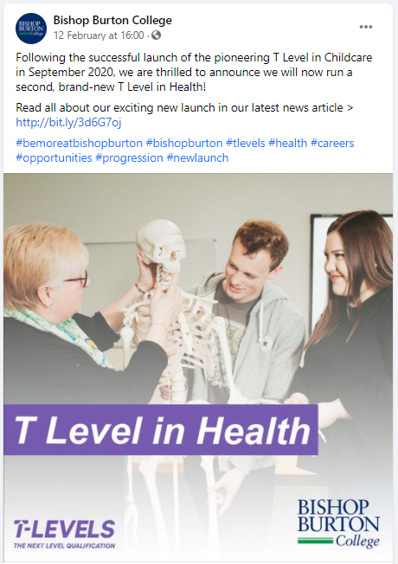 | - Provide information about T Levels and industry placements on commonly-used platforms  - Quick and easy to update  - Can show engaging multimedia content including video.
Videos | Student | La Retraite school YouTube video including interviews with current students:  Derby College created a student case study  Blackpool and the Fylde College | - Give students real-life examples of peers taking part in T Levels and industry placements.
Newsletters | Parents, guardians and carers | Newsletters  This is an example for parents, guardians and carers from Bury College. | - Help to keep audiences up to date on a regular basis  - Can be targeted at specific groups.
Direct sales | Employers | Weston College use direct sales through their own team.  Weston College Employer marketing | - Help to reach new employers  - Create good relationships through personal contact  - Are an effective follow-up to other marketing activities.
Trade shows, exhibitions, conferences | Employers | Taking part in trade shows, exhibitions and conferences in targeted locations or sectors should highlight T Levels to prospective employers | - Raise awareness about T Levels and industry placements  - Boost your interactions with employers.
Launch events | All audiences | Bishop Burton College online launch of a new T Level  Ursuline High School held a virtual information evening | - Provide valuable recommendations to students from their peers  - Can include ‘bring a friend’ options and incentives.
Careers events | Students and parents | Weston College created a page answering questions students might ask  Farnborough College created a T Levels week for students to sign up to  Exeter College created a page about all practical-based courses including T Levels | - Give a broad range of information about T Levels and industry placements  - Allow parents, guardians or carers to view the facilities and equipment available to T Level students.  - Promote additional professional qualifications included in your T Level offer. e.g. childcare licence to practise, first aid training, accredited digital training
Presentations and Webinars | All audiences | Chichester College created a recorded presentation for employers | - A cost-effective way of generating interest and raising awareness  - Can be targeted at specific audiences  - Can be recorded in advance and played multiple times.
Public relations / press | All audiences | City College Norwich PR case study and celebration:  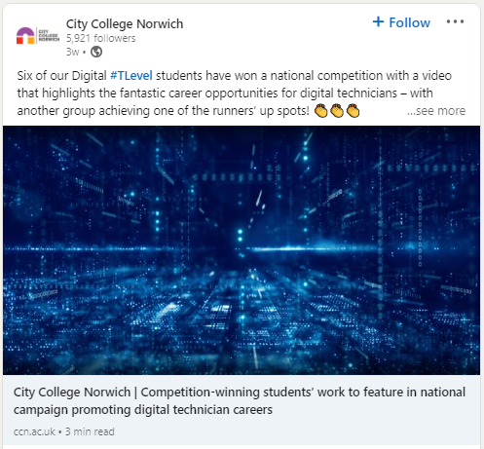  Exeter College PR following a visit from the Secretary of State:  https://exe-coll.ac.uk/secretary-of-state-visits-exeter-college-to-talk-t-levels/  Cirencester produced a promotional video | - Anyone searching for T Levels in their area can find these promotional videos and information.  - They can be sent out by email to target groups and feeder schools.  - Quick and easy audience access and reasonable cost to produce.
Literature | Students | Bishop Burton College brochure to attract new students:  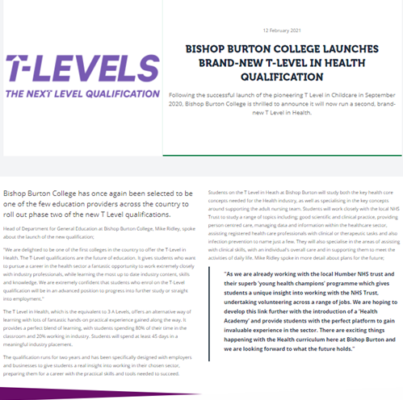  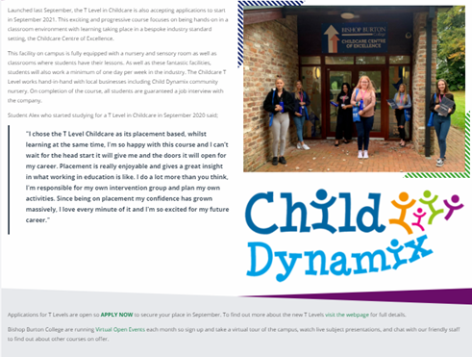Dudley College produced a parent’s guide and an employer’s guide | - Good for feeder schools to have access to  - Prospective students/parents/carers can read at their leisure

