## INDUSTRY PLACEMENT PROGRESS MONITORING PROCESS

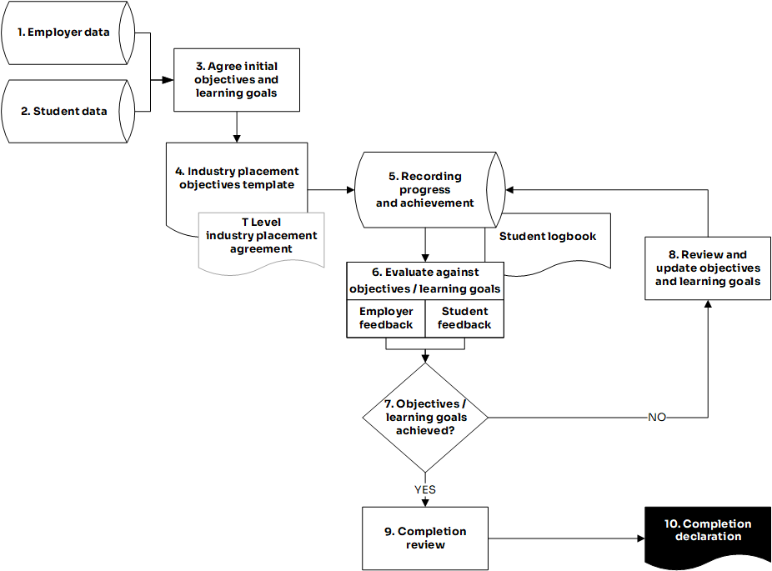

| Activity | Provider guide reference | Description |
| --- | --- | --- |
|  | Page 21-22 | Employer data includes, location, skill needs, project/task availability, supervisor, accountabilities and attendance requirements.  As well as collecting and storing practical data and information, at this stage you’ll need to understand the projects or tasks that an employer can offer, and how students in the workplace will be making meaningful contributions that align to their T Level learning.  Placements work well where work undertaken matches learning already completed to allow practice and consolidation.  Also at this stage, you can identify how employers can support any additional learning needs or whether they have funding or other requirements to support a successful placement. |
|  | Page 13-20 | Capture specific learner requirements. As well as their learning progress and requirements, this will ordinarily include their availability for attendance, travel, SEND needs, reasonable adjustments or any other relevant information in support of a positive placement experience.  At this stage you can consider student work-readiness assessment and student preparation training. |
|  | Page 23-25 | Providers will need to draw up stretching learning goals against which to review student progress. These will be specific tasks, activities, duties and outputs for the placement. These may include behaviour development objectives as well as skills objectives with links to technical skills in the Occupational Specialism as set out in the TQ specification and in awarding body guidance.  Initial objectives will be linked to work outputs as well as T Level learning that is to be consolidated. For example, learning to use a software package, then applying it to a real-work activity and then evaluating the progress made in line with the ‘live’ project objectives. The employer may also want to set some project specific and performance indicators that could fit nicely with the learning activities.  Aim to closely match a learner to a placement based on mutually complementary objectives. Agreeing clear objectives and learning goals will build the foundation for progress review. |
|  | Page 22  [Example Templates](https://www.gov.uk/government/publications/t-level-industry-placements-delivery-guidance) | The “Industry placement objectives template” should include, role title, working pattern, duration (hours), objective(s), learning goals, activities, minimum starting requirements and suggested prior learning.  Work with the employer to bring together and capture the outputs of steps 1, 2 and 3 in your version of the template.  Example templates, developed by employers for all occupational specialism within each T Level route are available as models for you to adapt.  The “Industry placement objectives template” will need to align to and complement the “T Level industry placement agreement” (see page 27) which the student, provider and employer must sign before the placement starts. |
|  | Page 33 | Student progress and achievement data can include information on, attendance, performance, work outputs / outcomes, timekeeping, workplace behaviours and objectives / learning goals achievement.  Keeping a comprehensive record is essential for:   * effective progress and performance monitoring * refining of targets as work is completed * providing a record of attendance and therefore completion of the placement to validate and upload T Level programme results. |
|  | Page 34-35  [Annex F](https://assets.publishing.service.gov.uk/government/uploads/system/uploads/attachment_data/file/896937/Annex_F_progress_indicators.pdf) (Progress indicators) | You’ll need to build in mechanisms for reporting feedback from the employer and student and take these into consideration as you evaluate progress.  Progress must be reviewed regularly and embedded within the process with at least three formal reviews with the student and employer, which are likely to be professional discussions or meetings scheduled at the start, middle and end of the placement model that you’ve put in place.  You might find it useful to use the progress indicators to inform formal reviews.  You should also supplement formal reviews with less formal review points and real-time feedback from employers. |
|  | Page 35-36 | Students are expected to keep an accurate record of their placement. This will need to be created early on in the placement and updated regularly, and you should make sure that time and opportunities are provided to allow this to happen. A [student logbook template](https://www.aoc.co.uk/sites/default/files/Student%20logbook.docx) is available to download. It can be adapted locally but your version should contain the same content.  There should be sections to record self-assessment, reflections and evidence of progress towards objectives and goals. |
|  |  | The most rewarding aspect of the placement will be in the achievement of learning goals. Where these are challenging, relevant and exciting, they can form the basis of an exceptional CV to allow progress in a career, make an application for a relevant role, or convert learning to a substantive appointment. |
|  |  | As a result of changes in the workplace or student progress it may be necessary to update the initial objectives and goals.  Periodic review of objectives prevents any dip in performance and supports overall completion and achievement. Planned monitoring will keep everyone connected and focussed on the requirements of the placement. |
|  | Page 41  Page 47-49  [Annex F](https://assets.publishing.service.gov.uk/government/uploads/system/uploads/attachment_data/file/896937/Annex_F_progress_indicators.pdf) (Progress indicators) | Completion criteria are set out in the delivery guidance, including an [employer appraisal template](https://www.aoc.co.uk/sites/default/files/Employer%20reference%20template%20.docx) and an [end of placement review form](https://employerindustryplacements.co.uk/tools/end-of-placement-review-with-the-provider/), both of which can be adapted locally.  A completion review allows an assessment of success for that learner in the placement and also allows the key features of success to be captured to support other placements and the bank of placement best practice.  It may be useful to use the progress indicators at this stage.  Evidence could also be gathered at this stage for a case study to support future student recruitment and secure employer involvement. |
|  | Page 42-43  [Annex H](https://assets.publishing.service.gov.uk/government/uploads/system/uploads/attachment_data/file/896939/Annex_H_student_completion_declaration_form.odt)  (Student completion declaration form) | Evidence requirements are set out in the delivery guidance.  At the final review meetings, providers and employers must sign the industry placement completion declaration to confirm that the students have met the industry placement completion criteria.  Evidence may also be useful in the case of appeals or complaints. |