T LEVEL Curriculum

A Case study for T Level providers

INTRODUCTION
Providers who are delivering the first wave of T Levels have put a vast amount of time and thought into developing a brand-new T Level curriculum. This case study provides an insight into the different approaches some of these providers have taken to respond to the challenge. Their experience offers a range of useful ideas to support providers starting their T Level journey. Other useful resources are Action plan for considering different curriculum models and industry placements as part of curriculum planning.
In the following video, Matt Reynolds of Cirencester College explains how they designed the curriculum, who is involved, who led it and how long it took (6m19s - ctrl+click to view).

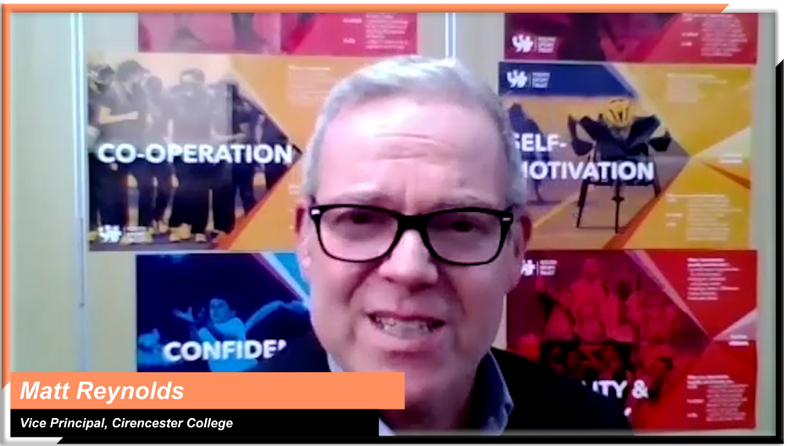
Matt Reynolds, Vice Principal Teaching, Learning and Development,
Cirencester College

INSIGHTS FROM T LEVEL PROVIDERS
To help you shape your approach, the following themes are explored:

Ctrl+click on a topic below to explore

Curriculum planning
Planning the curriculum strategy
Deciding on the structure of your curriculum
Moving away from traditional course structures
Involving employers in curriculum design
Maximising opportunities for students to combine theory and practice

Designing and developing content
Designing and developing T Levels content

Curriculum delivery
Preparing to deliver specialist content
Developing an assessment plan that supports curriculum delivery

Curriculum planning
Topic discussed | Learning points | Insights from T Level providers
Planning the curriculum strategy | To support successful T Levels delivery, it is important to have the right infrastructure, systems and processes in place. Giving curriculum leads the opportunity and time to fully understand the curriculum is vital, so they can plan strategic requirements such as:  - Reporting processes and tools  - KPI and sequence of learning timings  - Mode of delivery | In the following audio clip, Sam provides an overview of their strategic approach to curriculum planning (1m48s - ctrl+click to play).  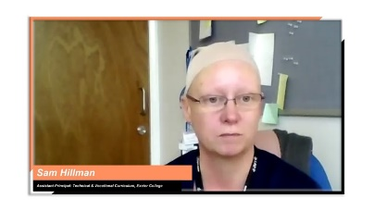  Sam Hillman, Assistant Principal: Technical and Vocational Curriculum,  Exeter College  “Don't underestimate the time needed for the curriculum team to really understand the T Level before they start thinking about delivering it. They have got to invest time and want to do it. Somehow in educational organisations, where budgets are tight and time is the enemy, you've got to try and find an oasis of time for people to plan and prepare”.  Dave Trounce, Deputy Principal, Weston College
Deciding on the structure of your curriculum | In the same way as with traditional courses, your first step should be turning the course specification into a workable document, such as a scheme of learning. | In this video, Edd describes how they produced a master scheme of learning, bringing together all the subjects and components of the T Level, and mapped onto it their industry placement model and assessment plan (1m57s - ctrl+click to view).  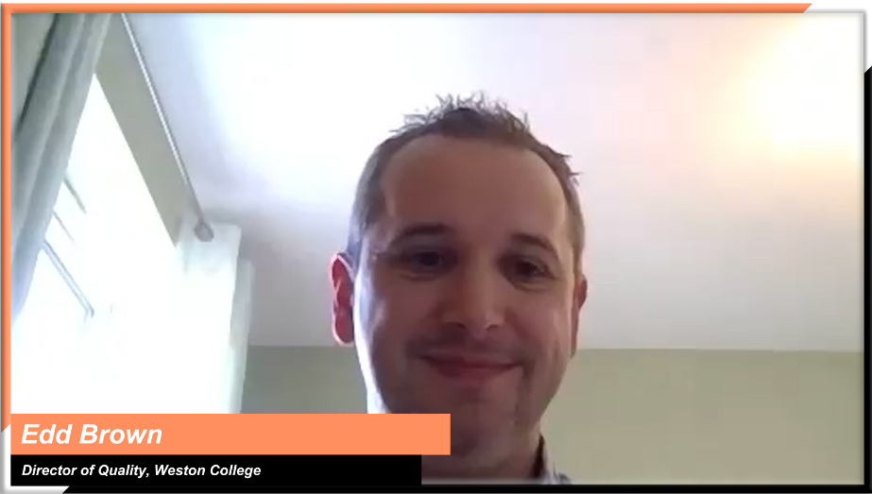  Edd Brown, Director of Quality & Workforce Development, Weston College
Moving away from traditional course structures | Unlike with traditional courses, this curriculum needs to include a model of the substantial industry placement and the way it will fit with your classroom teaching structure and assessment plan.  Look for ways to:  - move away from traditional course structures  - minimise duplication  - bring all different elements together to create a cohesive, exciting new course  - make time. | In this video, Matt explains how they built their curriculum around scenarios based on real life case studies, moving away from the traditional approach of planning their teaching around units (1m13s - ctrl+click to view).  Matt Reynolds, Vice Principal Teaching, Learning and Development,  Cirencester College
Involving employers in curriculum design | Working with employers throughout the curriculum planning process could help you to:  - identify current and future industry needs  - detect gaps in your curriculum  - increase student/employer interaction in a classroom setting  - develop industry placement models that fit with your overall curriculum strategy and, at the same time, meet employers’ needs.  Think about:  - forming curriculum working groups with employers  - strengthening one-to-one relationships between employers and curriculum leads  - inviting employers to meet the students and take part in classroom activities, from running sessions to judging competitions. | In this video, Danny describes the ways in which they involve employers in the development of their curriculum (1m6s - ctrl+click to view).  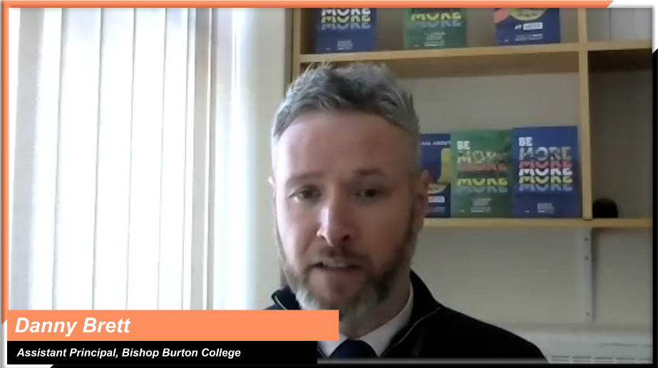  Danny Brett, Assistant Principal, Bishop Burton College  In this audio clip, Simon illustrates the value of liaising with employers on their specific skills needs, understanding the future of their industries and building them into a curriculum that supports the next generation of talent going into the sector (1m53s - ctrl+click to play).  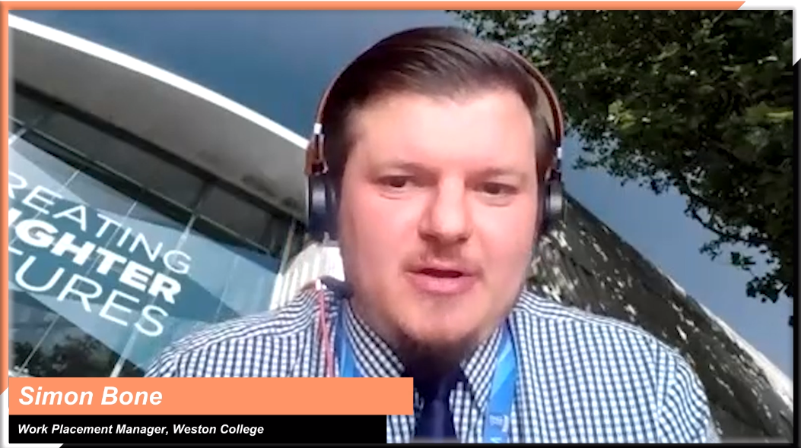  Simon Bone, Work placement Manager, Weston College  “Employers have engaged with and supported our development of the curriculum. In construction, [one of our employer partners] has been delivering each week virtually into the classroom. Over half term another employer is running a daily session for learners to drop into the workplace, to understand industry concepts. Our construction learners really look forward to that. We have had six different managerial instructors who delivered virtually into the classroom with Q&As. They were explaining their job roles and what the students would be doing. It has gone down exceptionally well.”  Sam Hillman, Assistant Principal: Technical and Vocational Curriculum,  Exeter College
Maximising opportunities for students to combine theory and practice | Combining theory and practice is a key goal of T Levels.  Take time to consider different industry placement models and how they fit in with your curriculum structure, to see what is possible and what would be most beneficial to your students.  Work closely with employers to ensure that the curriculum sequencing supports your chosen industry placement model and explore different ways of bringing practical aspects into the classroom. | In this video, Emma explains why it was important for them to make sure theory and practice were closely linked throughout the course (1m - ctrl+click to play).  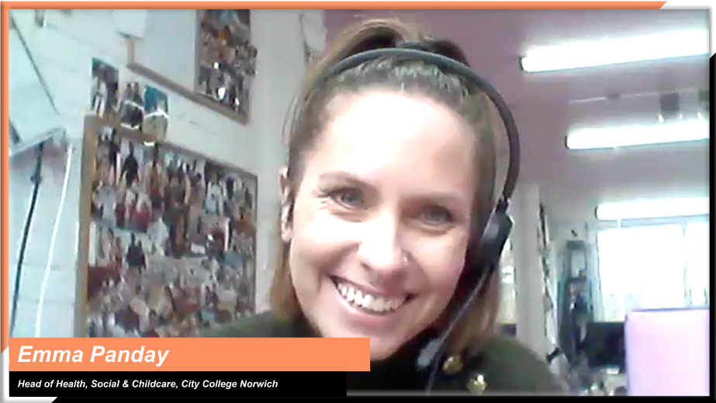  Emma Panday, Head of Health, Social and Childcare,  City College Norwich  In this video, Matt talks about their decision to build in a significant amount of experiential learning early on in the course (1m03s - ctrl+click to play).  Matt Reynolds, Vice Principal Teaching, Learning and Development,  Cirencester College

Designing and developing content
Topic discussed | Learning points | Insights from T Level providers
Designing and developing T Levels content | Building a curriculum from scratch could well be a new experience for most providers. T Levels give you the freedom to create something special, building a real and meaningful student experience.  Some of the early T Level providers have offered helpful tips for the design and development of T Level content:  - remember T Levels are brand new technical training. Look at T Levels as new and different  - pinpoint the specialisms your organisation wants to focus on  - consider how can you manage overlaps between competencies  - decide how will the T Level be taught  - start with what T Levels are really about – competencies and real-world experience, case studies and scenarios  - avoid using the specification as a check list of things to do  - link student workplace expectations and employer experiences into the theory you’ll teach  - use all the support that’s available. | Matt provides insights into designing a course from the beginning and developing content and explains some of the support that’s available. In this video, he describes how they approached designing a course. (1m21s - ctrl+click to view).  Matt Reynolds, Vice Principal Teaching, Learning and Development,  Cirencester College  “It can be quite daunting for staff when they're thinking about approaching something like a T level and trying to make sense of it. It's quite a considerable task to take on.  The reality is that many vocational teachers have never actually drawn up a complete curriculum or scheme of work or designed a course from scratch on a blank piece of paper.  Most teachers are familiar with adapting courses and perhaps specifications are updated every two or three years or so.  When somebody starts working at a new institution, they may inherit somebody else’s records and scheme of work, that they then have to adapt and revise. That's where teachers are familiar… … but starting with a blank sheet of paper is something that most teachers are not familiar with.”  “If you are brand new to T Levels, where do you go for support? There are a number of support options available to you. The Education and Training Foundations (ETF) have ‘Area Relationship and Development Leads’ who work with providers to access the T Level Professional Development offer (TLPD).  The TLPD offer provides a wealth of free support and resources for individuals and organisations delivering T Levels, this covers everybody in the organisation from Governors and senior leadership through to teachers and support staff.  The Association of Colleges and the Sixth Form Colleges Association also have valuable resources in support of the design and delivery of T Levels. Awarding bodies provide further detail and support.  The Department for Education Support with delivering T Levels for providers has comprehensive information and updates.”  Matt Reynolds, Vice Principal Teaching, Learning and Development,  Cirencester College

Curriculum delivery
Topic discussed | Learning points | Insights from T Level providers
Preparing to deliver specialist content | Assessing your staffing resource and identifying skills gaps as early as possible is an essential part of preparing for T Level delivery.  It will:  - inform the design of your CPD offer  - help you identify other relevant courses and qualifications  - guide you through hiring versus upskilling decisions  - encourage you to work with employers to explore ways they could get involved in curriculum delivery. | In this video, Edd highlights the importance of assessing the available skillset to identify gaps, in order to determine how to best upskill staff through CPD and other qualifications (52s - ctrl+click to view).  Edd Brown, Director of Quality & Workforce Development, Weston College  This video outlines one of the challenges posed by the advanced level of content in T Levels and the need to ensure that knowledge is current and relevant, and the different ways of teaching. (1m18s - ctrl+click to view)  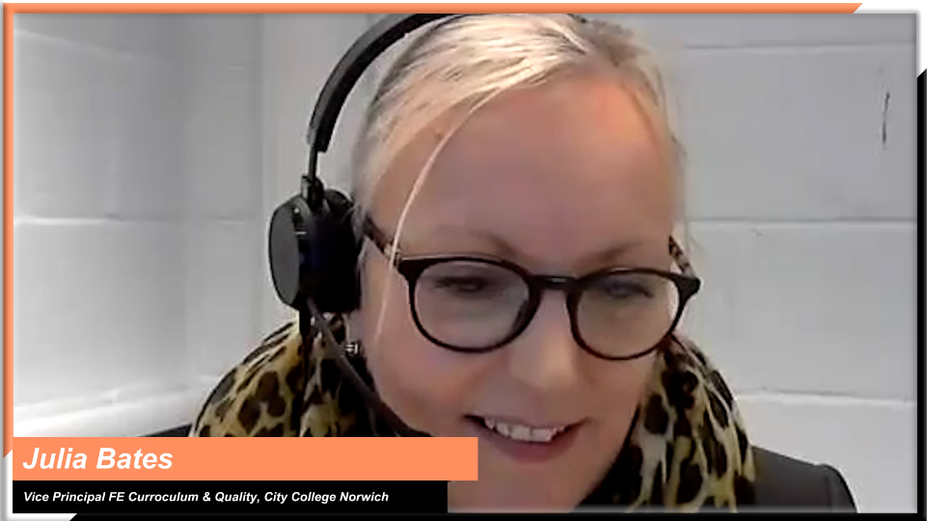  Julia Bates, Vice Principal FE Curriculum and Quality, City College Norwich  In this clip, Ashley talks about how they involved employers in curriculum delivery to cover parts of the curriculum where there was a lack of internal expertise (49s – ctrl+click to view).  Ashley Grute, Assistant Principal, HSDC
Developing an assessment plan that supports curriculum delivery | With T Levels being a new qualification with a different assessment structure to traditional vocational courses, it is essential that you put together an assessment plan that will enable you to track both individual and cohort progress throughout the year and identify gaps in learning.  This will:  - highlight areas of the curriculum that require more attention  - help you assess the effectiveness of your curriculum sequencing  - inform your revision plans  - enable you to make the necessary tweaks to the curriculum for the next cohort. | In this video, Matt explains different aspects of their formative assessment methodology and how they developed it with help from their sixth form, which delivers A Levels (1m7s – ctrl+click to view).  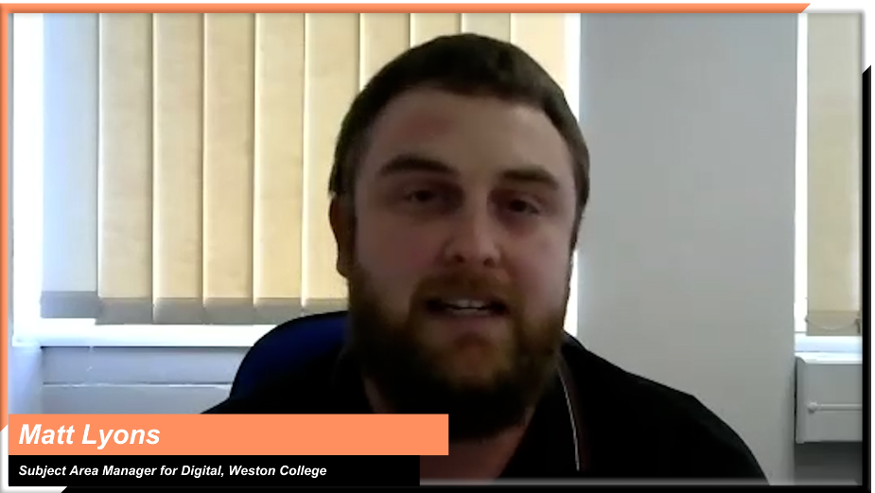  Matt Lyons, Subject Area Manager for Digital, Weston College  In this audio clip, Sam discusses how tracking assessment results by cohort and learner enables them to identify parts of the curriculum that might need more attention (41s – ctrl+click to play).  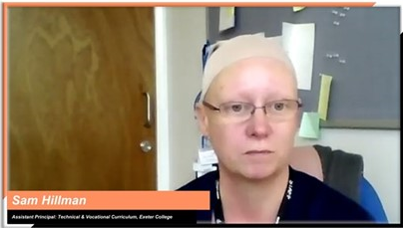  Sam Hillman, Assistant Principal: Technical and Vocational Curriculum,  Exeter College  In this audio clip, Roz explains their method of monitoring student progress and identifying gaps in knowledge to inform revision practices (1m22s-ctrl+click to play).  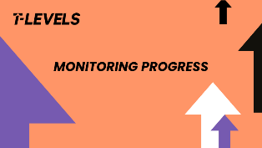  Roz Hicks, Head of Media, Business & Digital Industries,  City College Norwich

