student support

A Case study for T Level providers

INTRODUCTION
Once enrolled on a T Level programme, it is essential that learners receive the best possible support to help them achieve and thrive and it is important to focus on both their learning and their welfare. This case study outlines how providers have put comprehensive and easy-to-access support in place to meet the individual needs of their learners.

INSIGHTS FROM T LEVEL PROVIDERS
To help you shape your approach, the following themes are explored:

Ctrl+click on a topic below to explore
Assessing students and planning support
Developing robust initial assessment systems to identify student starting points and knowledge and skill gaps
Planning the provision of student support
Providing welfare support and additional learning support throughout the course
Celebrating student success

Assessing students and planning support
Topic discussed | Learning points | Insights from T Level providers
Developing robust initial assessment systems to identify student starting points and knowledge and skill gaps | The initial assessment of T Level students is a vital step in making sure individual student needs are catered for. This ensures that appropriate support systems can be put into place.  Think about:  - whether you want to include taster days and interviews in your initial assessment process  - which aspects of student progress you would like to capture via your diagnostic tasks  - what your strategy is for assessing readiness for the workplace  - how best to identify welfare support needs  - how long you would like the initial assessment period to last. | “Once students enrolled, we carried out some diagnostics for the first few weeks of the term. We spent time with the students undertaking various exercises and tasks to understand where they had got to with their learning. This gave us a clear view of each student’s starting point against which we could monitor future progress.”  Roz Hicks, Head of Media, Business & Digital Industries,  City College Norwich  In this video, Emma outlines their initial assessment process, which provides an opportunity to more accurately shape their support strategy (1m53s - ctrl+click to view).  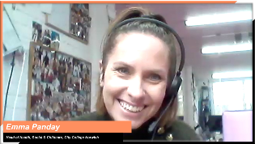  Emma Panday Head of Health, Social and Childcare, City College Norwich  In this video, Morag describes how they adjusted existing processes and policy to accommodate changes for T Levels – early initial assessment, assessing learning needs and support requirements, monitoring progress, preparing students for placements. (3m55s - ctrl+click to view).  Morag Davis, Assistant Principal for Technical Curriculum,  Nelson and Colne College
Planning the provision of student support | Providers have found tailoring their existing support models works well for T Level students. However, the specific requirements of T Levels need to be taken into account.  When planning support, think about the need for:  - one-to-one and group tutorials  - academic study skills sessions  - tailored exam technique sessions  - personal development opportunities  - work-related skills development  - pastoral support sessions  - career support services  - financial support  - employability skills  - staff CPD and collaboration  - adjustments to existing systems tracking student progress. | In this clip, Vicki explains the planning process around student support, discussing how they tailored their existing systems and processes to align with T Level delivery requirements, enabling them to accurately map the skills needs of the students and focus on personal development. (3m25s - ctrl+click to view).  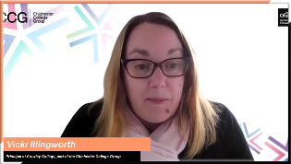  Vicki Illingworth, Principal at Crawley College,  part of the Chichester College Group  “Our student services department supports learners around the financial assistance that the college can provide through different grants. Learners can put in an application for any uniform, equipment, travel expenses, DBS checks and which then go to a panel to be agreed to make sure the students can access all areas of the course.”  Katy Langfield, Learning Support Manager, Bishop Burton College  “We made sure all our team worked closely together to help one another because it has to be a joined-up approach to ensure the student feels supported. Our department and faculty heads, tutorial and curriculum teams, work placement coordinators, learning mentors and employer representatives meet to discuss and identify student needs and how best to support them. This is already in place for other courses, and we have further developed it for T Levels.”  Thomas Rushforth, Work Placement Team Leader, Barnsley College
Providing welfare support and additional learning support throughout the course | Even after planning your support package, you may need to adapt to your students’ support needs. Flexibility is key.  Think about:  - how you can identify emerging barriers to learning and support needs – some providers have made use of e-learning platforms, like Skills Forward, as well as more traditional methods  - which teams should work together to keep up to date with learners’ needs  - how often to schedule meetings with senior leadership to flag challenges and discuss putting a new or adapted provision in place  - effective use of bursaries  - whether the processes you have in place for learners to access pastoral and learner mentor support are effective  - how to support learners that are attending industry placements outside term-time. | In this video, Katy outlines a comprehensive package of support made available to all T Level students to enable them to thrive regardless of their individual needs (3m30s - ctrl+click to view).  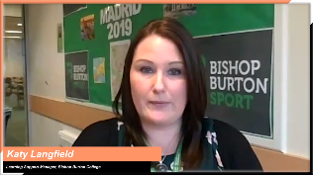  Katy Langfield, Learning Support Manager,  Bishop Burton College  In this clip, Matt talks about the importance of ensuring the availability of support for students going on placements during the summer holidays (40s - ctrl+click to view).  Matt Lyons, Subject Area Manager for Digital, Weston College  In this clip, Morag talks about how they have adapted their processes to use bursaries to support students (2m42s - ctrl+click to view).  Morag Davis, Assistant Principal for Technical Curriculum,  Nelson and Colne College

Celebrating student success
Topic discussed | Learning points | Insights from T Level providers
Feedback to students on progress made with celebrations of milestones and successes | Providers have found that using every opportunity to celebrate advances in students’ personal development has benefited their T Level students’ well-being.  Consider:  - which small progression steps you could track  - how to track progress  - how they can be celebrated or rewarded  - feedback of progress and areas for improvement  - intervention if required. | “We recognised quite early on that we needed to find ways of celebrating students’ small wins and achievements. We used a series of connect employability badges that all our learners can apply for by evidencing their personal development and growth around employability skills. We find opportunities to applaud the change development process, and this, in turn, supports retention and interest.”  Jess Leech, Assistant Principal for Students, Barnsley College  In this clip, Thomas describes how they plan to introduce checkpoint certificates to celebrate key industry placements milestones along the way, adapting their process and systems to accommodate this (1m02s - ctrl+click to view).  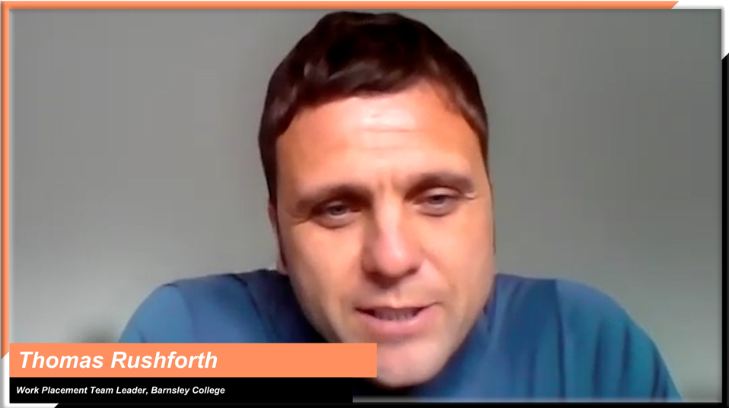  Thomas Rushforth, Workplace Team Leader, Barnsley College

