FACILITIES and finance

A Case study for T Level providers

INTRODUCTION
Effective planning, development and financial investment is critical for T Level success. This case study looks at how some of the Wave 1 providers have planned for the resources and facilities needed for T Level delivery and the financial investment involved. Although some are talking about government funding, there is no guarantee that such funding will be available in future years. However, the lessons learnt are still important.
In this video, you will hear from Mike Ridley of Bishop Burton College. Mike talks about how the college converted an on-site commercial nursery to a fully equipped educational setting replicating a real nursery, where the Education and Childcare T Level students are based (3m1s - ctrl+click to view).
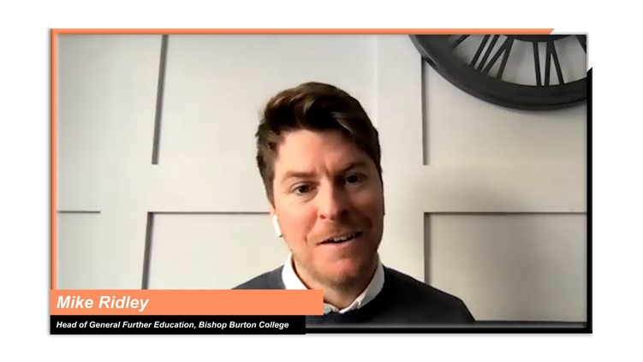
Mike Ridley, Head of General Further Education, Bishop Burton College

INSIGHTS FROM T LEVEL PROVIDERS
To help you shape your approach, the following themes are explored:

Ctrl+click on a topic below to explore
Developing world-class facilities
Creating a bespoke T Levels learning space
Collaborating with employers and universities on the design of the new facilities
Being ready to start construction work as soon as you can

Looking at funding and investment
Planning for investment
Considering different funding options

Developing world-class facilities
Topic discussed | Learning points | Insights from T Level providers
Creating a bespoke T Levels learning space | Creating a bespoke T Levels learning space with state-of-the-art facilities will:  - facilitate T Level delivery by providing teachers with the right tools to keep students engaged  - assist with marketing and branding, as it offers a concrete way to demonstrate to students, parents, and employers that this qualification is different from other Level 3 qualifications  - help with recruitment, as it can easily capture the interest of potential students. | In this video clip, Matt talks about how they built a prominent T Level area within their computing department, which has served as a focal point when engaging students, parents, and employers (52s - ctrl+click to view).  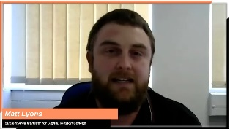  Matt Lyons, Subject Area Manager for Digital, Weston College  “I think that it is really important when it comes to selling the T Levels – it’s been an easy sell because we've had an actual building to show people. The A Level students are really impressed by the T Level facilities and are asking if they can enrol, in order to work in the T Level area.”  Ruth Coyle, Director of La Retraite Roman Catholic Girls’ School
Collaborating with employers and universities on the design of the new facilities | Linking in with employers and local universities can help to inform the kind of equipment and facilities that are needed for the delivery of T Levels. This will not only help you meet industry requirements but will also help you align your provision and facilities with HE courses and other progression routes.  Consider creating learning spaces that are modelled after real workplaces, so the students can start having a feel for being in a work environment.  Also, explore setting up partnerships with local universities that would allow your students to use some of their facilities, if developing your own is not a possibility. | In this video clip, Ruth explains the process of research with employers into the resources and facilities that they use so that they can be replicated in the education setting to create a state-of-the-art facility for each T Level (1m4s- ctrl+click to view).    Ruth Coyle, Director of La Retraite Roman Catholic Girls’ School  “To make sure that we had the right facilities we consulted with our partner boards and local universities as to what the facilities should look like and what equipment we should have in these facilities to make sure that we're meeting the requirements of the sector, but also potentially supporting our students with progression onto HE.”  Ashley Grute, Assistant Principal, HSDC
Being ready to start construction work as soon as you can | If new buildings, structures, or refurbishments are part of your implementation plan, a core message from early providers is to have everything in place as early as possible.  This will require:  - having a clear plan of what industry-standard facilities will be needed to deliver T Levels  - sourcing architectural, project management and bid writing expertise  - finding the right people to support any potential funding bids, which can, often, be complex and technical  - having a construction company lined up to start work as soon as funding is secured. | Wave 1 providers had the opportunity to apply for a DfE Capital Fund. In this video clip, Ruth talks about the importance of bringing in specialist help when applying for funding and being ready to start work in the event they received the funds (2m22s - ctrl+click to view).  Ruth Coyle, Director of La Retraite Roman Catholic Girls’ School

Looking at funding and investment
Topic discussed | Learning points | Insights from T Level providers
Planning for investment | As T Levels are larger qualifications than traditional full-time FE programmes, you will need to invest in staffing, facilities, and equipment.  Make sure you:  - are clear on the qualification specifications, especially when it comes to occupational specialisms, where industry standards are expected to be met  - think about the long-term costs of the required equipment, including licence renewal, maintenance, and the cost of replacing the equipment after depreciation  - think about the effect of the new offer on room utilisation metrics when considering what additional facilities you will require  - don’t underestimate your staffing needs and the associated costs, especially when it comes to more specialist subjects  - start planning 18 months before your T Levels delivery starting date  - look into funding options (e.g., Local Enterprise Partnerships (LEPs), government funding, employer assistance, college matching). | In this video, Jerry outlines the considerations that need to be taken into account when planning the purchase of specialist equipment, including maintenance costs and the future need for replacements. Jerry talks about this in the context of the Specialist Equipment Allocation funding that was available to Wave 1 providers (3m39s- ctrl+click to view).    Jerry White, Deputy Principal, City College Norwich  In this video, Jerry describes the main areas of investment for T Level implementation (1m44s- ctrl+click to view).  Jerry White, Deputy Principal, City College Norwich
Considering different funding options | During the initial stage of exploring which T Levels and Occupational Specialisms to offer, think about how you can combine programmes with low investment needs with ones that have high investment needs. Also, look at the requirements of different funding options during that initial decision-making process.  For example, some providers have based their T Level offer on the needs of the local area and have been able to secure funding from Local Enterprise Partnerships (LEPs) and the local authority, in addition to government funding.  Think of the best way to combine funding from different sources. | In this video, Jerry details their approach to investment and funding, and talks about how they, successfully, brought different funding sources together (3m27s- ctrl+click to view).  Jerry White, Deputy Principal, City College Norwich

