T LEVEL IMPLEMENTATION

A Case study for T Level providers

INTRODUCTION
Wave 1 T Level providers have deployed a variety of tools and strategies when implementing their T Levels. This case study looks at some of the different elements of T Level implementation and how challenges have been tackled along the way.
In this video, you will hear from Dave Trounce from Weston College, who explains how they assessed their college’s readiness for implementing T Levels and how they shaped their journey and built confidence within the organisation (1m8s - ctrl+click to view).
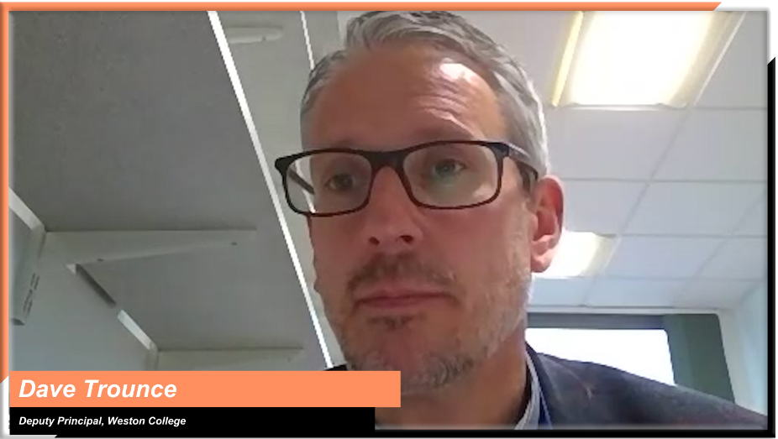
Dave Trounce, Deputy Principal, Weston College

INSIGHTS FROM T LEVEL PROVIDERS
To help you shape your approach, the following themes are explored:
Ctrl+click on a topic below to explore
First steps
Setting up an implementation board
Setting up T Level working groups
Preparing staff for the implementation process

The implementation planning process
The T Level Planner
Structuring an implementation plan

Engaging your staff
Using an implementation plan as a tool for raising awareness and internal communication
Engaging staff and partners beyond those directly involved in T Level implementation

First steps
Topic discussed | Learning points | Insights from T Level providers
Setting up an implementation board | Many T Level providers have established a board to drive T Level implementation across the organisation.  These boards:  - have been established early (many starting 18-months before T Level delivery)  - have clear and relevant representation from across the organisation  - have clearly defined roles in developing and implementing the plan  - have accountability measures in place, linking in with senior management / governance teams  - help to identify areas for staff CPD and building a sense of ownership. | In this video, Dave explains how one of the first actions for their T Level implementation was to set up a college-wide board, and the focus they placed in securing buy-in across the organisation. He goes on to outline the board’s role at different stages of implementation and delivery (4m 14s - ctrl+click to view).  Dave Trounce, Deputy Principal, Weston College  “The great thing about our Implementation Board is bringing different senior leaders together. The Board members have responsibility for different facets and so you get joined up thinking and make sure that nobody assumes somebody else is doing it.  “Equally you do not miss out on those nuggets that could really help you. For example, by having representation from the business growth and the industry placement team, we got some really nice collaboration going, so the business growth team at the college goes out and engages with Chambers of Commerce and employers. They do this with one voice for the college, not different teams potentially contacting the same employers”.  Dave Trounce, Deputy Principal, Weston College
Setting up T Level working groups | How will the implementation of each T Level be managed and what accountability structures are required?  Many providers have set up T Level-specific groups or working parties, who report into the wider T Level implementation board.  These groups:  - are led by subject-leads or Heads of Faculty  - include input from marketing, teaching, quality, maths and English, and employer engagement colleagues  - have T Level specific project plans, something facilitated in the T Level Planner  - host regular meetings to agree actions and review progress. | “The way we structured it at Weston is that every pathway we are offering has its own implementation plan that covers all key areas and all then feed up into a T level board.”.  Edd Brown, Director of Quality & Workforce Development, Weston College  Dave explains in this clip how their T Level implementation groups are set up and how they are supported by specific members of the main board to ensure success (57s - ctrl+click to view).  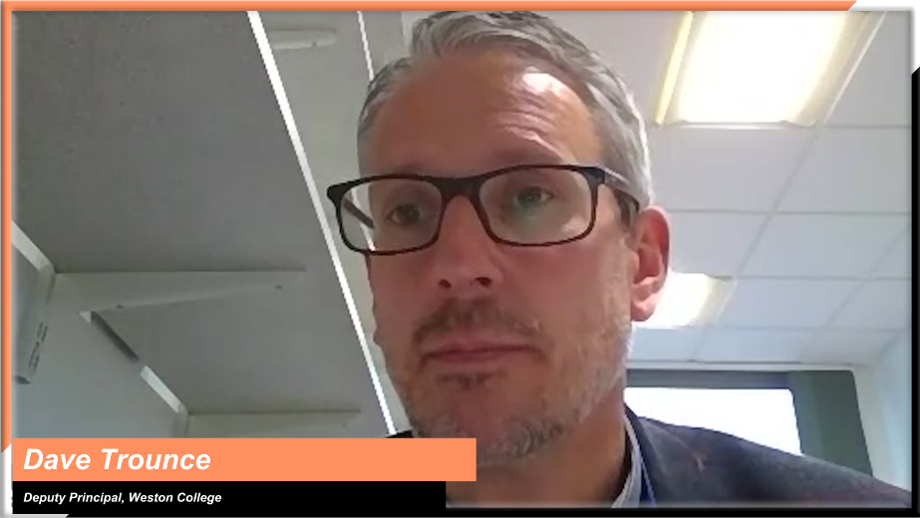  Dave Trounce, Deputy Principal, Weston College
Preparing staff for the implementation process | T Levels provide a unique opportunity to ‘think big’ and develop technical education from the ground up.  Consider what preparation needs to be done before the implementation process starts. For example:  - do members of staff understand the opportunity they have to design T Level delivery from scratch?  - do staff have the right curriculum design experience?  - what training might they need to increase their skills and confidence in this area?  Have a look at the Education & Training Foundation’s T Level Professional Development offer – that “supports staff delivering T Levels with the teaching skills, subject knowledge and confidence they need for the benefit of their learners” | In this video, Matt explains what a big step it is for staff to be required to develop a course from scratch, and how important it is for them to receive support in developing relevant skills and confidence (1m 21s - ctrl+click to view).  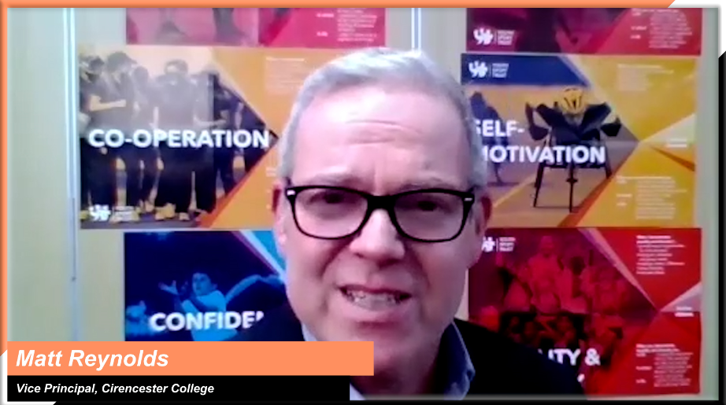  Matt Reynolds, Vice Principal Teaching, Learning and Development,  Cirencester College

The implementation planning process
Topic discussed | Learning points | Insights from T Level providers
The T Level Planner | On 1 October 2021, the Department for Education will be launching an online planning tool, built around the experiences of the first wave of T Level providers, to help you successfully plan, develop, and implement your T level offer.  The tool will allow you to:  - make an action plan, assigning tasks to relevant staff members, with deadlines, email reminders, and a quality assurance process  - rate your progress against factors, such as employer and stakeholder engagement, progression routes mapping and student recruitment, to be able to have, at any time, a quick overview of where your organisation is in the implementation process  - run reports for different stakeholders  - have easy access to other relevant support resources. | The Strategic Leadership Group consists of a number of Wave 1 providers, who come together every few months to share their experiences and insights to help shape support for future providers. Below are some comments from their discussion on the T Level planning process and the upcoming planning tool:  “Our action/working group consisted of middle management staff. We shared with senior leadership by exemption and in board meetings. The precursor to the T Level Planner enabled us to share with senior leadership actions completed and offer reassurances.”  “Having all these prompts about what we needed to be considering and doing was invaluable in starting on a plan and deciding who we needed to get involved from the get-go.”  “It made it obvious we would have to include the whole school. We had to win hearts and minds – we were changing the whole structure of an organisation. Such a tool is vital in this process.”  “Route specificity was essential in order to distribute the workload appropriately. But having a tool which would send automatic emails every time an action was assigned to a member of staff, as well as follow-up reminders would have made a big difference.”  “Accountability sat with me, but we had T Level leads, each with their own implementation team. Having the entire planning process in the context of a tool that would allow me to easily quality assure and keep up-to-date with the teams’ work would have made my working life a lot easier”.
Structuring an implementation plan | Different T Level providers have structured their implementation plan in different ways.  Some have structured their plan around the learner journey, for example:  - recruitment  - induction  - curriculum  - teaching and learning  - assessment and exams  - the industry placement  - facilities and resources.  Others have focused their plans around key areas of work or departments, for example:  - academic calendars, sequencing of the curriculum and timetabling  - MIS and quality systems  - employer engagement.  Which approach might you use? | “Implementation planning for us has been really trying to follow the learner journey. We started looking at marketing recruitment and IAG as a theme so that we ensured we were getting the right entry criteria and requirements for learners. Then we looked at the induction program for learners and built on our collegiate induction standards to ensure that they were fit for purpose for T level learners. This has developed a more robust diagnostic period and assessments. The next part was around planning teaching and learning. This involved looking at the sequencing of the curriculum, how the curriculum is built and designed and how we build that into our skills maps. The result of this is that learners can see the program and the skills they will develop over time. We then focused on assessment and exams. We wanted that to be planned separately. Next, we focussed on industry placements and employer engagement, so that is led by a couple of different departments within the organisation. The final part is facilities and resources, looking at any new facilities or specialist resources for the T levels”.  Edd Brown, Director of Quality & Workforce Development, Weston College  In this video, Matt explains how they approached the development of their implementation plan so that it met the needs of both students and employers (1m7s - ctrl+click to view).  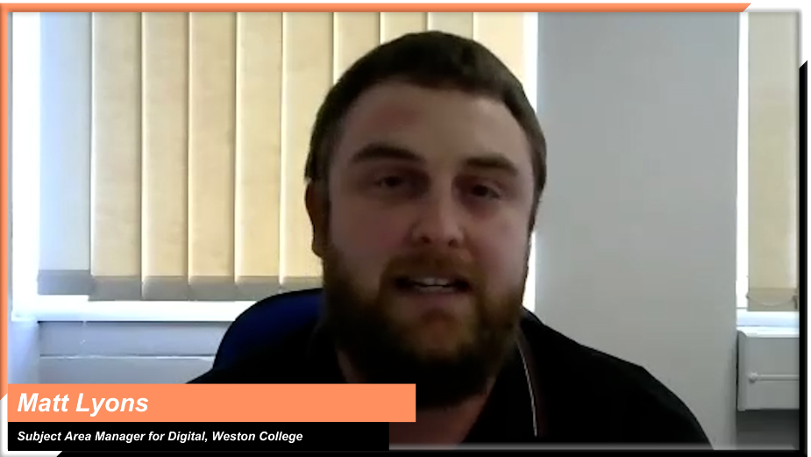  Matt Lyons, Subject Area Manager for Digital, Weston College

Engaging your staff
Topic discussed | Learning points | Insights from T Level providers
Using an implementation plan as a tool for raising awareness and internal communication | How might you use an implementation plan to raise awareness, support and engage with staff across the organisation?  It is important that senior managers use this as an opportunity to engage with all internal stakeholders early on – from governors and heads of department to teachers and operational staff. | “Early planning has supported awareness raising in all groups of staff from professional service support, academic staff, strategic leadership Group and the Board of Governors.  As we moved deeper into development, our implementation plan enabled us to provide clear and transparent direction to each key stakeholder along with clarity of expectation and the awareness of how their part supported each of the components within the colleges wider strategic plan which created a real sense of engagement and pride within our teams.”  Danny Brett, Assistant Principal, Bishop Burton College  “Buy-in from governors, teachers and faculty heads – it’s really important that everyone is onboard with T Levels right from the start. Involve faculty heads early on so they are part of the decision making. It places them really well to then understand how they need to develop and train their staff. Think beyond senior managers wanting T Levels on the curriculum – it has a much wider scope and you need to think about the various managers and areas of the colleges that need to be involved.”  Matt Reynolds, Vice Principal Teaching, Learning and Development,  Cirencester College
Engaging staff and partners beyond those directly involved in T Level implementation | Think about how you might engage with internal staff and external partners who aren’t directly involved in T Level implementation.  Regular updates and briefings for staff help to:  - ensure they are aware of the strategic significance of T Levels for the organisation  - ensure those from different campuses or other areas of the organisation have the opportunity to have an input  - broaden external marketing, as staff share the concept of T Levels with family, friends, and other connections.  Providers have also found it useful to create a central repository, for all staff to access information relevant to their area of work. | In this video, Matt and Danny discuss the importance of identifying all stakeholders -including those not directly involved with the development of T Levels- as early as possible, to raise awareness and get buy-in across the organisation (1m39s - ctrl+click to view).  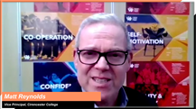  Matt Reynolds, Vice Principal Teaching, Learning and Development,  Cirencester College  and Danny Brett, Assistant Principal, Bishop Burton College  “There is so much information available when it comes to T Levels, and there are almost weekly updates. For us, part of our implementation programme was to create information hubs within the college. These house updates from the Institute of Apprenticeships and Technical Education, the Association of Colleges, and the DfE themselves. So, for us as a college we created a single hub where we picked up all the information and dropped it in, available to all staff.”  Matt Reynolds, Vice Principal Teaching, Learning and Development,  Cirencester College

