T LEVEL STRATEGY

A Case study for T Level providers

INTRODUCTION
How will T Levels fit into your overall post-16 offer? Which T Levels should you be delivering and are they going to replace existing provision fully or partially? These types of strategic discussions and decisions will be the first steps in adapting your organisation’s post-16 strategy. This case study offers insights from several Wave 1 T Level providers into the processes they have undertaken around strategic decision-making.
In this video, you will hear from Morag Davis from Nelson and Colne College explaining how important it has been strategically to align T Levels with their core values whilst balancing the needs of students and employers. She goes on to explain how they have worked with employers to identify specific needs and how this has shaped their offer (3.03s - ctrl+click to view).

Morag Davis, Assistant Principal for Technical Curriculum, Nelson and Colne College

INSIGHTS FROM T LEVEL PROVIDERS
To help you shape your approach, the following themes will be explored:
Ctrl+click on a topic below to explore
Aligning T Level strategy to the needs of the local economy
Establishing how T Levels can contribute to meeting local economic priorities
Working closely with employers to identify skills gaps

Establishing how T levels fit within your overall strategy
Aligning T Levels with the strategic direction and values of your organisation
The value of T Levels as part of a wider curriculum strategy

Developing skills for life and work
Instilling a career-focused ethos
Establishing T Levels as a driver of social mobility and career progression

Aligning T Level strategy to the needs of the local economy
Topic discussed | Learning points | Insights from T Level providers
Establishing how T Levels can contribute to meeting local economic priorities | Identifying the distinctive priorities and needs of industries in your region and mapping occupational trends is an important first step in helping you shape your T Level strategy.  Consider how you might regularly draw this intelligence from:  - local and regional employer networks  - local enterprise partnerships (LEPs)  - skills advisory panels  - national and regional labour market intelligence. | In this video, Danny highlights the importance of working with local and regional employers and stakeholders, such as LEPs and Skills Advisory Panels, to shape their offer around the needs of their regional economy and its workforce (1m12s - ctrl+click to view).  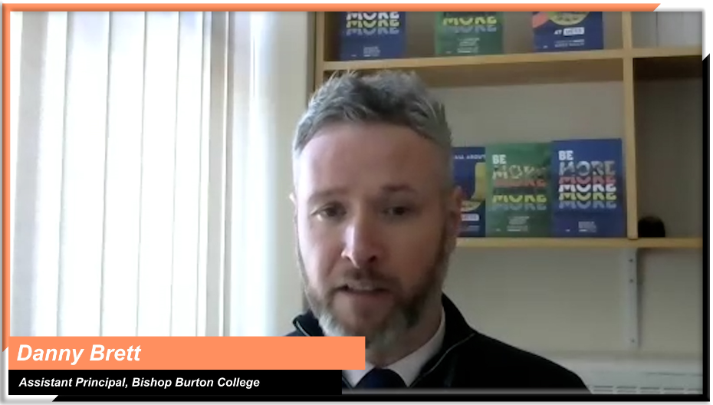  Danny Brett, Assistant Principal, Bishop Burton College  In this video, Matt explains the value of working with their LEP and employers to design an offer that will ensure their students leave the college being work ready (1m26s - ctrl+click to view).  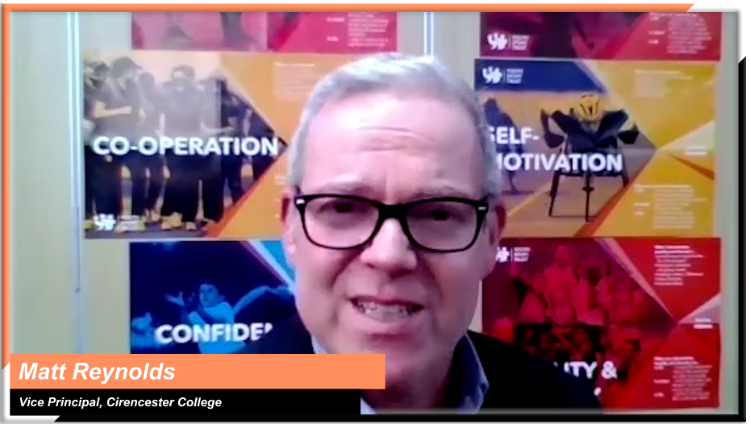  Matt Reynolds, Vice Principal Teaching, Learning and Development,  Cirencester College
Working closely with employers to identify skills gaps | Establishing relationships with employers from the start to help you identify skills gaps is essential.  It will give you an additional level of detail to inform your strategy around:  - current skills gaps  - future skills gaps  - which T Level occupational specialisms you could focus on to meet these skills needs. | In this clip, Ashley describes how they have based their strategic decision making on labour market intelligence and feedback from employers to meet local workforce needs (1m06s - ctrl+click to view).    Ashley Grute, Assistant Principal, HSDC  “We work very closely with employers to make sure that we understand where their skills gaps are, and we work with our business development unit as they are very close to our employers.  We know where the skills gaps are now and where employers think the skills gaps will be in the future. So, we can match up those skills. For example, we wanted to deliver the digital T level because that was one of our LEP priorities and is a need of the wider community.”  Morag Davis, Assistant Principal for Technical Curriculum  Nelson and Colne College

Establishing how T levels fit within your overall strategy
Topic discussed | Learning points | Insights from T Level providers
Aligning T Levels with the strategic direction and values of your organisation | Aligning T Levels with the values and strategic direction of your own organisation, supports and strengthens your ability to:  - build deeper employer relationships  - meet immediate and future regional skills needs  - focus on learner outcomes and progression routes  - establish clear partnerships. | In this clip Dave outlines Weston College’s strategic view of T Level development and how they considered the wider landscape and the college ethos within it (1m31s - ctrl+click to view).  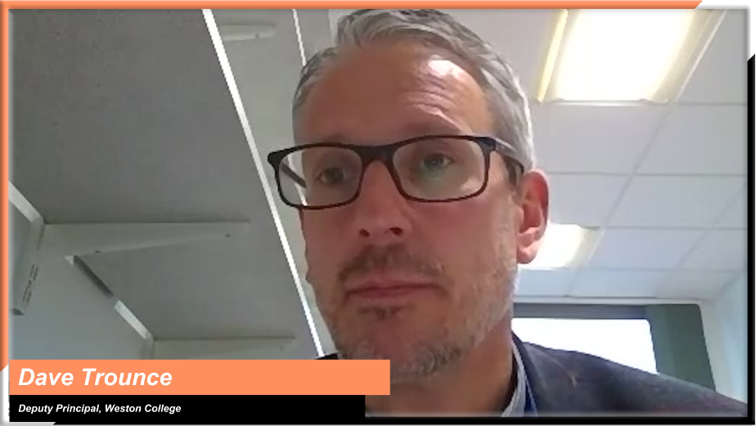  Dave Trounce, Deputy Principal, Weston College  “Another of our strategic values is ‘destinations not qualifications’, which basically means that when a learner comes to us, we are already talking to them about their eventual destination.  It is not about the qualification they are taking; it is about the skills they are developing, the experiences of work that they require. That is what's important and so T levels with the substantial industry placement, fit in, as they have been developed by employers. We definitely don't see our Level 3 as a pipeline to university only, so T levels work for us and provide a joined-up approach”.  Morag Davis, Assistant Principal for Technical Curriculum,  Nelson and Colne College
The value of T Levels as part of a wider curriculum strategy | The introduction of T Levels can often instigate a wider review of your curriculum strategy.  It provides an opportunity to review:  - the strategic fit of T Levels within your wider curriculum  - the existing provision that T Levels might replace  - how your T Level offer meets the needs of your students and employers  - how T Levels fit as part of your progression route from Level 2 to Levels 4 and 5. | Matt talks about their view of T Levels as the new Gold Standard of vocational training, which will eventually replace their previous offer (47s - ctrl+click to view).  Matt Reynolds, Vice Principal Teaching, Learning and Development,  Cirencester College  In this video, Dave explains how T Levels will replace some existing provision and how it has been important for them to make sure that the offer is a good fit for the right groups of learners (1m10s - ctrl+click to view).  Dave Trounce, Deputy Principal, Weston College  “T Levels for us offered that high quality alternative to A Levels that could fast-track learners into a career or apprenticeship. We had to tie this up with our Level 2 and Level 4 and 5 offer, so we have a very clear progression route through our organisation and with the employer.”  Morag Davis, Assistant Principal for Technical Curriculum,  Nelson and Colne College
“One thing that we did early was to agree the offer. We discussed whether we would run T Levels alongside vocational equivalents if there was one. We decided to switch off vocational equivalents in childcare and construction and solely focused on the T Levels in those two curricula areas. But we decided to run the vocational equivalent in IT alongside the digital T Level. We then discussed entry criteria so that when we were marketing parallel qualifications, young people were incredibly clear on what the requirements were.”
Sam Hillman, Assistant Principal, Exeter College

Developing skills for life and work
Topic discussed | Learning points | Insights from T Level providers
Instilling a career-focused ethos | What does a career-focussed ethos look like? For those currently delivering T Levels, it means:  - inspiring a love for learning and challenging students to deepen their academic and technical knowledge and skills  - instilling confidence  - giving learners a wide range of industry experiences  - focusing on the development of soft skills and work appropriate behaviours  - preparing students for work and for life.  How might you foster this ethos in your own context? | “We focus on careers, not courses. We want any programme that we deliver -that includes T levels- to provide a wide range of experiences that help learners develop the knowledge, skills and behaviours that they need within a given industry. We want learners to be ready to learn, ready for work and ready for life… So whatever pathways we offer, we want them to be delivered in a way that supports learners to build knowledge, confidence, and capacity to deal with more challenging academic and technical learning.”  Dave Trounce, Deputy Principal, Weston College
Establishing T Levels as a driver of social mobility and career progression | Consider the impact T Levels could have on the social mobility of your students and the wider community.  A positive impact could be achieved by:  - supporting students who have struggled academically in the past to flourish  - providing students with higher-level technical skills  - creating opportunities for students to move into the best jobs and fulfilling careers  - retaining talent in your region. | “We have high aspirations for our young people and we genuinely want them to have better life chances. They are going to have them if they can attain these higher-level technical skills and not just get any old job but get the best jobs and where it's appropriate, to go away from Norfolk and perhaps come back and bring it all back when they've got that experience.  Julia Bates, Vice Principal FE Curriculum and Quality,  City College Norwich  Morag explains how important it was for them to ensure that the T Level offer would support the social mobility of their learners (1m6s - ctrl+click to view).    Morag Davis, Assistant Principal for Technical Curriculum,  Nelson and Colne College

