COLLABORATION

A Case study for T Level providers

INTRODUCTION
T Level development and implementation is complex. In this case study, Wave 1 providers share their experiences of, and the benefits derived from, collaborative work within their own organisations and with external partners and stakeholders.
In this clip, you will hear from Ashley Grute of HSDC, who explains the importance of collaboration with external partners, including employers, other T Level providers, universities, and schools (3m14s - ctrl+click to view).
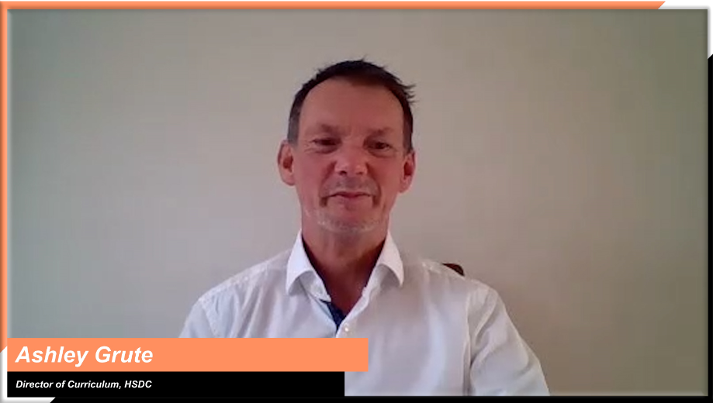
Ashley Grute, Assistant Principal, HSDC

INSIGHTS FROM T LEVEL PROVIDERS
With insights from some of the leading early T Level providers, this case study will explore the following two themes:

Ctrl+click on a topic below to explore
Collaborating within your organisation
Embedding a cross-team approach to T Level implementation

Collaborating outside your organisation

Collaborating outside your organisation
Working with other T Level providers
Working with schools and universities
Working with employers
Accessing support available to T Level providers

Collaborating within your organisation
Topic discussed | Learning points | Insights from T Level providers
Embedding a cross-team approach to T Level implementation | For those overseeing the day-to-day implementation of T Levels, collaborating with senior and front-line colleagues has been essential.  Think about:  - engaging in regular updates with senior managers and governors to discuss strategic direction  - working towards a shared understanding of T Levels  - liaising with faculty leads about staff and resourcing requirements  - conducting detailed planning and development with particular teams e.g., marketing, student welfare, curriculum planning, data, employer engagement, etc.  - sharing existing good practice with others to help them adapt to their particular role  - bringing curriculum and industry placement teams together to ensure meaningful placements that are aligned with the curriculum. | In this audio clip, Roz explains why it was important for the heads of area that looked after the different T Levels to work together in the early stages of implementation (1m10s - ctrl+click to view).  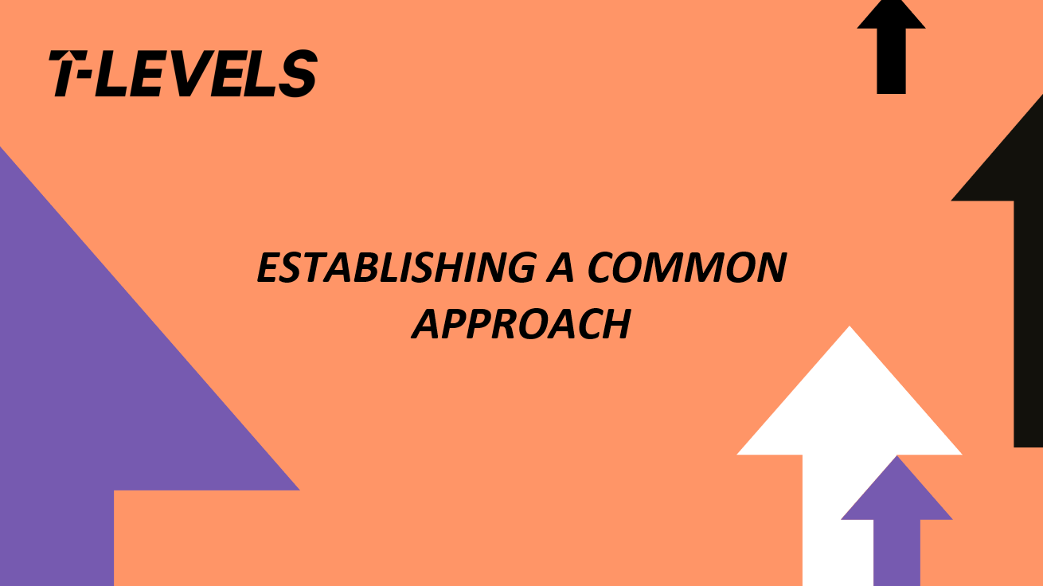  Roz Hicks, Head of Media, Business & Digital Industries,  City College Norwich  In this audio clip, Roz talks about the importance of working with their Industry Placement team, who needed to understand the curriculum in order to generate ideal placement opportunities (1m06s - ctrl+click to play).  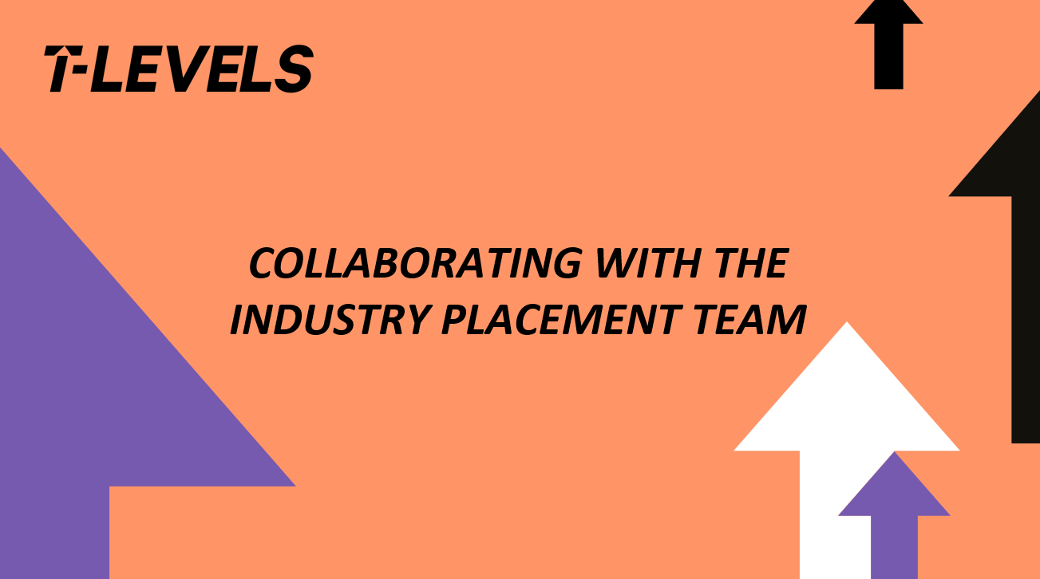  Roz Hicks, Head of Media, Business & Digital Industries  City College Norwich

Collaborating outside your organisation
Topic discussed | Learning points | Insights from T Level providers
Working with other T Level providers | Collaborating with other providers is a great way to better understand the requirements of T Level implementation and share lessons learnt. In some cases, T Levels have instigated genuine provider collaboration for the first time.  Consider:  - getting in touch with a provider who is further along the process and has, ideally, started delivery to ask for advice, ideas, and feedback  - engaging with providers in the same position as you to work through problems together and develop a support group  - working with T Level providers in your region to organise joint CPD sessions or coordinate employer engagement strategies. | “Collaboration provides a valuable opportunity to share good practice and to discuss ideas around design and delivery. I think it is a real opportunity to share ideas and good practice and it’s also a form of therapy for staff to be able to talk with other providers about problems and share concerns and come up with solutions.”  Ashley Grute, Assistant Principal, HSDC  In this video, Morag talks about the benefits of joining the Lancashire Digital Routeway Network and how it increased their access to different opportunities they wouldn’t have had access to as an individual college (1m4s - ctrl+click to view).  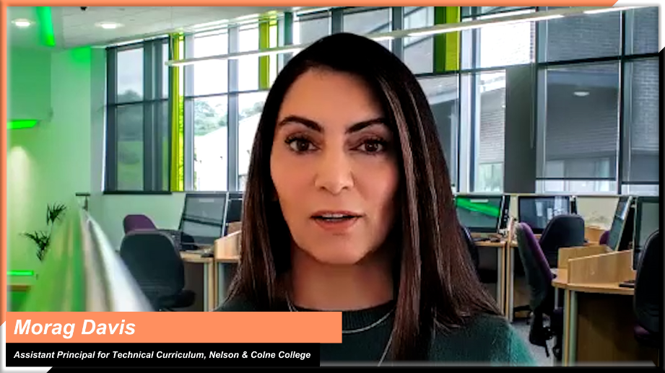  Morag Davis, Assistant Principal for Technical Curriculum,  Nelson and Colne College  In this clip, Matt talks about how T Levels offered a rare opportunity to collaborate widely with other colleges (46s - ctrl+click to view).  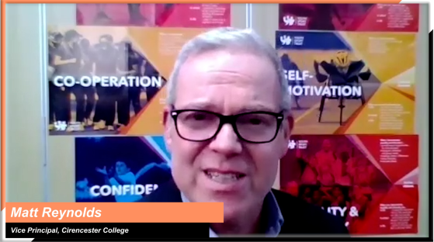  Matt Reynolds, Vice Principal Teaching, Learning and Development,  Cirencester College
Working with schools and universities | Early engagement and collaboration with other educational institutions has supported the progression pathways of learners. This has included:  - working with schools to raise awareness of T Levels with students, staff, and career advisors  - working with universities to provide specialist input into the curriculum, provide state of the art facilities and set up progression pathways. | “We have really benefited from collaboration with schools. We have been into lots of schools to raise awareness around T Levels, talking to students, staff, and holding events for career staff. We have worked closely with local universities, firstly to raise awareness, but also to try and create more opportunity for our students moving forward. One of the things that we've done as a college is create a health and nursing Academy with Portsmouth and Chichester Universities. And this will mean that our students get the chance to use the amazing facilities at the unis, get input from some University lecturers and will get guaranteed interviews on their degree programmes. So, I think that collaboration with universities has been really beneficial.”  Ashley Grute, Assistant Principal, HSDC  “I would advise providers to have conversations with their local higher education providers to make sure that they understand T Levels. We provide updates to ensure they understand the context behind these qualifications as potential progression providers.”  Stephen Carr, Head of Construction & Experience of Work Team,  City College Norwich
Working with employers | Change is always challenging and an important part of preparing for T Levels is ensuring that staff have current knowledge of industry standards and terminology so they can bring this alive in the classroom and have confidence when in discussions with employers  For the case study providers this has included:  - working with employers to give staff exposure to industry placements to support curriculum planning and teaching  - working closely with employers on the design of the curriculum and how they can get involved  - training staff to plan industry placements to match employers’ needs and to secure high-quality placement opportunities | In this video, Matt explains the importance of taking a different, broader approach to working with and building lasting relationships with employers (37s – ctrl+click to view).  Matt Reynolds, Vice Principal Teaching, Learning and Development,  Cirencester College  In this video, Ruth explains why it is vital for staff to go on industry placements to develop current experience of industry (54s - ctrl+click to view).  Ruth Coyle, Director, La Retraite Roman Catholic Girls’ School  “All our teachers on the course went out on an industry placement themselves. They've actually been out for five days, to foster links and to make sure that what is taught in class matches industry standard.”  Roz Hicks, Head of Media, Business & Digital Industries,  City College Norwich
Accessing support available to T Level providers | There is a great deal of resource and support available to providers implementing T Levels.  Make sure you:  - work with the Association of Colleges (AoC) if you are eligible for their support package  - make full use of the T Level Professional Development (TLPD) offer delivered by the Education and Training Foundation (ETF)  - access the various support material offered by awarding organisations (AOs)  - access the comprehensive information on support.tlevels.gov.uk and subscribe to the fortnightly T Level newsletter  - take every opportunity to get involved and offer your insights, advice, opinions, and feedback. | “Take every opportunity to collaborate where possible to learn from what's going really well and the mistakes of the first providers delivering T levels. You should connect with other providers or attend online meetings and conferences available for T levels from ETF, DfE, or AoC. There is a wealth of knowledge out there about T levels that we continue to join because there's still much to learn and you learn best by talking to and sharing experiences with others.”  Sam Hillman, Assistant Principal: Technical and Vocational Curriculum,  Exeter College  In this clip, Morag talks about how she collaborated with their Organisational Development Manager to ensure staff took full advantage of the CPD training available (1m25s - ctrl+click to view).  Morag Davis, Assistant Principal for Technical Curriculum,  Nelson and Colne College  In this video, Matt advises colleagues to make the most of the support offered by organisations such as DfE and AoC and take advantage of any opportunities for collaboration (47s - ctrl+click to view)  Matt Reynolds, Vice Principal Teaching, Learning and Development,  Cirencester College

