Digital Systems

A Case study for T Level providers

INTRODUCTION
Although T Levels have similarities to other level 3 courses, they also have significant differences. Providers have found that whilst they can learn from other programmes, they have had to develop and update their systems to support all aspects of T Level set up, delivery and assessment. This case study looks at how some of the Wave 1 providers have approached this challenge and developed the systems needed for T Level delivery.

INSIGHTS FROM T LEVEL PROVIDERS
To help you shape your approach, the following themes are explored:

Ctrl+click on a topic below to explore
Digital systems to support implementation and delivery
Tracking planning
Tracking industry placements
Tracking student progress

Digital systems to support implementation and delivery
Topic discussed | Learning points | Insights from T Level providers
Tracking planning | On 1 October 2021, the Department for Education will be launching an online planning tool, built around the experiences of the first wave of T Level providers, to help you successfully plan, develop, and implement your T level offer.  The tool will allow you to:  - make an action plan, assigning tasks to relevant staff members, with deadlines, email reminders, and a quality assurance process  - rate your progress against factors, such as employer and stakeholder engagement, progression routes mapping and student recruitment, to be able to have, at any time, a quick overview of where your organisation is in the implementation process  - run reports for different stakeholders  - have easy access to other relevant support resources. | The Strategic Leadership Group consists of a number of Wave 1 providers, who come together every few months to share their experiences and insights to help shape support for future providers. Below are some comments from their discussion on the T Level planning process and the upcoming planning tool.  “Accountability sat with me, but we had T Level leads, each with their own implementation team. Having the entire planning process in the context of a tool that would allow me to easily quality assure and keep up-to-date with the teams’ work would have made my working life a lot easier”.  “Route specificity was essential in order to distribute the workload appropriately. But having a tool which would send automatic emails every time an action was assigned to a member of staff, as well as follow-up reminders would have made a big difference.”  “Our action/working group consisted of middle management staff. We shared with senior leadership by exemption and in board meetings. The precursor to the T Level Planner enabled us to share with senior leadership actions completed and offer reassurances.”  “A tool that enables you to easily track progress enables you, in turn, to put in place early intervention measures”.
Tracking industry placements | With industry placements being closely aligned to the curriculum, having a digital tool, whether in the form of a phone app or other computer software, to record and track different aspects of the learner’s journey can be very valuable.  Some wave 1 providers have managed to successfully align such software with existing systems, helping communication and efficiency of data input.  Think about recording and tracking:  - industry placement attendance  - employer feedback  - learning targets and progress against those targets  - assignments  - personal reflections  - communications between students, teachers, and employers  - compliance. | In this video, Simon talks about the software they have developed to track industry placements and explains how it links to other college systems to help efficiency of data input (1m41s - ctrl+click to view).  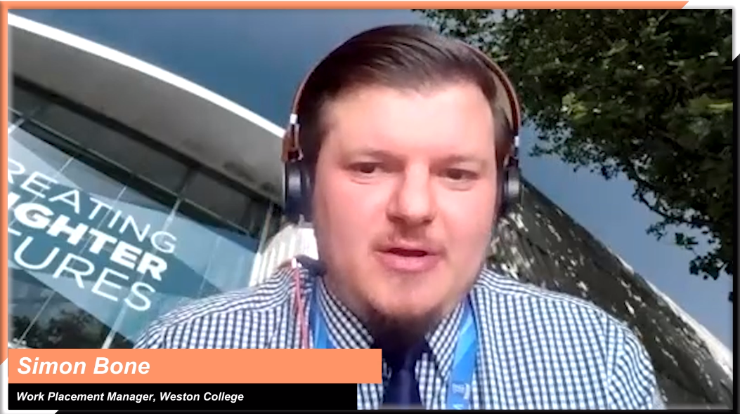  Simon Bone, Work Placement Manager, Weston College  “We set start and end dates that automatically build a logbook, a journal for the student to have as a reflective commentary from the start to finish of their industry placement. We ask them to reflect that back into their learning and how it’s impacting on their study. Also, the impact on them, both personally and professionally and in terms of their career steps. The software also enables us to track progress from an employer point of view, so we make sure that the employer gives a rating on how the student is performing in that placement. Firstly, it can highlight any areas of concern and we can work on overcoming identified barriers. But equally, and far more often, it shows just how well a student can quickly adapt to industry and provide real value to that business. Importantly the software allows us to communicate directly with employers and learners and track the feedback, which is a very useful resource”.  Simon Bone, Work Placement Manager, Weston College
In this video, Mike describes how an easy-to-use app on students’ phones logs the hours they spend at their placement, removing the need for the employer to sign off timesheets, and enabling the college to track hours worked against total hours required (56s - ctrl+click to view).
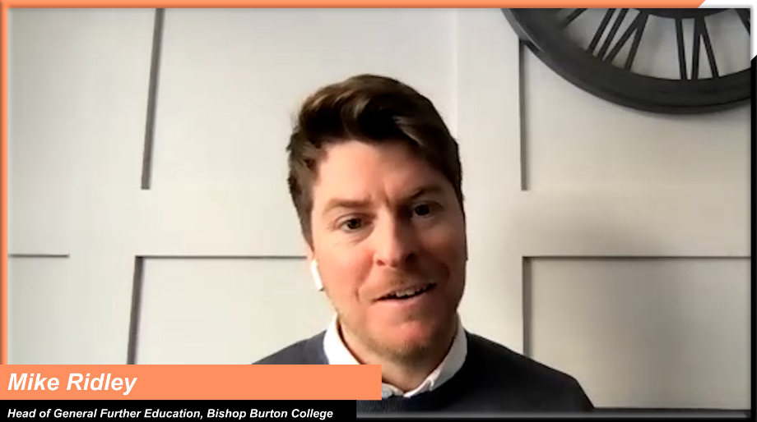
Mike Ridley, Head of General Further Education, Bishop Burton College
“In our student records system team, we have designed and developed two key tracking systems for students. One does all the tracking of student referral, positive behaviours, targets, recording placement hours, dates and times. It has the capacity to store the agreement with employers where we document industry placement objectives, and we can use it to record mid and end of placement reviews. Our pastoral and curriculum teams can use it to get a comprehensive overview of student progress. The other system is used by students to log and reflect on the hours they’ve done in the placement, look at skills checks, score themselves and it really works to develop targeted action plans. Both systems integrate with our main CRM and MIS systems which means nothing is done in isolation and we have more synergy to meet the goals we have set and to be able to accurately track progress and produce reports.”
Vicki Illingworth, Principal at Crawley College,
part of the Chichester College Group

Topic discussed | Learning points | Insights from T Level providers
Tracking student progress | Having the right systems in place to monitor student progress is essential. Whether using a traditional spreadsheet, a more complex data analysis software or a new app, think about what would be most beneficial to you and your students.  Are your systems able to:  - record learners’ starting points and subsequent assessment outcomes, as a way to assess progress  - offer students a platform where they can upload their work and receive regular feedback  - set short-term targets and long-term goals for each student and create personalised plans to achieve them  - identify gaps, both individually and across cohorts  - produce targeted reports for students and parents. | In this clip, Matt talks about how they use an e-portfolio system where students upload all the work they complete throughout the year, allowing staff to provide regular formative feedback to help students track their progress and identify gaps (1m48s - ctrl+click to view).  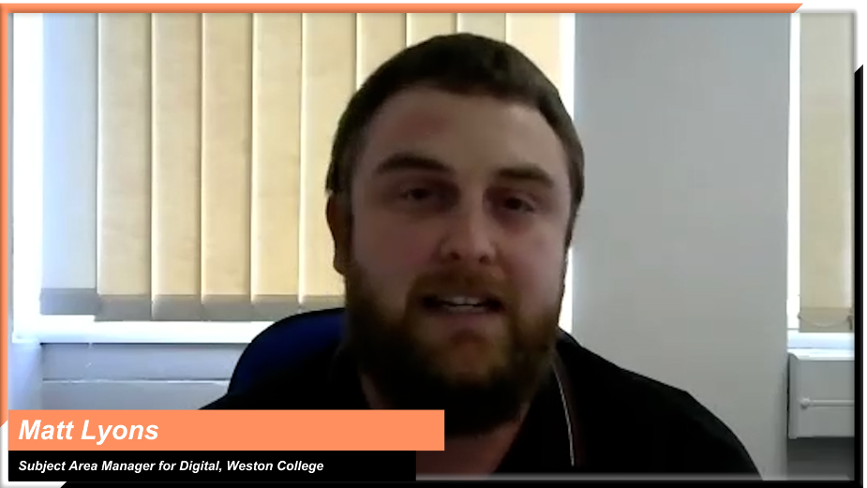  Matt Lyons, Subject Area Manager for Digital, Weston College  “To monitor T Level student progress, we track “distance travelled” during a student’s T Level course. From enrolment conversation records and initial diagnostic assessments through to tracking attendance, course work submissions, quality of work, progression and evidence, Bishop Burton use spreadsheets and Power BI so that a dashboard view of the student’s progress is available to our curriculum leads. Pro Monitor is used for tracking SMART targets, enrichment focus points, mental health, grades and internal college certification.  We have looked at different ways of tracking student progress and we are always looking at systems to support efficient, effective monitoring and reporting. Bishop Burton has piloted the use of Skills Forward which is an eLearning Assessment Solution and from September 2021, we will use it to track T Level core areas, employability skills and to produce 3 student reports per year. Other courses will also be monitored on Skills Forward from September so it will be a college wide / all courses focused system.”  Mike Ridley, Head of General Further Education, Bishop Burton College

