APPROACHES TO ASSESSMENT

A Case study for T Level providers

INTRODUCTION
Ensuring that students have the right guidance and support from teaching staff is fundamental to their success in achieving the T Level qualification. This starts with early engagement and initial assessment, and continues throughout the programme with formative assessments - all aimed at preparing the student to succeed and thrive at work. In this case study, Wave 1 providers talk about their approach to assessment.
In this video, Emma Panday from City College Norwich explains the assessment approach they take - including diagnostics, formative assessments, feedback, and recapping and support - to enable their learners to be ready for the industry placement and exams (1m49s - ctrl+click to view).
v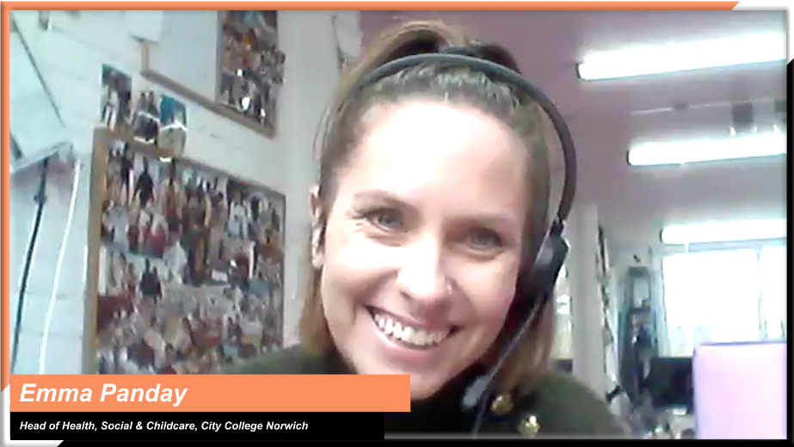
Emma Panday, Head of Health, Social and Childcare, City College Norwich

INSIGHTS FROM T LEVEL PROVIDERS
With insights from some of the leading early T Level providers, this case study will explore the following themes to help you shape your approach:

Ctrl+click on a topic below to explore
Initial assessment and diagnostics
Capturing the student’s starting point

Formative assessment
Building on effective practice from other courses to inform your approach to formative assessment
Using different approaches to formative assessment to track progress and identify gaps in knowledge
Involving employers in the teaching and assessment of soft skills
Helping students build exam-focused skills

Initial assessment and diagnostics
Topic discussed | Learning points | Insights from T Level providers
Capturing the student’s starting point | Establishing a robust initial diagnostic assessment process is essential in identifying each student’s starting point and gaps in knowledge and skills.  It can help you:  - find out where your students are academically  - understand to what extent they are ready for the workplace  - identify potential  - have a benchmark against which to measure student effort and improvement  - pitch the lessons at the right level. | In this video, Matt explains how they use initial assessments to understand students’ potential and to identify where they have particular needs (2m37s - ctrl+click to view).  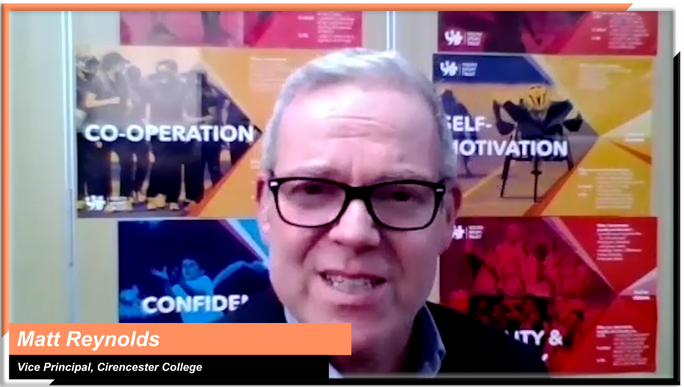  Matt Reynolds, Vice Principal Teaching, Learning and Development,  Cirencester College  “Once students enrolled, we carried out some diagnostics for the first few weeks of the term. We spent time with the students undertaking various exercises and tasks to understand where they had got to with their learning. This gave us a clear view of each student’s starting point against which we could monitor future progress.”  Roz Hicks, Head of Media, Business & Digital Industries,  City College Norwich

Formative assessment
Topic discussed | Learning points | Insights from T Level providers
Building on effective practice from other courses to inform your approach to formative assessment | Although T Level assessment requires a different approach, consider what effective practice might be drawn from other courses you deliver, such as A Levels and BTECs.  This can inform the way you approach:  - formative assessment of academic learning  - formative assessment of skills and employer-set projects  - effective use of portfolios as part of formative assessment  - progress milestones  - minimum expected grading. | In this video, Matt and Edd explain different aspects of their formative assessment methodology and how they developed it with help from their sixth form, which delivers A Levels (1m46s - ctrl+click to view).  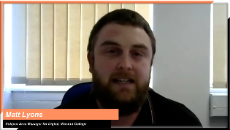  Matt Lyons, Subject Area Manager for Digital and  Edd Brown, Director of Quality & Workforce Development,  Weston College
Using different approaches to formative assessment to track progress and identify gaps in knowledge | With T Levels structured around end of the year exams, continuous assessment offers an opportunity to:  - keep an eye on student progress throughout the year  - identify gaps  - build student confidence in performing under pressure  - predict final grades.  Think about:  - having frequent assessments points  - using a variety of different assessments, such as presentations, projects, peer reviews, past exam questions, and mock exams  - using a progress tracker to keep you updated on both individual and cohort progress. | In this audio clip, Roz talks about how they track student progress and how they have approached continuous assessment (2m19s - ctrl+click to play).  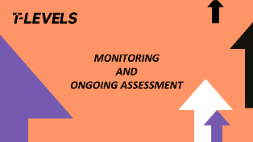  Roz Hicks, Head of Media, Business & Digital Industries,  City College Norwich  In this audio clip, Sam discusses how the college uses assessment, such as mini and full mocks, to keep track of student progress, help them identify support needs, and prepare students for sitting exams (1m19s - ctrl+click to play).  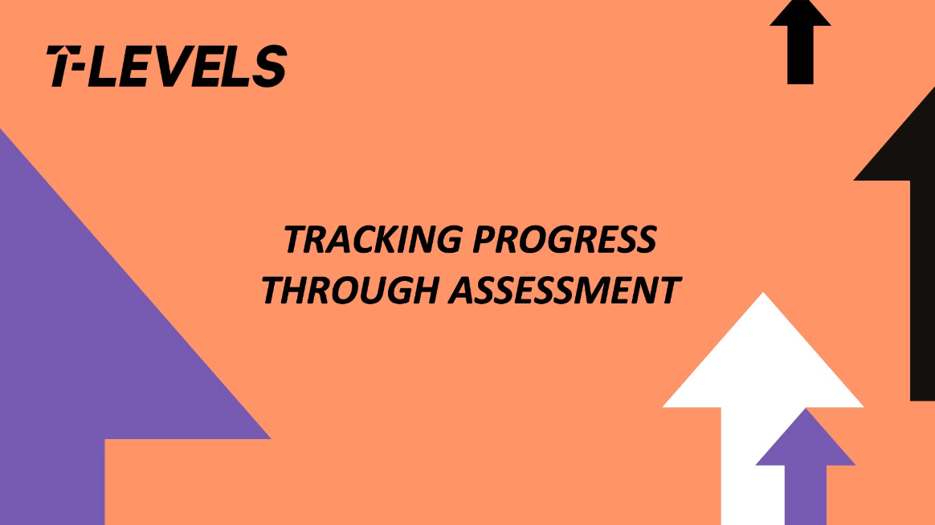  Sam Hillman, Assistant Principal: Technical and Vocational Curriculum,  Exeter College
Involving employers in the teaching and assessment of soft skills | Think about bringing in employers to support the students’ learning and formative assessment tasks.  Consider how employers could:  - support the development of students’ employability skills  - input into specialist technical content  - be involved in assessments and provide direct feedback to students on their progress and how this might align to expectations in the workplace. | Bishop Burton College brought employers into lessons to provide learners with valuable feedback on employability skills and assess their readiness for the workplace.  “A recent example shows how we have worked with our employers to support our students to develop the soft skills required in employment, such as personal appearance or confidence. Our employer partner, as part of this work, held a range of zoom sessions with our students, which demonstrated the sector context and how best students could develop those skills. We really feel opportunities like this are key to a student making that successful transition into employment.”  Danny Brett, Assistant Principal, Bishop Burton College
Helping students build exam-focused skills | Providing students with the time and input to develop exam-focused skills is essential.  Think about:  - using sample exam questions provided by Awarding Organisations  - using past exam questions from relevant courses  - working with students on how best to structure their answers  - exploring how best to approach an exam paper based on question weightings  - setting extended writing tasks to prepare students for the employer-set project  - conducting mock tests in exam conditions to build confidence in performing under pressure  - factoring in revision periods and space for additional learning where gaps are identified | “We've been using at regular intervals, the bank of example exam questions that Pearson has provided. We have put together several strategies and given the learners extra exam techniques, looking at the weighting of the questions and how to structure their answers. It's been quite difficult because we've inherited a generation that hasn't gone through an exam process. They haven't done the revision. They haven't done the exams. We need to build those skills back in for those students. So, we record the exam questions. They get marked. Feedback is given for improvements and if they can move on to more complex questions. The level is quite high, nearly level 4, so that is stretching the learners well beyond where they've been stretched before.”  Stephen Carr, Head of Construction & Experience of Work Team,  City College Norwich  In this video, Sam explains how they use formative assessment to help students familiarise themselves with exam type questions, focusing on both recent and older lessons to promote deeper learning (1m36s - ctrl+click to play).  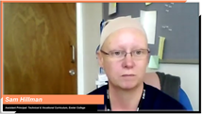  Sam Hillman, Assistant Principal: Technical and Vocational Curriculum,  Exeter College

