Employer Engagement

A Case study for T Level providers

INTRODUCTION
Engaging employers to provide high-quality industry placements is one of T Levels' most important yet challenging requirements. This case study aims to provide insights from early T Level providers about the ways in which they are engaging employers, the benefits they are getting from investing in building strong relationships with them, and the ways in which they are involving employers in the development and delivery of the curriculum.
In the following video, you’ll hear from Matt Reynolds from Cirencester College, one of the Wave 1 T Level providers. Matt talks about the importance of taking time to develop long-lasting relationships with employers (37s - ctrl+click to view).
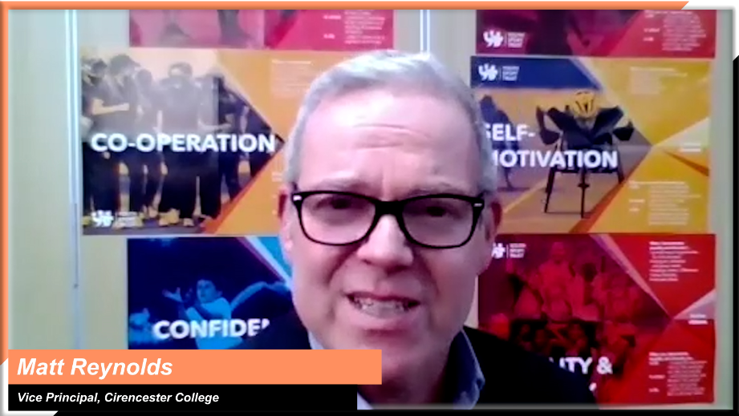
Matt Reynolds, Vice Principal Teaching, Learning and Development, Cirencester College

In this clip, Danny Brett from Bishop Burton College provides a holistic overview of their employer engagement and industry placement strategies (2m42s ctrl+click to play).
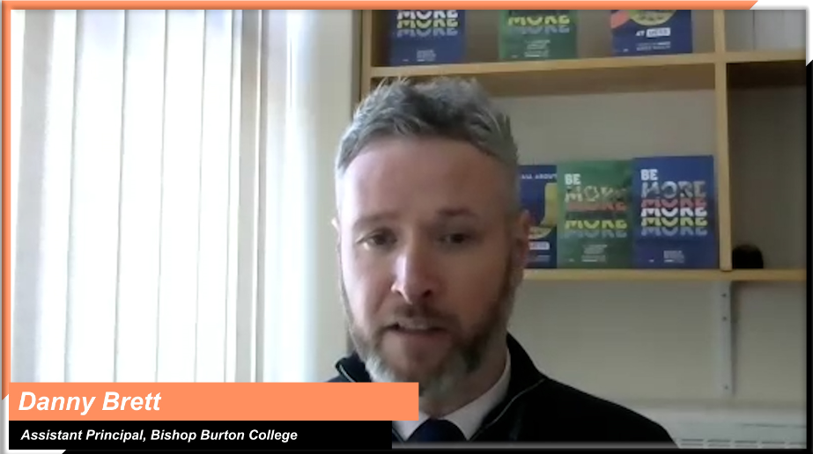
Danny Brett, Assistant Principal, Bishop Burton College

INSIGHTS FROM T LEVEL PROVIDERS
To help you shape your approach, the following themes will be explored:
Ctrl+click on a topic below to explore
Building relationships with employers
Starting with employers where relationships already exist
Establishing employer working groups for each T Level route
Exploring how industry placements might feature as part of employers’ talent pipelines
Hosting T Level ‘launch’ events to generate a profile in the region and attract employers to find out more

Supporting employers with industry placement planning and delivery
Agreeing on tasks, projects and targets that align with the needs of students and employers
Agreeing on industry placement models that work for both the employer and your curriculum
Removing unnecessary administrative burdens for employers

Involving employers in the development and delivery of the curriculum
Consulting employers and learners as you design your curriculum content
Tailoring aspects of the curriculum to align with industry needs
Involving employers in curriculum delivery

Building relationships with employers
Topic discussed | Learning points | Insights from T Level providers
Starting with employers where relationships already exist | When engaging employers, think about your existing employer networks and links. You may be surprised just how well connected you and your teams already are. For example:  - ask your staff about their existing employer networks  - look at relationships teaching staff have made through industry insight experiences  - engage alumni students employed in relevant sectors  - speak with employers who support students on volunteering placements  - link with stakeholders such as Local Enterprise Partnerships (LEPs) to get access to their events and employer networks. | “The things that have worked best have been making sure that we capitalise on those strong relationships that we have with employers that we've already worked with. We made sure that they had all the information needed to understand the T Level offer. Some employers have even gone to the extent of doing short videos to endorse the qualification as a result. It’s really nice to see employers working so closely with us”.  Adam Bird, Priestley College  Admissions, Marketing and IAG Manager & T Level Development Manager  “We've got very successful alumni who we’ve tapped into and contacted to get them involved. In the future, we're going to do the Health Science Midwifery T Level, and we've got some ex-students on board that work for the NHS to help us with that, which is fantastic.”  Ruth Coyle, Director of La Retraite Roman Catholic Girls’ School
Establishing employer working groups for each T Level route | Developing employer working groups has proved an effective way to understand the needs of employers in specific skill areas and engage support for several aspects of both curriculum and placement development.  Such partnerships have resulted in providers being able to:  - develop content that accurately meets employer needs  - engage employer expertise for support and advice  - help create a talent pipeline for employers. | “We’ve created partner boards for each of the T Level routes which has enabled us to engage with employers and has made them realise how much we need them and their expertise. We’ve explained how we are trying to create a clear talent pipeline for the employers and that they can play a part in selecting the right students for their organisation moving forwards.”  Ashley Grute, Assistant Principal, HSDC  In this video, Matt talks about putting together a group of employers to provide advice throughout the development process. He highlights the importance of not just relying on existing engagement teams. (52s - ctrl+click to view)  Matt Reynolds, Vice Principal Teaching, Learning and Development, Cirencester College
Exploring how industry placements might feature as part of employers’ talent pipelines | One of the major benefits of T Levels for employers is the development of their future talent pipeline.  As a provider, you’ll need to understand how employers are approaching the recruitment and development of their workforce so that:  - T Level learning aims are closely aligned to the requirements of employers you’re working with  - students can hit the ground running both during their industry placements and on completion of their programme. | In order to better understand what makes an effective talent pipeline, Cirencester College ran a short survey asking employers what was missing from the CVs of the applicants that did not make their shortlists.  In this short video, Matt tells us how, by asking this question, they got employers to engage, and how they proceeded to build the employers’ requirements into their teaching and delivery (1m18s - ctrl+click to view).  Matt Reynolds, Vice Principal Teaching, Learning and Development, Cirencester College  “We had events with employers coming into classrooms with groups of students to talk about their sectors and inspire students into potential career paths.  We also wanted to raise awareness of the amazing skills, abilities and passion that our students have so that employers could embrace the opportunities around providing placements for T Level students.”  Ashley Grute, Assistant Principal, HSDC
Hosting T Level ‘launch’ events to generate a profile in the region and attract employers to find out more | As you’re setting up your T Level launch events, think broadly about who to invite. Consider the following:  - staff may have employer links through different aspects of their work  - parents are often employers  - teams in your organisation work with employer groups and networks for various reasons.  All may be interested to learn about T Levels and the opportunities to offer industry placements. | “We put on employer information events about T Levels for people to come and find out more. Employers are attending the events, which is fantastic, and we've developed some great relationships, so it’s certainly worthwhile.  We also launched an employer pledge initiative, which further helped inspire employers. Industry Placement Coordinators then worked very closely with those employers, and some of them are now offering placements.”  Adam Bird, Marketing and IAG Manager, Priestley College  “When we have any events with parents, we talk to the parents about T Levels, and obviously, some parents are in business. We invite them to think about whether their business would like to get involved. And so again, we've got new business links that way.”  Ruth Coyle, Director of La Retraite Roman Catholic Girls School

Supporting employers with industry placement planning and delivery
Topic discussed | Learning points | Insights from T Level providers
Agreeing on tasks, projects and targets that align with the needs of students and employers | As you’re planning industry placements, two of the key challenges that you’ll face will be:  - finding opportunities for students to demonstrate their worth by making meaningful contributions in the workplace  - exposing students to a range of workplace experiences relevant to their course.  Defining and delivering those meaningful experiences requires collaboration across your organisation and effective communication with employers throughout students’ placements. | “We have industry placement liaison officers who support tutors to align their students to the correct employers for industry placement. By all staff working closely with employers and learners, there will be the potential to identify workplace opportunities and challenges for everyone.”  Peter Chapman, Special Project Leader, Exeter College  “One of our link employers is the Railway Delivery Group, who set a virtual challenge for the digital T Level students. The students had to create an app and then present it to a board of managers at the Railway Delivery Group to be judged. The idea from the winning team was actually used, so they've solved a real problem.”  Ruth Coyle, Director of La Retraite Roman Catholic Girls School
Agreeing on industry placement models that work for both the employer and your curriculum | Planning and relationship building with partners is essential to create flexible industry placement models.  For example, placement models could be:  - one or two days a week on a regular basis  - a substantial single block  - a combination of regular and block models.  Early planning will allow all stakeholders to discuss the most appropriate fit for their circumstances.  Discuss with the employer contingency plans, in case of missed hours due to illness or other unanticipated factors. | “We had 16 placements to fit into an organisation so that each student could go in 1 day per week. So it was an ask to fit everything in and made curriculum planning at this early stage very important. The college made sure employers were part of the planning.  We negotiated set times and days for students’ placements, working with employers to build bespoke timetables to make sure they could all attend. Students had different job roles using a carousel system, where students could spend a minimum of 6 days over 6 weeks in one role, then transition into another and so on. Within that first year, they would have experience of four roles. In year two, they plan that students will focus on two roles in more depth. Employers were involved in all stages.”  Mike Ridley, Head of General Further Education, Bishop Burton College  In this video, Mike describes how, through conversations with their employers, they developed flexible plans for industry placements with contingency time built in (28s - ctrl+click to view).    Mike Ridley, Head of General Further Education, Bishop Burton College
Removing unnecessary administrative burdens for employers | Shielding employers from aspects of administration is key to maintaining their commitment and support.  Accurate, auditable and effective learning records are important and must be simple for both the student and the employer, so that they aren’t a distraction or a burden.  By using proven systems, processes and templates and drawing on your experience from other programmes you deliver, as well as examples from early T Level providers, you can start designing effective approaches.  Have a look at these Industry Placements Guidance Resources for some examples and ideas. | Mike describes how an easy-to-use app in students’ phones logs the hours they spend at their placement, removing the need for the employer to sign off timesheets, and enabling the college to track hours worked against total hours required (54s - ctrl+click to view).  Mike Ridley, Head of General Further Education, Bishop Burton College  In this audio clip, Edd explains that from the point of matching students to industry placements, they use a tailored software to enable students to track and record industry placement activities, targets and learning (54s - ctrl+click to play).  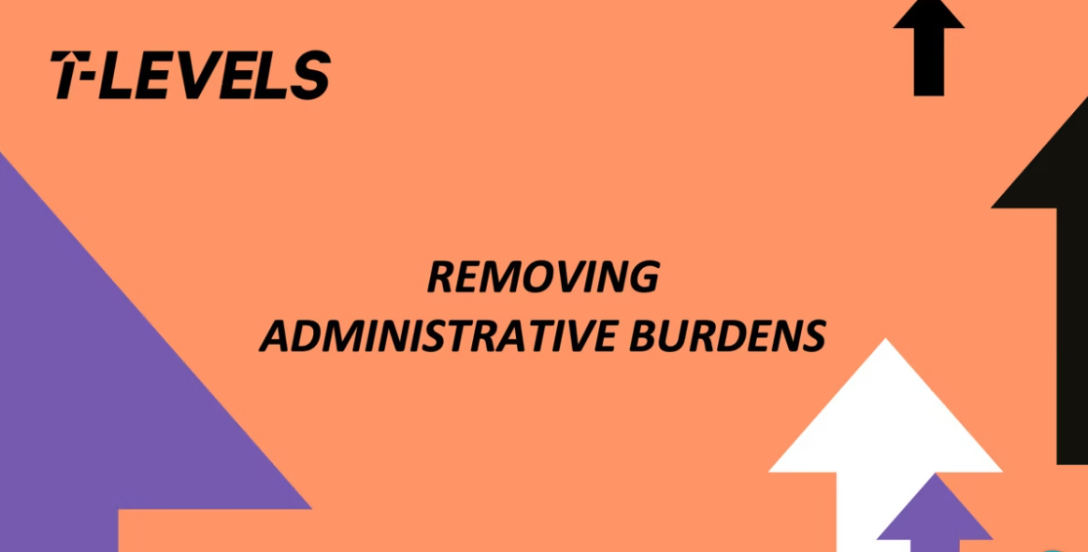  Edd Brown, Director of Quality & Workforce Development, Weston College

Involving employers in the development and delivery of the curriculum
Topic discussed | Learning points | Insights from T Level providers
Consulting employers and learners as you design your curriculum content | Wide consultation can help define a curriculum that accommodates technical learning and builds in the soft skills learners will need in the workplace.  Engaging employers and learners early on in this process will help put together a package that works for all.  You can do this by:  - facilitating focus groups  - running surveys  - making use of employer networks  - approaching employers and students participating in other work-based programmes, such as apprenticeships  - contacting former students. | “One of the most difficult things is to fit everything into a T Level. The size of the placement and the sequencing of the programme of study was difficult. So, getting employers on board and getting them to help shape your curriculum will make the process of fitting all those things together much easier.”  Matt Lyons, Subject Area Manager – Digital Principal, Weston College  Matt talks about how they consulted with apprentices that had been in the workplace for a year to develop evidence-based guidance for their learners (1m 27s - ctrl+click to view).  Matt Reynolds, Vice Principal Teaching, Learning and Development, Cirencester College
Tailoring aspects of the curriculum to align with industry needs | Two-way communication and understanding between employers and teachers or trainers can support curriculum content and identify industry placement opportunities.  Many staff delivering T Levels have participated in placement opportunities to support their understanding of industry needs and help them develop the T Level curriculum.  This allows the creation of a curriculum based on a solid and up-to-date knowledge of industry's latest requirements. | In this audio clip, Ruth talks about how staff, by participating in placements, developed a better understanding of current industry needs, and worked with employers to develop real-life content examples for the curriculum (40s - ctrl+click to play).  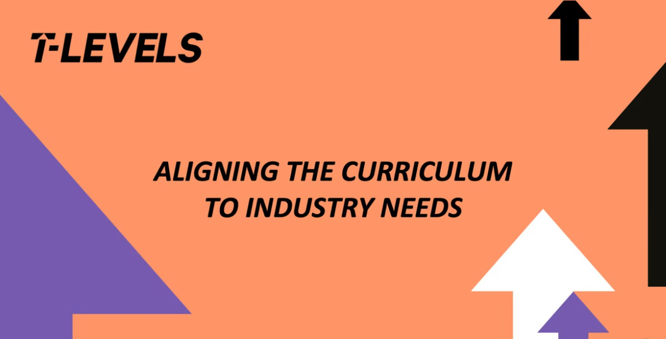  Ruth Coyle, Director of La Retraite Roman Catholic Girls’ School  “We set up industry advisory boards using the expertise of the business growth team to get some key employers to commit. At those industry advisory boards, we were able to explain the T Level to employers to get their input around what they think needs to be included or how they can participate in the delivery. So, this is the kind of college-level implementation that carries on to this day.”  Dave Trounce, Deputy Principal, Weston College  In this audio clip, Edd talks about the importance of setting up curriculum-led groups with employers to inform the development and delivery of their T Level offer (45 s - ctrl+click to play).  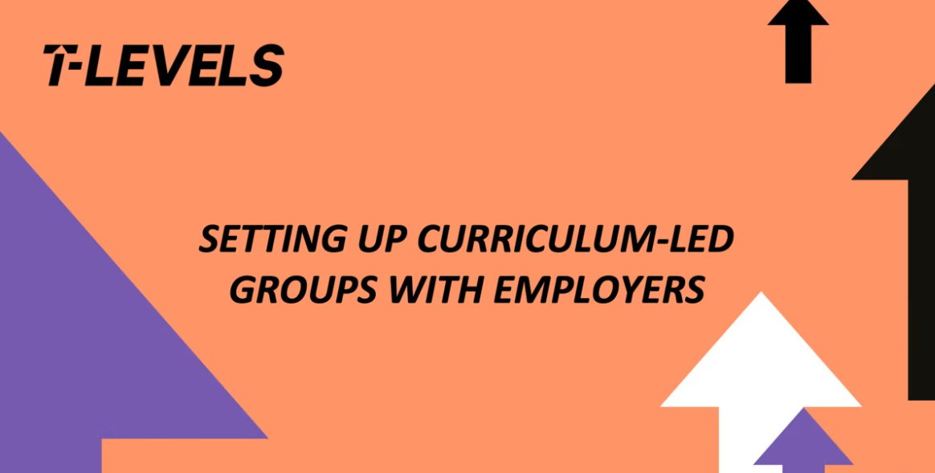  Edd Brown, Director of Quality & Workforce Development, Weston College
Involving employers in curriculum delivery | Through building strong relationships with employers, it is possible to learn about the scope of their business and the potential they have to support the curriculum.  Such opportunities may be small and discreet but add to a diverse and meaningful offer. They may be able to support in delivering specific aspects of the curriculum.  Small inputs not only add to the diversity and breadth of the learning offer, but also help employers to develop confidence in their ability to offer industry placements in the future. | In this video, you will hear from two providers, explaining how they identified and created innovative opportunities for employers to get involved in curriculum delivery, giving them the chance to share their specialist expertise with learners and build confidence around offering industry placements (1m37s - ctrl+click to view).    Adam Bird, Marketing and IAG Manager, Priestley College  Ashley Grute, Assistant Principal, HSDC

