DESIGNING T Level industry placements

Introduction
The T Level industry placement guidance for education providers provides education providers with a range of delivery models and approaches that can be combined to create meaningful, high-quality industry placements.
Thoughtful placement design can help more employers participate while ensuring students complete placements that support their learning and development.

Who benefits from industry placement?
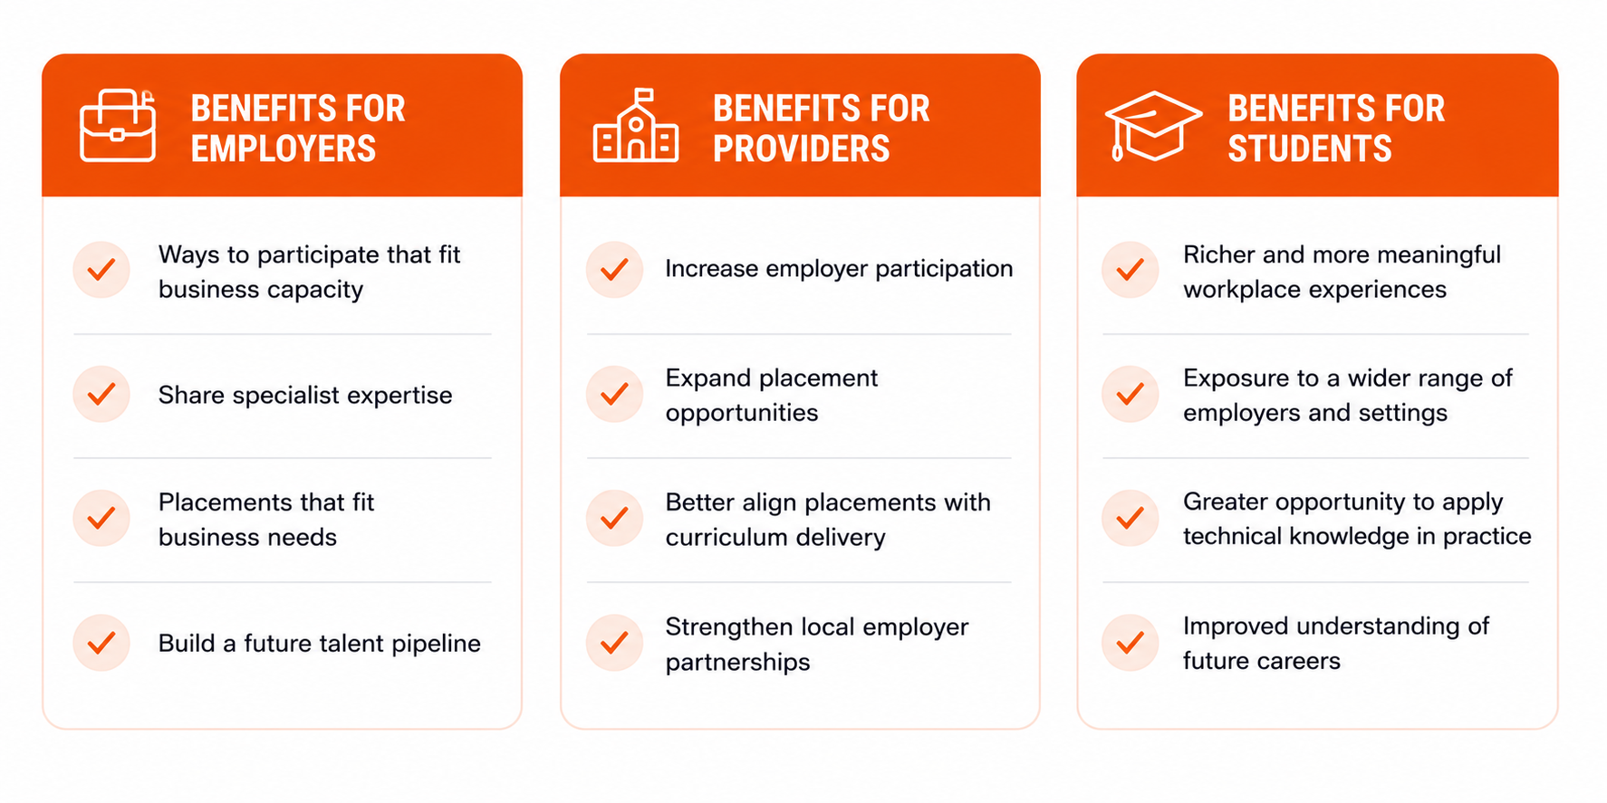

Industry Placement requirements
The T Level Industry Placement Delivery Guidance is the key reference document for education providers delivering T Levels. It explains the core requirements that all industry placements must meet, together with the range of delivery approaches that providers can use when designing placements. Separate information is available for employers providing or overseeing industry placements.

Creative combinations: Building placements

The T Level industry placement guidance provides a range of delivery approaches that can be used to design industry placements which are both meaningful for students and practical for employers. Thoughtfully combining these approaches can increase employer participation, create more placement opportunities and help providers respond to different local contexts, while maintaining high-quality learning experiences.
Delivery approaches such as work taster activities, multiple employers, small team projects and remote working can be used individually or combined where appropriate. For example, a student might begin with work taster activities to explore different parts of an industry before moving into a longer placement with a preferred employer. Alternatively, a student could complete part of their placement through a small team project, overseen by an external employer either on the employer’s premises or using provider facilities, before progressing into workplace-based activity.
There is no single model for designing an industry placement. Providers should select the combination of delivery approaches that best supports the employer’s capacity, the student’s readiness and the intended learning goals.
Whatever approach is used, every placement should continue to meet the core industry placement requirements. This includes ensuring that students undertake meaningful workplace activity, are supported by appropriate employer oversight, work towards agreed placement objectives and individual learning goals, and receive regular feedback and review throughout their placement.
Where remote working forms part of a placement, it should only be included where the employer is able to provide appropriate supervision, the student has a suitable environment and equipment, and remote working reflects the nature of the role. Where possible, remote working is recommended to account for no more than 20% of placement hours, although a higher proportion may be appropriate in sectors where remote working is established practice.
Careful planning and ongoing collaboration between providers and employers will help ensure that delivery approaches are combined appropriately, remain aligned to each student’s learning goals, and continue to provide a high-quality industry placement experience.

Example placement models
The following examples illustrate how different delivery approaches can be combined while continuing to meet the core industry placement requirements.

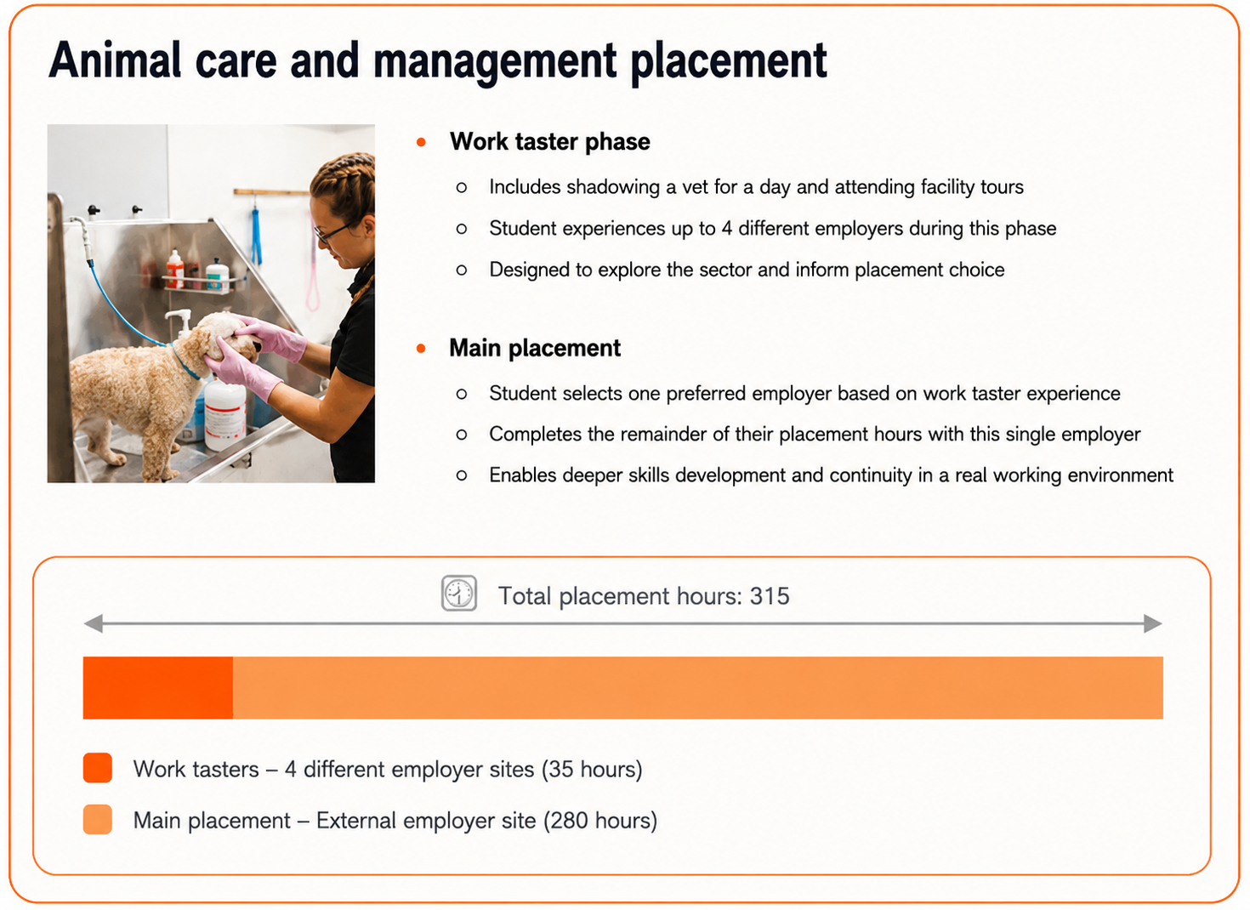

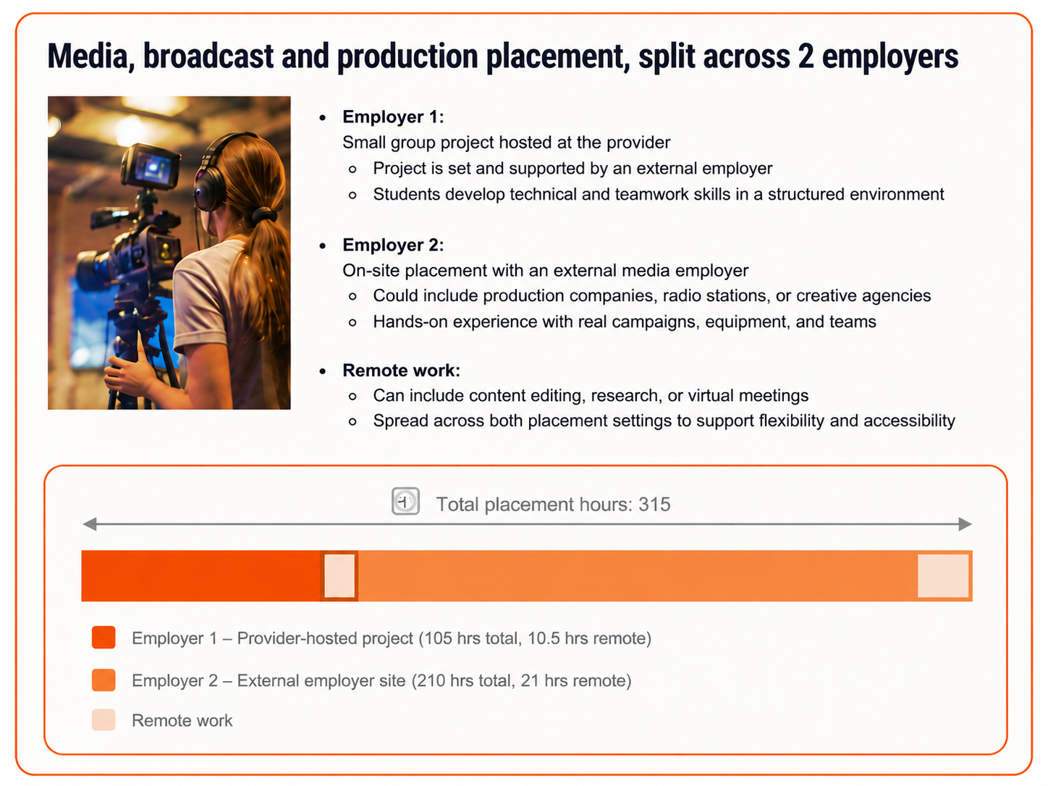

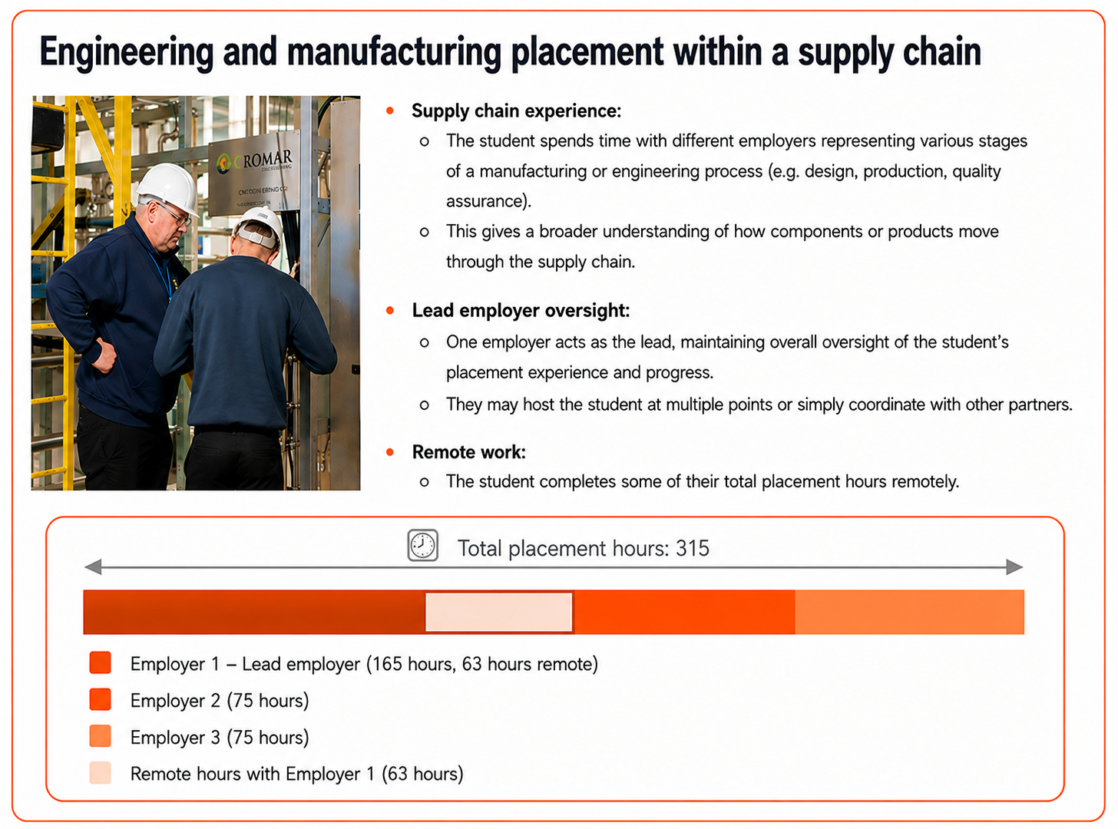

Things to consider when designing industry placements
The T Level industry placement guidance provides a range of delivery approaches that enable providers to design creative and inclusive industry placements. Careful planning helps ensure these approaches are used appropriately while continuing to meet the core industry placement requirements.
Overcomplication of models: Combining too many approaches can create overly complex placements that are difficult to manage or explain to employers and students. Simplicity and clarity should remain a priority.
Placement fragmentation: Spreading hours across multiple settings (e.g. tasters, projects, several employers) may reduce continuity for the student, limiting opportunities for deeper skill development and relationship building.
Supervision and oversight: Ensuring clear, consistent supervision across all elements of the placement can be challenging – particularly if students are completing hours remotely or at multiple sites. Agree review meetings and employer feedback arrangements before the placement begins.
Remote work risks: While remote work offers convenience and accessibility, it may reduce exposure to workplace culture and direct employer interaction. It’s important that remote tasks are well-structured, purposeful, and regularly reviewed.
Misalignment with learning goals: Some arrangements may fall short of student expectations – particularly where learners have a clear interest in a specific occupation – or may not provide enough opportunities to apply their technical knowledge meaningfully. It’s essential that placements remain aligned to the T Level’s learning goals and support each student’s progression.
Compliance and audit risk: When using blended models, there is a greater need to maintain accurate tracking and documentation to demonstrate compliance with guidance, the recommended approach to remote hours, the rationale for any higher proportion in sectors where remote working is established practice, and supervision arrangements. Documentation should clearly record placement objectives, learning goals, typical activities and employer reviews.
Employer confusion or uncertainty: If employers are unfamiliar with flexible models (e.g. small team projects or remote work), they may be hesitant to engage. Providers should work with employers to understand how different delivery approaches work, what employers are responsible for, and how the placement will continue to meet the core industry placement requirements.

Helping employers say yes
There’s more than one way to get involved. These flexible approaches make it easier for employers of all sizes to offer meaningful T Level placement opportunities - even if a full placement isn’t possible right now.

■ Not ready for a full placement?
Start with a work taster. Work taster activities can provide a great introduction to your organisation and should make up no more than 35 hours of the industry placement.
■ Can some tasks be done remotely?
Remote hours can count where the employer is set up to support remote work, the student has a suitable environment, and supervision, safeguarding and communication arrangements are clear.
■ Got a real challenge to solve?
A small team project may count towards the placement where an external employer oversees it, each student has a clear role and responsibilities, progress is monitored against learning goals, and the employer runs at least one formal review meeting with each student.
■ Need help on something short-term?
A placement can be split across multiple employers, usually no more than two unless the student would benefit from broader sector exposure or the work does not suit two employers. The student must work to a single set of learning goals, and all employers must write an appraisal.

Different delivery approaches can be combined to create a meaningful placement that works for both the employer and the student, provided the core industry placement requirements continue to be met.

