

Post-16 pathway qualifications implementation timeline
This image is a Gantt chart displaying the tasks listed in the 16-19 Pathways Implementation Plan, under the heading Implementation timeline. The chart shows the timeline running from left to right, starting in May 2026 and ending in 2028. Tasks are shown in two strands of work:
- subjects, content and qualification development - with a separate horizontal line of tasks related to new qualification subjects introduced in 2027, 2028, 2029 and 2030
- provider transition - as a single line of related tasks.

© Crown copyright 2026

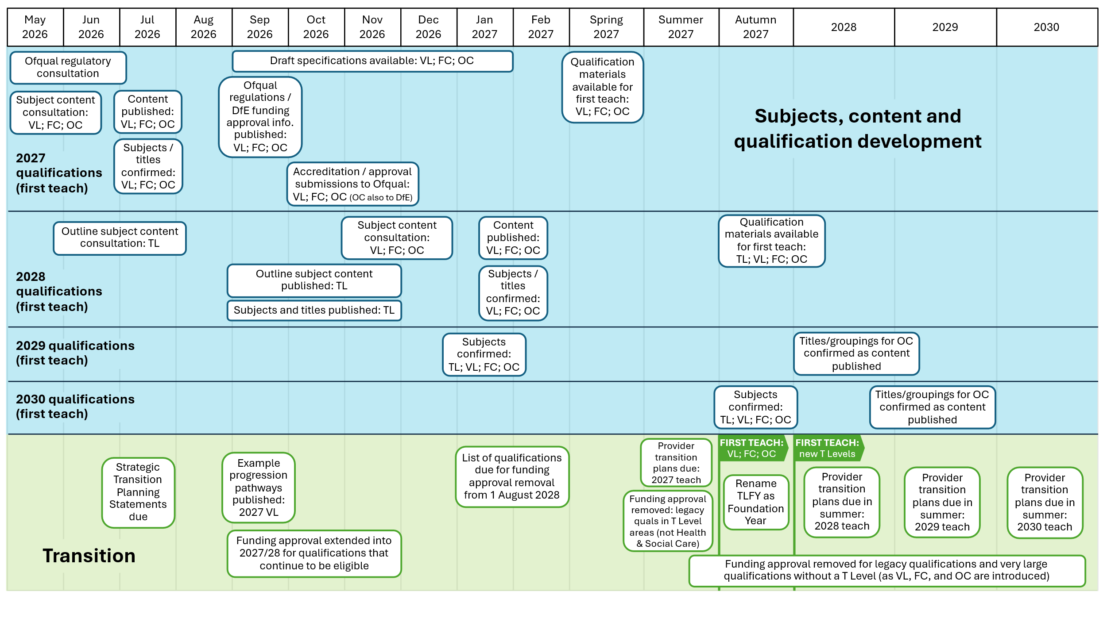
Key
TL – T Levels
VL – V Levels
FC – Foundation Certificates
OC – Occupational Certificates
TLFY – T Level Foundation Year

