

National policy environment for Post-16 pathway qualifications
This image shows four boxes reading ‘T Levels’, ‘V Levels’, ‘Foundation Certificates’ and ‘Occupational Certificates’ under the heading ‘Pathway’ inside a light blue ring. The ring has segments reading ‘Regulation’, ‘Content setting’, ‘Curriculum development’, ‘Workforce’, ‘Delivery and teaching support’, ‘Provider accountability’, ‘Ofsted inspection’, ‘Capital’, ‘Inclusion and diversity’, ‘Funding arrangements’, and ‘Careers advice and guidance’.

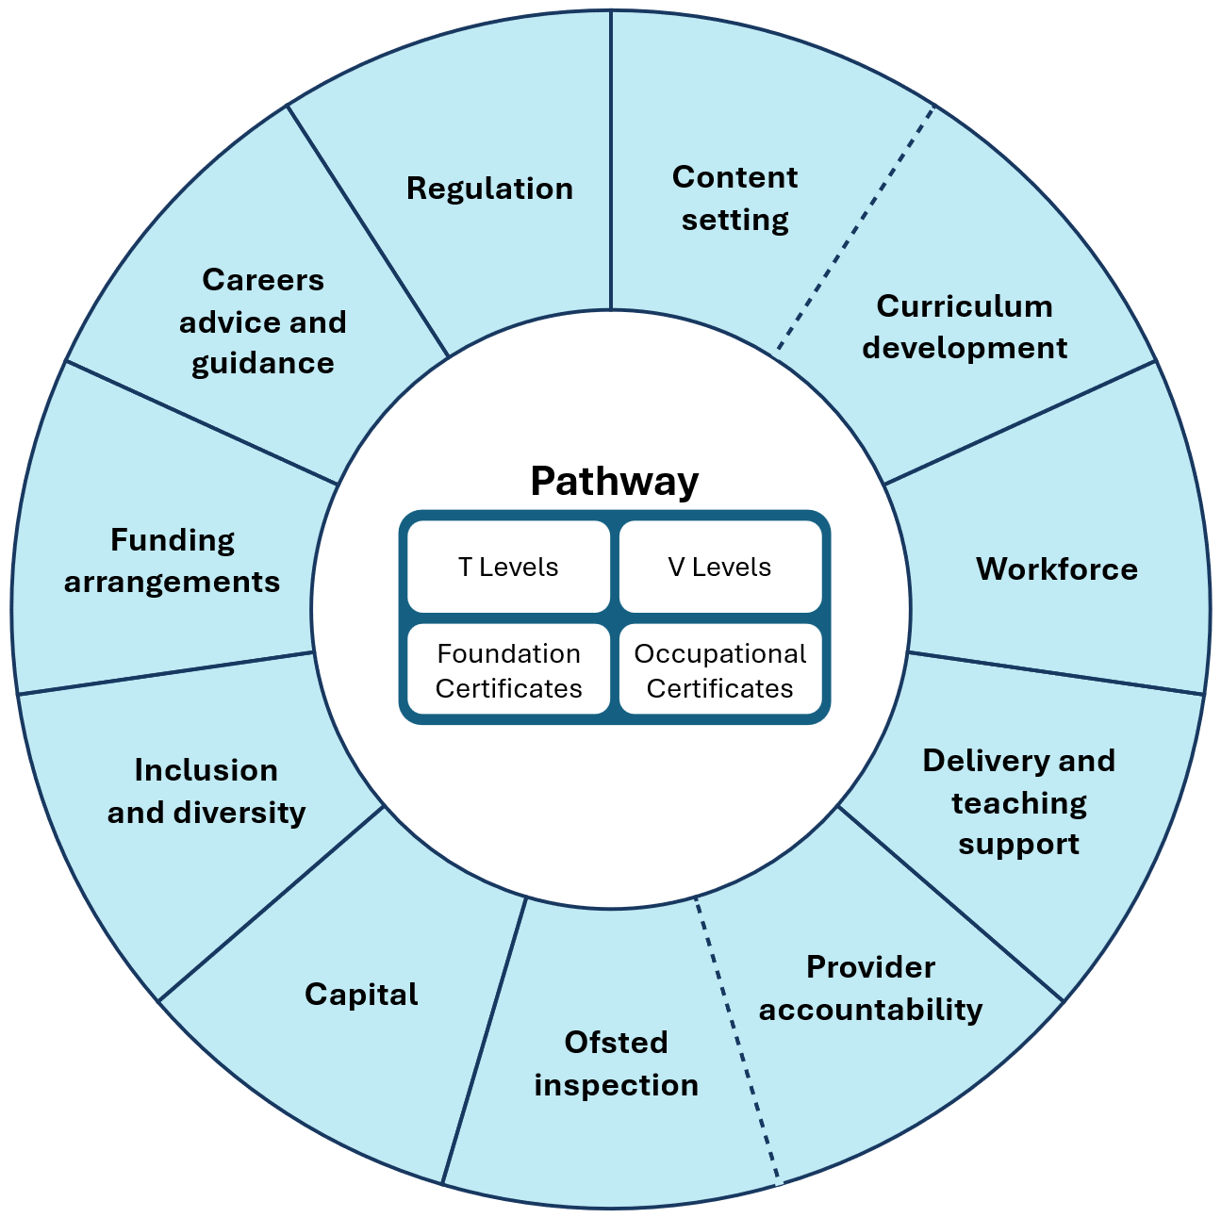

© Crown copyright 2026

