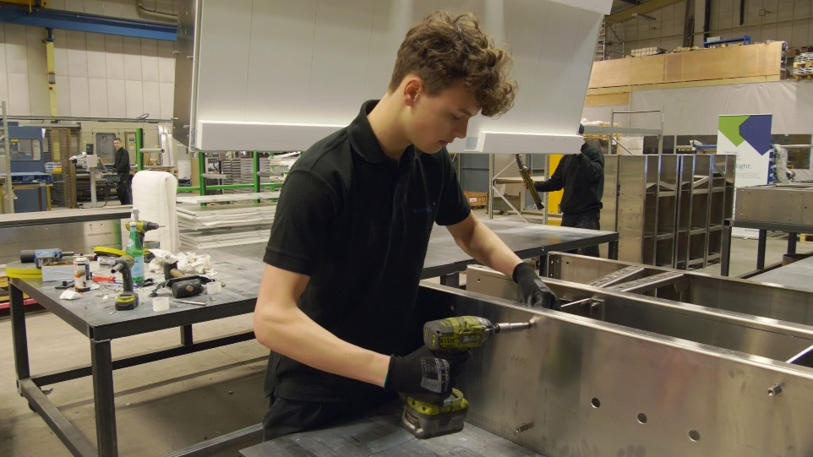

END OF PLACEMENT REVIEW
The end-of-placement review is a three-way discussion between the school or college, the employer and the student, using the employer’s appraisal(s), the student’s reflections, and any evidence from midpoint reviews.
It provides an opportunity to reflect on what the student has achieved, their progress towards learning goals, and where further development may be needed. The school or college leads this meeting and records the main points as evidence that the student has completed their placement.
Below is a template to help you consider what is likely to be discussed during the final review. The school or college is likely to provide their own version of this form.

APPRAISAL
Employers are expected to complete an appraisal of the student’s performance and progress towards their learning goals before a final review meeting.
The appraisal provides written feedback on how the student performed during their placement – including their skills, behaviours, attendance, reliability and attitude to work. Gather insight from a student’s line manager and/or mentor before providing an appraisal.
If the placement took place across more than one employer (for example, with supply chain partners or through a multi-placement model), each employer must complete an appraisal for the period the student spent with them.
The school or college will usually give you a form or template for the appraisal. There’s an example below, or you can use your own format if preferred.
Please note, the student may wish to attach their appraisal to their CV when applying for future opportunities.

APPRAISAL AND END OF PLACEMENT REVIEW
STUDENT PERFORMANCE AND FEEDBACK
INDUSTRY PLACEMENT – EMPLOYER APPRAISAL
To be completed as each placement nears completion (and before the final review meeting)
Student’s name:
Student’s industry placement role:
Employer organisation:

Student’s role and responsibilities during the placement:
Please describe what they worked on; the team(s) they worked in; and any specific skills they used.
Performance and behaviour
Please comment on the student’s: attendance and reliability; attitude and approach; and, communication, teamwork and flexibility
Strengths
Comment on the student’s particular strengths. For example: technical skills, interpersonal skills, initiative and/or approach to customers and colleagues.

Line manager’s name:
Role:
Signature:
Date:

INDUSTRY PLACEMENT - FINAL REVIEW
Led by the school or college
Student’s name:
Student’s industry placement role:
Provider organisation:
Student’s line manager:
Employer organisation:
Review date:

OVERALL FEEDBACK
Summarise how the student has performed overall – including their attitude, behaviour, teamwork, motivation, and development of technical or occupational skills.

STUDENT FEEDBACK
(discussion prompts)
Has the placement given you opportunities to meet your learning goals?
Did you feel supported, and was communication clear and effective?
How could the placement opportunity have been improved?
Has it helped you to decide if this is the type of work that you wish to pursue?

REVIEW AGAINST LEARNING GOALS
(OUTLINED IN THE INDUSTRY PLACEMENT AGREEMENT):
What specific knowledge has the student acquired and/or enhanced during this placement?
What practical skills has the student applied and/or further developed during this placement?

