The planning cycle for Industry placements

USER GUIDE

Purpose of the cycle
The industry placement planning cycle provides a clear structure for schools and colleges to plan, deliver and review high-quality T Level industry placements year on year.
It brings together all the key processes – from early strategy and employer engagement through to delivery and evaluation – in one place, helping teams coordinate activity, share responsibility and continuously improve.
The cycle can be used across the organisation or by individual T Level routes to track actions, assign responsibilities and monitor progress.

How to use the planning cycle
Treat the cycle as an annual planning tool. Review and refresh the cycle annually as part of your self-assessment or quality improvement processes.
Use the phases to allocate ownership across curriculum, employer engagement and quality teams – ensuring no single team carries the whole responsibility.
Adapt the level of detail to suit your context. Large colleges may complete the cycle per T Level route; smaller providers may complete one cycle covering all routes.

The five phases of the planning cycle
Phase 1 – Strategic setup and planning
This phase establishes the foundation for successful delivery.
Providers should confirm their T Level offer, map responsibilities across departments and integrate placement activity into curriculum design and timetables.
Agree realistic placement targets, set up systems for recording employer contacts, and plan training and budget allocation early.
Key considerations:
- How will placements support curriculum intent and local skills needs?
- Are staff clear on their roles and escalation routes?
- Do current systems capture employer and placement data effectively?
Helpful tools:
Use these complementary tools to support this phase:
- Developing an employer engagement strategy
- T Level funding to support industry placements
- Preparation ahead of employer engagement – Questions to ask curriculum colleagues
- Developing your customer journey

Phase 2 – Employer engagement and relationship building
This phase focuses on developing long-term relationships with employers.
Activity should move from awareness-raising to practical scoping of placement opportunities that fit your occupational specialisms.
Strong communication, clarity of expectations and a professional approach are key to success.
Key considerations:
- Do you have an engagement plan and clear follow-up process for enquiries?
- How are you prioritising employers that align to your curriculum areas?
- Are you co-designing placements that work for both employers and students?
Helpful tools:
Use these complementary tools to support this phase:
- Employer enquiry handling
- Map and identify employer opportunities
- Using your internal networks as a route to employers
- Marketing channels – ideas and options

Phase 3 – Curriculum alignment and student matching
This is where curriculum intent meets employer need.
Work with subject staff and employers to define learning aims, suitable tasks and realistic project scopes.
Ensure student selection processes are fair, transparent and inclusive, giving all learners a chance to demonstrate potential.
Key considerations:
- How are placements mapped to learning outcomes within the qualification?
- Are project or task descriptions clear and achievable?
- Do your matching processes consider student readiness, interests and support needs?
Helpful tools:
Use these complementary tools to support this phase:
- Building creative and flexible industry placements
- Typical tasks for industry placement students checklist
- Skills area introductory presentations
- Role descriptions for industry placement students

Phase 4 – Placement readiness and delivery
This phase ensures students and employers are prepared before placements begin.
All safeguarding, health and safety and insurance checks must be complete.
Students should understand workplace expectations and employers should know how to support and supervise effectively.
Regular communication during placements helps maintain quality and resolve issues early.
Key considerations:
- Have all readiness checks been documented and approved?
- Do both students and employers know who to contact for support?
- Are reviews and monitoring points scheduled from the start?
Helpful tools:
Use these complementary tools to support this phase:
- Setting out key activity milestones for employers
- Student induction checklist
- Confidently handle employer objections
- Preparing students for industry placements

Phase 5 – Review and improvement
The final phase captures feedback and lessons learned from employers, students and staff.
Reflection should feed directly into next year’s planning cycle – closing the loop and driving improvement over time.
This is also an opportunity to celebrate success stories and strengthen ongoing partnerships.
Key considerations:
- What feedback mechanisms are in place to gather insights from employers and students?
- How will findings be analysed and shared internally?
- Are improvements recorded and embedded into curriculum planning for the following year?
Helpful tools:
Use these complementary tools to support this phase:
Gather valuable employer feedback
Showcase success with a case study
Build and share impactful newsletters

Embedding the cycle
The planning cycle works best when it becomes part of normal business planning rather than an additional task.
Teams can integrate it into existing meetings, dashboards or quality systems, ensuring placement planning is visible and shared.
Reviewing progress against the cycle each year provides a clear evidence base for inspection, self-assessment and continuous improvement.

In summary:
The cycle turns placement delivery into an ongoing process of planning, engagement, delivery and review.
It promotes shared ownership between curriculum, employer engagement and support teams.
It enables providers to adapt placement delivery to changing employer needs, student profiles and local labour market priorities.
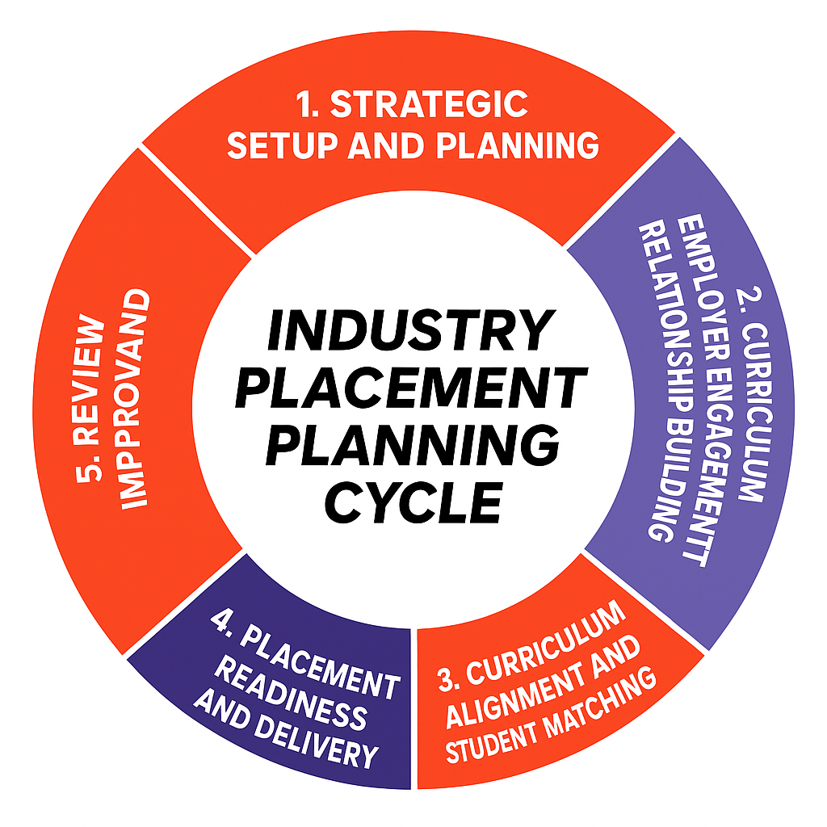

Phase 1 – STRATEGIC setup and planning*
*Make sure you have read the latest version of the T Level Industry Placement Delivery Guidance before completing your planning cycle
phase 1 tasks | your notes
- Set a target for the number of industry placements needed next year, considering:
- Base targets on T Level cohort sizes and occupational specialisms
- Use local labour market and LSIP data to check feasibility
- Identify and confirm key staff roles responsible for planning, coordination and delivery of placements.
- Clarify who leads employer engagement, student matching and quality monitoring
- Record responsibilities in your delivery plan or structure chart
- Agree clear internal communication routes and escalation points.
- Ensure everyone knows how to raise or resolve placement issues
- Share contact lists or escalation charts with curriculum teams
- Integrate industry placements into curriculum planning and timetables.
- Schedule placement periods early and allow flexibility for employer availability
- Align to teaching content so students can apply classroom learning
- Plan and allocate budget and staff time using available T Level industry placement funding.
- Review DfE funding guidance to ensure correct use of funds
- Include admin and safeguarding capacity
- Create a high-level calendar of key milestones
- Capture all major stages – employer outreach, employer commitment, student prep, readiness checks, and review points
• Use a CRM or tracker to identify progress
- Agree the system for recording employers’ details and contact records with employers:
- Use a CRM or shared spreadsheet to log activity and follow-up
- Ensure all departments use the same process
- Identify any skills and knowledge gaps and plan training.
- Consider refresher training for staff on compliance or student support.
- Review annually through your self-assessment cycle

Phase 2 – EMPLOYER ENGAGement and relationship buiLding
phase 2 tasks | your notes
- Develop an employer engagement plan that prioritises sectors and employers aligned to your T Level specialisms.
- Use internal data and local networks to prioritise contacts
- Map current and potential employers
- Update or create promotional materials for employers
- Review website and Connect Service entries for consistency
- Include key messages on benefits and expectations – sell the student not the course
- Plan targeted outreach or events to raise employer awareness where appropriate.
- Consider sector-specific breakfasts or virtual briefings
- Capture attendance and follow-up actions in your CRM
- Implement a consistent process for handling and responding to employer enquiries promptly
- Assign ownership for follow-up within 24 hours
- Use or adapt the Employer enquiry handling template
- Log all employer engagement activity in a central system.
- Track contact, notes, and progress to prevent duplication
- Review engagement data quarterly to spot gaps or opportunities
- Develop the relationship with employers who agree to offer placements.
- Move employers from interest to planning stage with structured scoping meetings
- Capture agreed roles, dates and key contacts
- Consolidate relationships through wider collaboration.
- Explore how employers could engage in curriculum design, taster days or other activities
- Discuss longer-term workforce development

Phase 3 – CURRICULUM ALIGNMENT AND STUDENT MATCHING
phase 3 tasks | your notes
- Select an industry placement model with the employer
- Match timing, scope and duration to employer projects and student needs
- Use DfE guidance on flexible models
- Flex the model to meet employer and student needs.
- Consider split placements or short projects if it improves relevance
- Explore online elements to increase flexibility (see Building creative and flexible placements)
- Plan each placement in detail.
- Agree the role, learning outcomes, hours and location
- Document communication and support arrangements
- Agree a process for selecting students.
- Ensure fairness and transparency
- Give students a realistic experience of applying for a job (see Role descriptions for industry placement students)
- Help employers prepare selection documentation.
- Provide templates for interview questions
- Keep selection materials consistent across employers
- Prepare students for interviews or selection
- Run mock interviews and feedback sessions
- Check understanding of workplace expectations

Phase 4 – PLACEMENT READINESS AND DELIVERY
phase 4 tasks | your notes
- Ensure all employer health, safety and safeguarding checks are completed and recorded.
- Confirm risk assessments and insurance before placements start
- Keep evidence on file for audit
- Check the employer is prepared for day one.
- Ensure mentors and supervisors understand their role
- Use briefing checklists or short induction sessions
- Prepare students for the workplace.
- Cover dress code, communication and punctuality
- Check they know where they are going on day one and who to report to
- Agree the process for check-ins and feedback.
- Schedule mid-point and end reviews
- Use consistent feedback forms (see Setting out key activity milestones for employers)
- Agree pastoral support and care for each student.
- Identify contact staff for out-of-hours placements
- Coordinate with safeguarding leads

PHASE 5 – REVIEW AND IMPROVEMENT
actions for year end | your notes
- Collect feedback from students and employers.
- Use structured templates for consistency
- Review both quantitative and qualitative feedback
- Identify how to improve future placements
- Analyse trends in completion, satisfaction and skills development
- Discuss findings with curriculum teams
- Identify positive experiences to share.
- Create short case studies and testimonials
- Feature them in employer communications
- Analyse all feedback and identify quality improvements.
- Record improvement actions and assign ownership
- Feed findings into your next planning cycle
- Integrate the action plan into your quality improvement cycle.
- Monitor progress termly
- Evidence improvements in your self-assessment report

