RESOURCE: developing YOUR EMPLOYER journey

A strategic tool to help you design a consistent and engaging experience for employers working with your organisation on T Levels.

INTRODUCTION
Employers play a vital role in the success of T Levels. Their involvement provides students with the real-world experience and insight they need to succeed.

While most employers are keen to help, engaging with a college or school is rarely their top priority. That means the experience you create for them – how easy it is to make contact, who responds, what happens next – is crucial.

This resource will help you take a step back and map what the employer journey looks and feels like from their perspective. The aim is to make engagement with you meaningful, straightforward and rewarding, so employers come back and recommend you to others.

Your mapped journey can then feed into your wider Employer Engagement Strategy. It should also act as a precursor to operational checks on your day-to-day systems and processes, for which you can use our companion resource, Employer Enquiry Handling.

WHY MAPPING YOUR EMPLOYER JOURNEY MATTERS
A clear and joined-up employer journey ensures that:
- Employers always know who to contact and what to expect
- Teams across your organisation give consistent messages
- You can spot where interest is lost or slowed
- Students benefit from more, and better, opportunities

Mapping also helps you see how data, marketing and communications can work together. When aligned with your enquiry-handling and recording systems, you can track employer interactions from first contact to repeat engagement, turning one-off placements into long-term partnerships.

THE FIVE STAGES OF THE EMPLOYER JOURNEY
Below are five simple stages you can use to plan or review how employers experience your organisation. These can apply to any form of engagement, from short tasters and live projects to full industry placements. The idea is to move employers down the funnel from awareness to loyal, returning, customers.

Stage | Purpose | what employers should feel | what you can do
Awareness | Employers first hear about your organisation and T Levels | Interested and curious | Use social media, events and local networks to raise awareness. Ensure your website clearly explains how employers can get involved. Use stories that highlight students’ skills and outcomes.
Interest | Employers seek more information or make contact. | Welcomed and understood. | Respond promptly to enquiries, tailor information, handle perceived barriers with confidence and focus on how students can support their business. Record details in your shared system so teams are aware.
Decision | Employers consider whether to take part. | Confident and supported. | Provide role descriptions, set out key milestones and simplify next steps. Offer to visit or introduce them to a student or the college team. Use your system to note key questions and follow-ups.
Action | Employers commit and an activity or placement is arranged. | Reassured and well guided. | Make the process easy and organised. Confirm dates, contacts and expectations. Track progress and communication through your system. This is delivery stage!
Loyalty | Employers have delivered an activity or placement and reflect on the experience. | Valued and proud. | Say thank you, gather feedback and celebrate success. Record outcomes and plan how to keep in touch for future opportunities.

Tip: Keep “Sell the student, not the course” at the centre of every stage. Employers connect with people, not programmes.


MAPPING YOUR OWN JOURNEY
Use this activity to visualise how employers currently interact with you and where you could improve their experience.

What you’ll need:
- Flipchart or digital whiteboard
- Sticky notes or virtual cards
- Marker pens
- 30–45 minutes with your team

Step 1: Map the stages
Write the five stages (Awareness, Interest, Decision, Action, Loyalty) across the top of your board. Under each heading, list the activities, touchpoints or communications that currently happen.

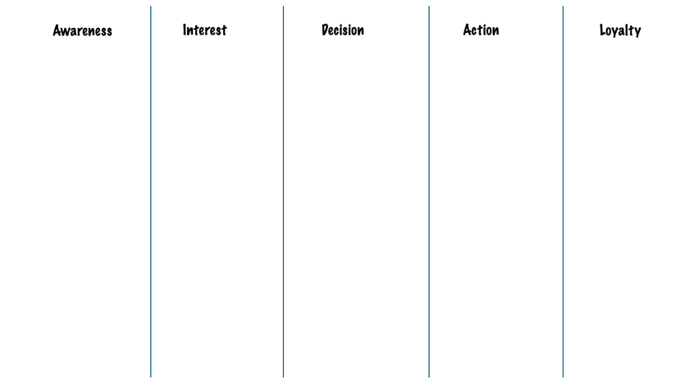

Step 2: Add the employer’s perspective
At each stage, discuss:
- What might the employer be thinking or feeling?
- What are their needs or frustrations?
- Who are they interacting with at our organisation?

Tip: You could even segment these perspectives by T Level or sector to find common themes across all your T Level provision and where employer perspectives and motivations might differ.

Step 3: Review and identify improvements
Ask yourselves:
- Are we consistent and joined up across teams?
- Do we respond quickly enough?
- Is it clear how employers can progress to the next stage?
- Are we recording engagement data at each step so we can measure activity and outcomes?
- What quick wins would make the biggest difference?

Step 4: Capture your actions
Agree three to five improvement actions and assign owners. Keep this visual map somewhere visible and revisit it each term.

Recording systems and data
Good data helps you see the whole journey, not just isolated moments. You do not need complex software to start; a shared spreadsheet can be enough. The important thing is that everyone uses it consistently.

When recording employer engagement, consider capturing:
- Who the employer is and which sector they work in
- How they first made contact (event, website, phone, referral)
- What stage of engagement they are at
- What activities or placements have been discussed or completed
- Any follow-up actions and dates

If your organisation uses a separate system for tracking industry placements, try to link the two so that employer and student information align. This helps avoid duplication and provides clearer insight into outcomes for both students and employers.

Keeping the journey alive
Once your journey is mapped, think about how to keep it active and evolving.
- Review the journey annually, or when processes change.
- Use employer and student feedback to update it.
- Share it with marketing, curriculum and apprenticeship teams so everyone understands the full picture.
- Celebrate success by showcasing examples of good employer experiences.

The more consistent and enjoyable the journey feels for employers, the more opportunities students will have to develop their skills and confidence in real workplaces.

Next steps
Once you have a shared vision of what good looks like, use the Employer Enquiry Handling tool to make sure your systems and processes deliver that experience consistently.

