CREATIVE AND DESIGN
T LEVEL: MEDIA, BROADCAST AND PRODUCTION
ROLE: MUSIC SERVICE ASSISTANT
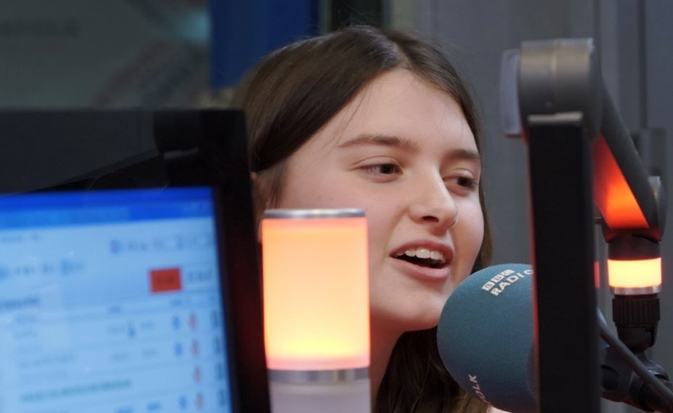


ROLE AND KEY RESPONSIBILITIES

As an industry placement student, you will support the music services team by:
- Assisting with the planning, promotion, and delivery of live events, including large-scale concerts and showcases.
- Supporting event producers by observing and contributing to the filming, sound recording, and editing of short promotional items, with training provided.
- Helping prepare posters, leaflets or website content to promote the service and its events.
- Assisting with event logistics such as organising resources, greeting participants, and collecting evaluation feedback.
- Shadowing staff at music centre events and contributing to the development of promotional activities.

ABOUT THE ORGANISATION
We provide music education and performance opportunities across the local area, working with schools, music centres and community groups. Our work includes organising concerts and events, running ensembles, and supporting young people of all abilities to take part in music.
Alongside live performances, we also create promotional and digital content to showcase our work and engage new audiences. This gives students valuable exposure to media and broadcast practices in a real music services environment.

STUDENT SPECIFICATION:

We are looking for a student who:
- Has an interest in the creative industries, particularly events, media, or music promotion.
- Is enthusiastic about developing skills in audio-visual production, editing and design - prior experience is welcome but not essential.
- Brings good communication and organisational skills, with a positive approach to teamwork.
- Has basic ICT skills (Word, Excel) and an openness to learning new software for editing or design.
- Is reliable, punctual and willing to follow agreed guidance in professional settings.
- Musical knowledge or ability would be an advantage but is not required.
Health, safety & compliance
- The student will be expected to follow all organisational health and safety rules and safeguarding procedures. Where the placement involves direct contact with children or young people, a DBS check and foundation-level safeguarding training may be required. This will be arranged with the provider and employer in advance.

