

ENGINEERING & MANUFACTURING
T LEVEL: ENGINEERING, MANUFACTURING, PROCESSING & CONTROL
ROLE: MECHANICAL FITTER

FITTER
Photo by ThisisEngineering on Unsplash

ROLE AND KEY RESPONSIBILITIES
As an industry placement student, you will support a skilled mechanical fitter working on automotive parts and other mechanical systems.
- Assist with installing, maintaining, repairing and modifying components under supervision.
- Help to fit, assemble, test and troubleshoot parts such as engines, transmissions, brakes, suspension and steering.
- Learn how to interpret technical drawings and use diagnostic software with guidance.
- Observe and practise the correct use of hand and power tools in a safe environment.
- Follow health and safety rules at all times, wearing appropriate PPE and contributing to a safe workplace.
ABOUT THE ORGANISATION
Company XX has a 40-year history of producing automotive components. We work closely with clients from design to delivery, specialising in lightweight and fuel-efficient vehicle parts.

Our employees work across multiple disciplines, from engineering design through to production, giving students a chance to experience a variety of roles. We also offer apprenticeships from Level 3 to Level 7, supporting career progression in the sector.

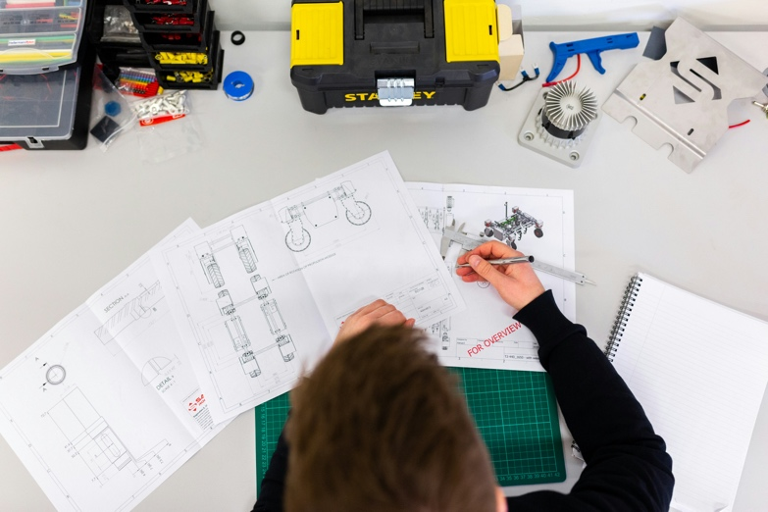

STUDENT SPECIFICATION:
We are looking for a student who:
- Has an interest in engineering, manufacturing and working with their hands.
- Is willing to follow instructions carefully and complete tasks to a high standard.
- Pays attention to detail and is eager to develop problem-solving skills.
- Communicates clearly and works well as part of a team.
- Has basic maths and IT skills, with a willingness to learn how to apply these in engineering and fault diagnosis.
- Is reliable, safety-conscious and enthusiastic about developing practical skills in a mechanical environment.



