

CREATIVE AND DESIGN
T LEVEL: CRAFT AND DESIGN
ROLE: FASHION STUDIO ASSISTANT

ROLE AND KEY RESPONSIBILITIES
As an industry placement student, you will support the fashion studio team by:
- Assisting designers, technical staff and production colleagues with day-to-day studio tasks.
- Supporting with garment costing, creating simple work plans or bills of materials, and entering information into product management systems under supervision.
- Helping to research and source fabrics, yarns, trims, and components, developing awareness of lead times and bulk ordering processes.
- Observing and contributing to measuring, handling, cutting and storing of materials, with opportunities to develop basic CAD/CAM skills.
- Assisting with administration such as ordering, invoicing, diary management, data entry and meeting preparation.
- Shadowing interactions with clients, suppliers and freelancers to understand professional communication in a design studio.
ABOUT THE ORGANISATION
Company XX is a medium-sized fashion house specialising in responsible and sustainable design. Our ethos is to rework surplus fabrics and garments into distinctive, functional pieces that balance creativity with wearability.

We design and manufacture across menswear, womenswear, luggage and accessories, with products stocked in leading stores across England and Europe. Our commitment to sustainability and craftsmanship has earned us recognition for innovation and integrity in fashion.

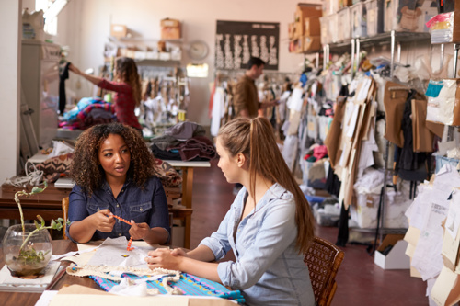

STUDENT SPECIFICATION:

We are looking for a student who:
- Has an interest in fashion and a willingness to learn technical and business aspects of studio work.
- Works well as part of a team and communicates clearly.
- Pays attention to detail, is observant, and confident in reporting issues when spotted.
- Has basic knowledge of fabrics, trims and garment construction, with some experience of cutting or sewing desirable but not essential.
- Is enthusiastic, reliable and able to learn quickly in a fast-paced studio environment.



