ENGINEERING &MANUFACTURING
T LEVEL: ENGINEERING AND MANUFACTURING
ROLE: RAILWAY MAINTENANCE TECHNICIAN

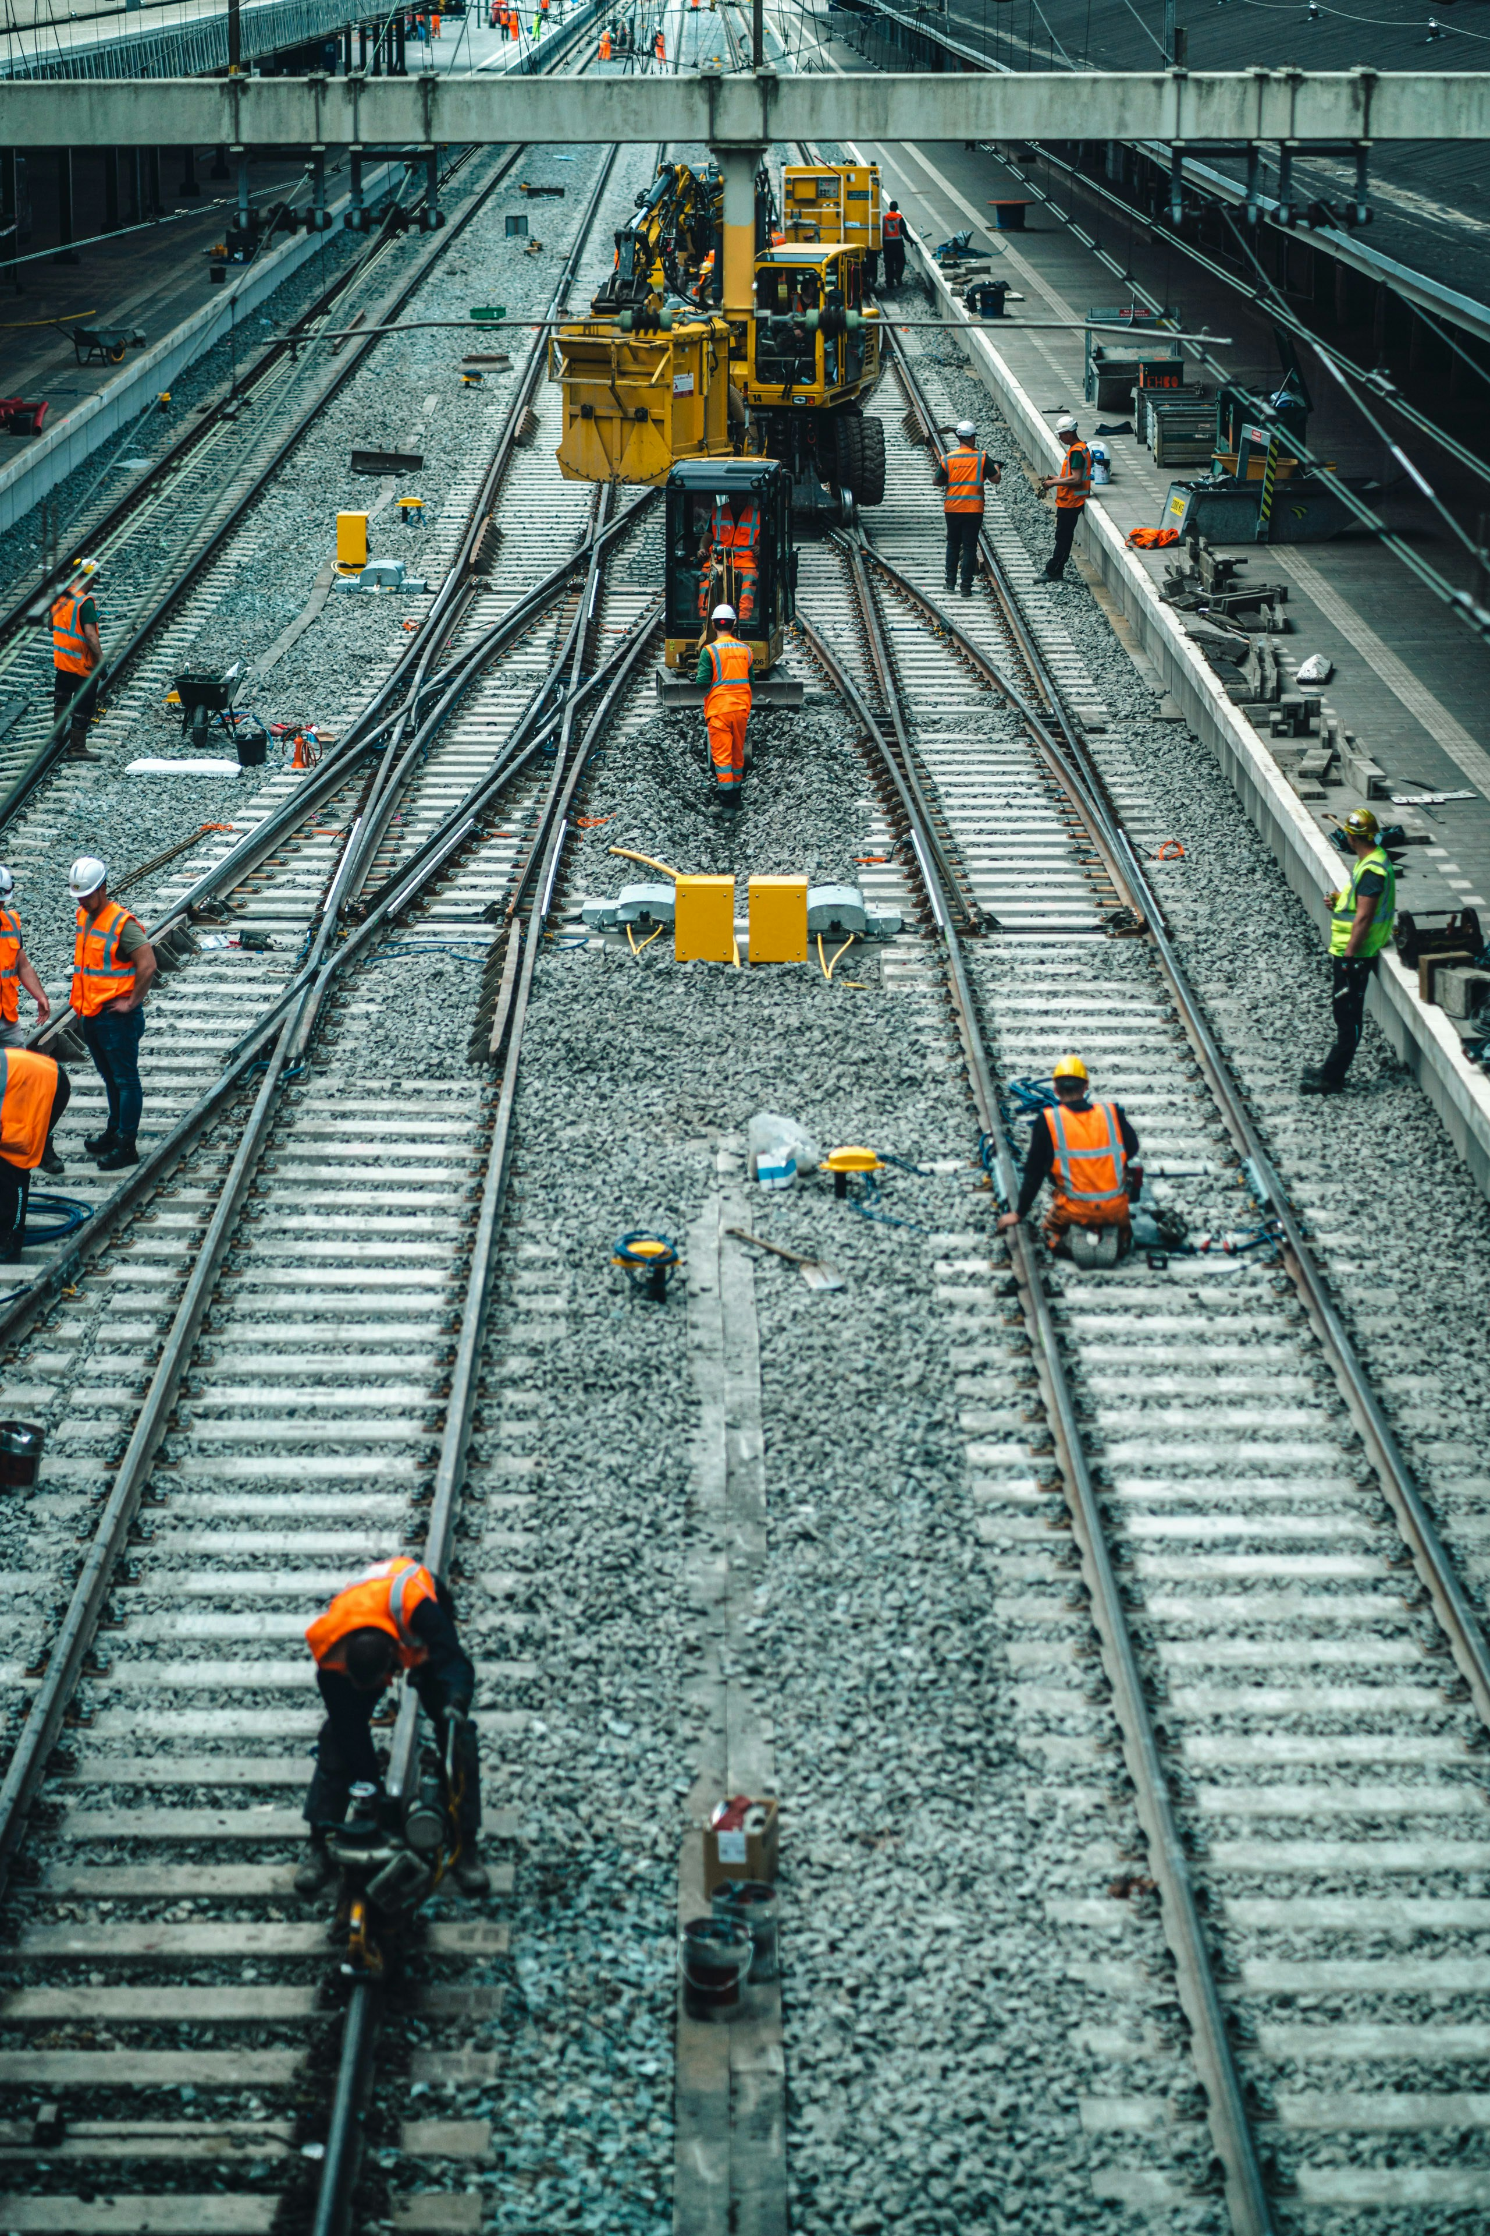

ROLE AND KEY RESPONSIBILITIES

As an industry placement student, you will support engineers and technicians on railway maintenance projects by:
- Assisting with scheduled inspections of track, signalling, and mechanical/electrical systems.
- Helping to record and process inspection data, with full training provided.
- Supporting colleagues in updating technical drawings and maintenance records using CAD and other software.
- Observing how faults are identified and contributing to simple repair or servicing tasks under supervision.
- Learning and following strict health and safety procedures when working on-site and in the office.
- Working as part of a team to ensure projects are delivered safely and to client standards.

ABOUT THE ORGANISATION

Company UU is an engineering and surveying business based in Shrewsbury, with expertise in rail and infrastructure projects. We work with clients across England to deliver high-quality surveying, inspection and maintenance services.

Students on placement with us will gain hands-on experience in data collection, inspection processes and technical documentation, while learning how rail engineering projects are delivered in practice.

Photo by Graddes on Unsplash

STUDENT SPECIFICATION:

We are looking for a student who:
- Has an interest in engineering, rail or infrastructure and is eager to learn new skills.
- Pays attention to detail when recording or processing data.
- Communicates clearly and works well as part of a team.
- Has basic ICT and mathematical skills, with training provided in specialist tools.

- Is reliable, punctual and committed to working safely at all times.



