

CONSTRUCTION

T LEVEL: BUILDING SERVICES ENGINEERING FOR CONSTRUCTION
ROLE: BUILDING SERVICES ENGINEERING TECHNICIAN

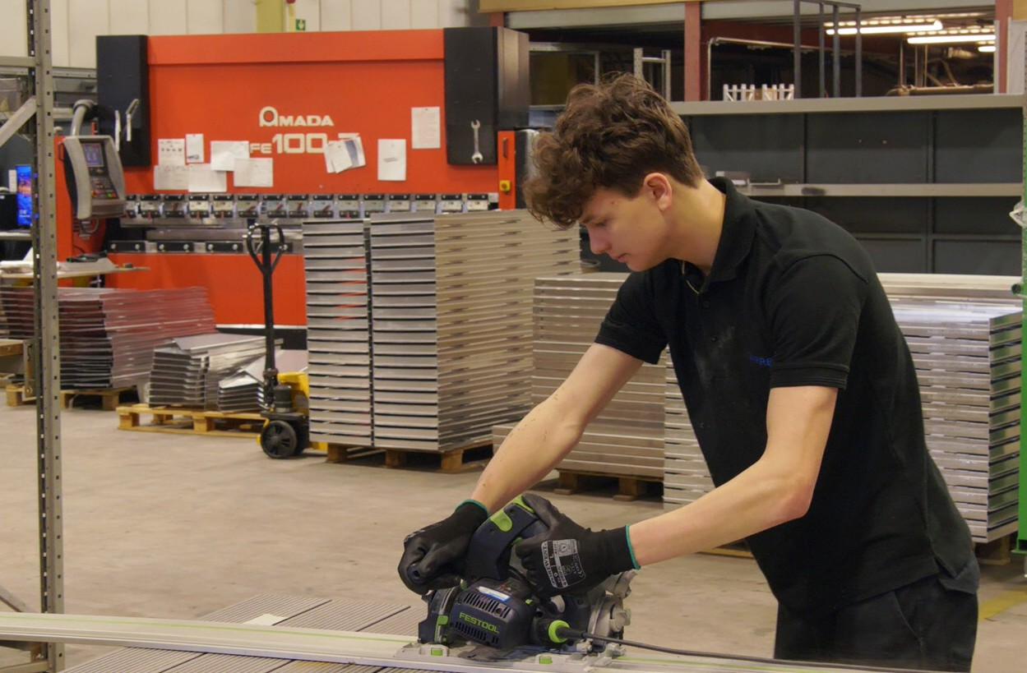

ROLE AND KEY RESPONSIBILITIES
As an industry placement student, you will support facilities managers and engineers by:
- Observing and assisting with the inspection, maintenance and servicing of building services systems (e.g. air conditioning, lifts, drainage).
- Helping to identify and record materials and components used, and learning how sustainability is assessed in practice.
- Supporting the preparation of reports, checklists and presentations, with opportunities to contribute findings under supervision.
- Shadowing meetings with clients, suppliers and other trades, and contributing where appropriate.
- Following health and safety guidance at all times and learning how risk assessments are applied in building services environments.

ABOUT THE ORGANISATION

We provide building services engineering support across a wide range of systems including electrical, mechanical, heating, ventilation, air conditioning, lifts and drainage. Our work focuses on maintaining safe, efficient and sustainable building systems, supporting clients in both commercial and residential settings. Health, safety and sustainability are at the core of everything we do.

STUDENT SPECIFICATION:

We are looking for a student who:
- Has an interest in building services engineering and a willingness to learn on the job.
- Enjoys problem-solving and is keen to develop analytical skills.
- Pays attention to detail and works carefully when carrying out tasks under guidance.
- Is organised, reliable and willing to follow agreed instructions and timelines.
- Has good basic numeracy, ICT and communication skills, with an openness to learning industry-specific tools and terminology.
- Demonstrates a positive attitude to teamwork, health and safety, and sustainability.


