BUSINESS ADMINISTRATION
T LEVEL: MANAGEMENT AND ADMINISTRATION ROLE: ADMINISTRATOR


ROLE AND KEY RESPONSIBILITIES

As an industry placement student, you will support the team by:
- Assisting with administration tasks such as emails, scheduling, and record-keeping.
- Helping to manage social media accounts and prepare marketing content.
- Supporting colleagues in developing and testing ideas for new projects.
- Contributing to promotional activities and learning how marketing strategies are developed.
- Taking part in team discussions, sharing ideas, and learning how projects are proposed and delivered.
- Supporting remote working practices, such as helping to set up online meetings, managing shared digital files, and communicating effectively via online platforms.
ABOUT THE ORGANISATION

Company E is a youth-led start-up with a team of eight, providing creative and digital skills training to young people who may not thrive in traditional education. We deliver sessions in coding, Photoshop, film-making, and wider personal development, helping young people build confidence and transferable skills.

Alongside training, we also take on client projects including web development, video production, branding and design. This gives students a unique opportunity to gain experience in a dynamic, entrepreneurial environment that combines learning, creativity, and business delivery.

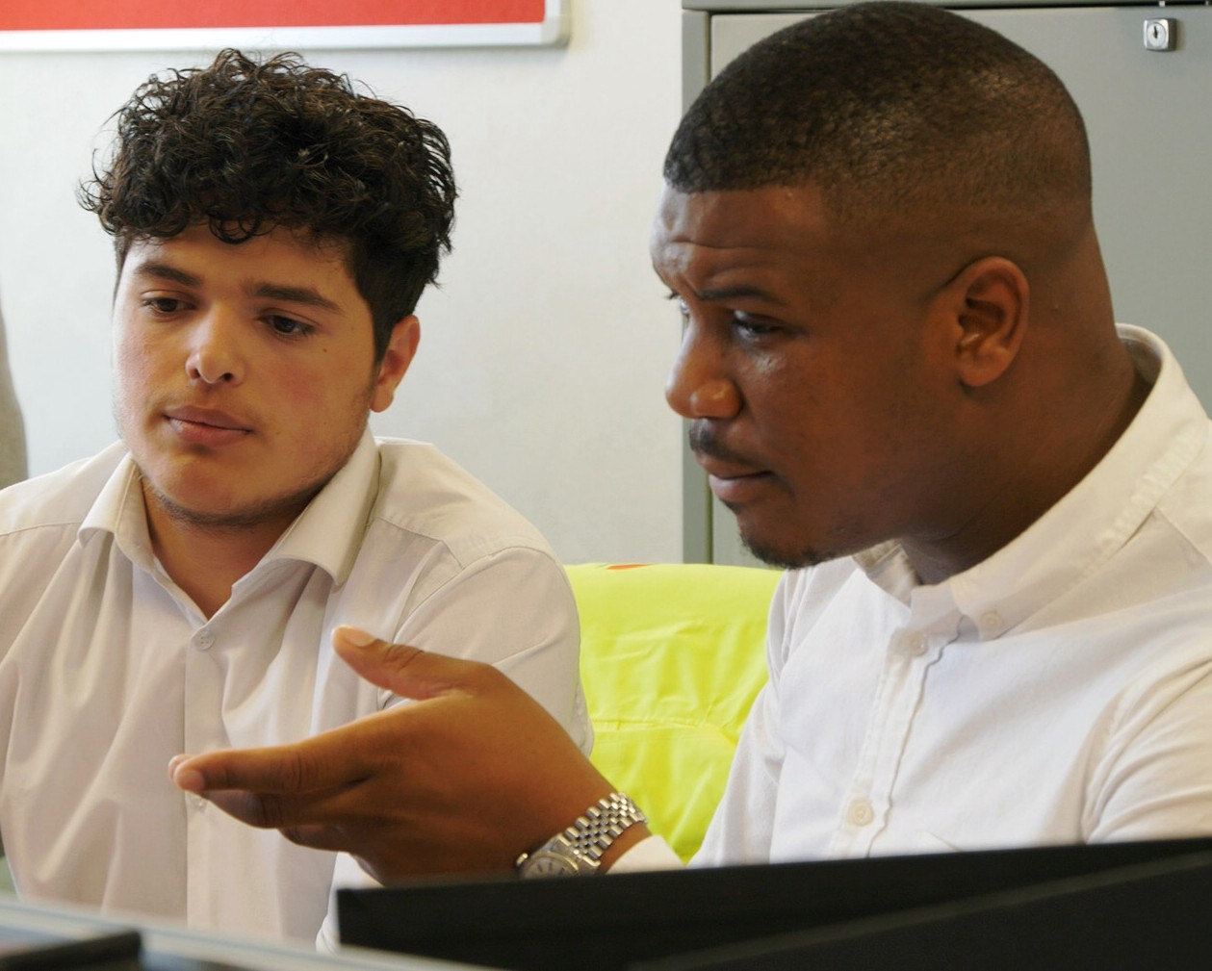

STUDENT SPECIFICATION:

We are looking for a student who:
- Is organised and reliable, with an interest in administration and business.
- Communicates clearly and positively, both verbally and in writing.
- Enjoys working as part of a team and is willing to share ideas.
- Has basic digital skills (Word, Excel, email) and is open to developing confidence in online collaboration tools such as Teams, Zoom or shared project platforms.
- Is adaptable and able to manage tasks both in-person and remotely, with guidance.
- Shows curiosity, takes initiative, and is open to developing an entrepreneurial mind-set.

