PLACEMENT ROLE DESCRIPTION

A placement role description shows the student what their job role is while they are working with you.

It outlines what they will do and what their responsibilities are. It tells supervisors and other people in the business what the student’s job involves. It also helps the provider choose the right student for the placement.

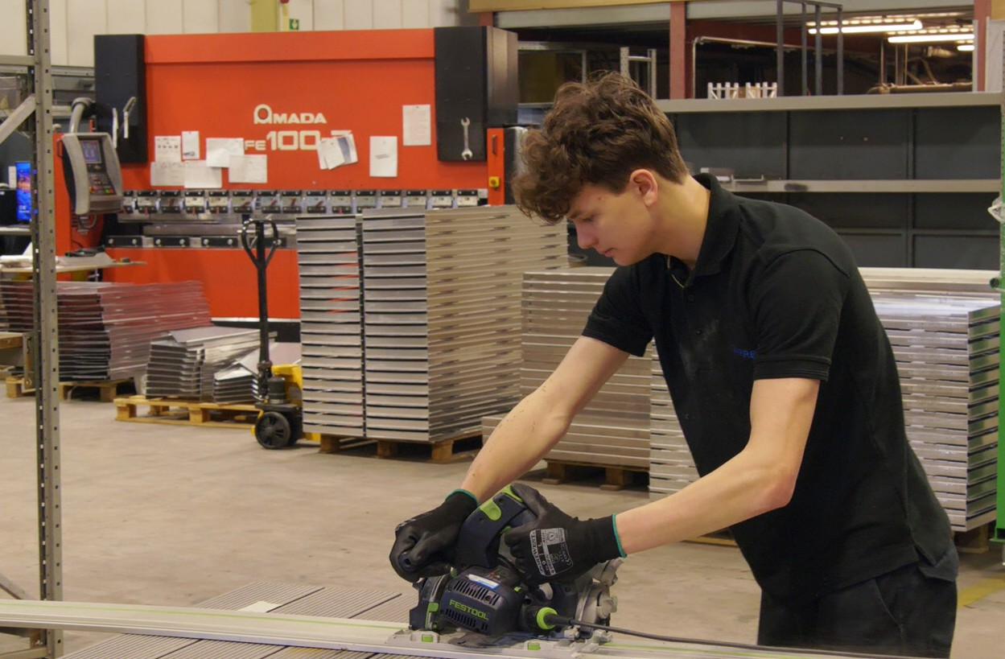

It’s advisable to write a placement role description for each student, which links to the development objectives and learning goals agreed with the student and their college or school. A few tips are given below followed by guidance on what the role description should cover.

WHAT SHOULD IT COVER?

THE ORGANISATION
Short description of the organisation and what it does (core activities). Brief statement of your values and mission – could come from your website or recruitment materials. Anything else about the working environment which might help bring it to life for the student.

ROLE AND KEY RESPONSIBILITIES
- Title of the role
- Short description of what it involves

TIPS
- Use straightforward language and avoid jargon

- Tell the student clearly what they will be doing

- Include the organisation’s name, address, website and contact details
- List of key responsibilities
- Job title of their supervisor – the person they will be working with most closely during the placement
- Extra information for the student, e.g. what a typical working day is like

STUDENT SPECIFICATION
Prepare a short description of the key things you’re looking for in the student. This could include technical skills, personal attributes and desirable behaviours suiting the role and organisational culture.

SKILL AREA
T LEVEL: XXX
ROLE: XXX

ROLE AND KEY RESPONSIBILITIES
As an industry placement student, you will support XXX by:
- XXX
- XXX

ABOUT THE ORGANISATION

Insert relevant image / company logo

STUDENT SPECIFICATION:
We are looking for a student who:
- XXXX

- XX

