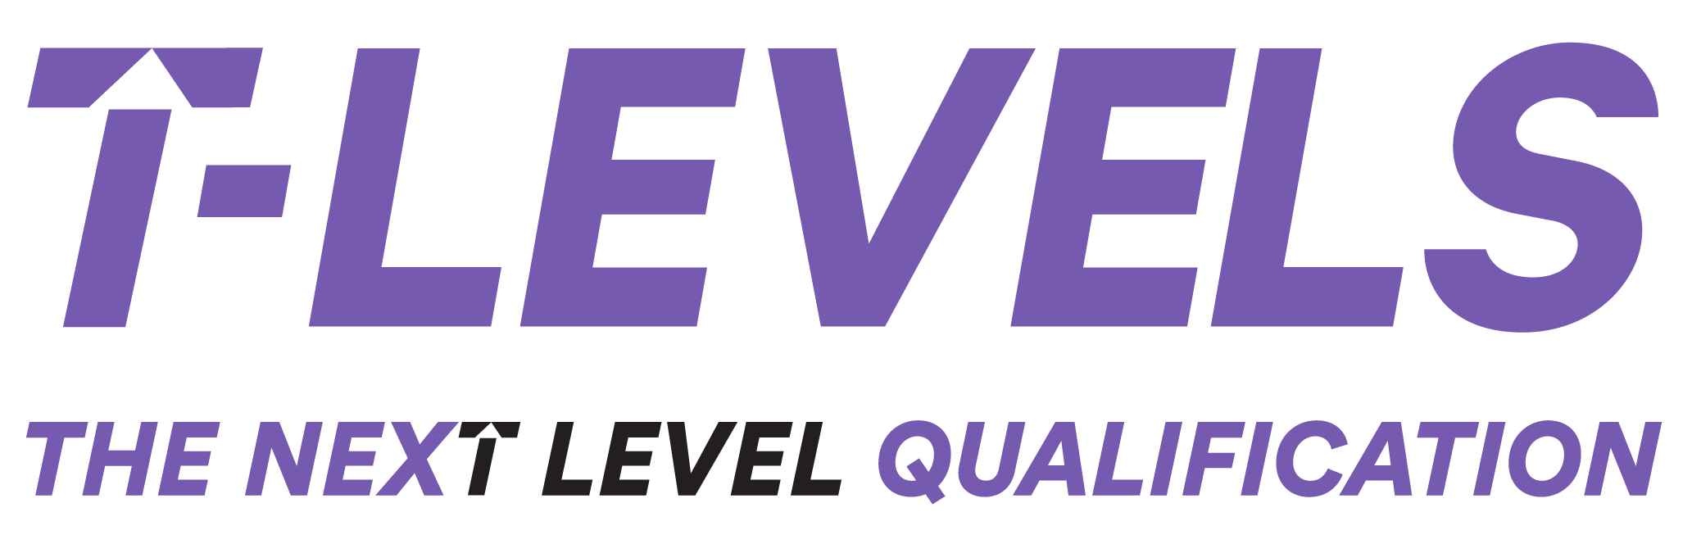

Breaking Boundaries: A collaborative approach to T Level Industry Placements with Amazon

1. Introduction 2
2.1. What are the essential design features of the model? 2
3. Engaging education partners 3
3.1. Natalie Vincent: Building bridges through relationships 3
3.2. Will Knox: Strategic flexibility and student readiness 3
3.3. The numbers 4
3.4. The consortia model timeline 5
4. Impact and benefits 6
4.1. For Students 7
4.2. For T Level providers 7
4.3. For Amazon 7
5. Challenges and lessons learned 8
6. Summary of lessons learned from the consortia model 9
7. Looking Ahead 10

1. Introduction
This report explores a pioneering approach to T Level industry placements led by Amazon. Initially developed through a close partnership with a single education provider, the programme has evolved into a structured, collaborative consortium model, enabling Amazon to work with multiple providers while maintaining a high-quality, scalable student experience.
Drawing on the perspectives of Jo Simovic (Amazon), Natalie Vincent (St John Bosco College), and Will Knox (Ada Lovelace School), the case study serves as an exemplar for both providers and employers looking to build meaningful placement pathways and long-term partnerships.
2. The Amazon-led consortium model – how did it evolve?
Jo Simovic, who leads the T Level initiative at Amazon, began by co-developing a bespoke digital placement programme with a single education provider in 2023. “It was super easy,” Jo reflects, “because you’ve got one provider… we could build the framework, and everything needed for the placement.” This allowed Amazon to construct a placement experience mapped in two-hour increments, with clarity about what students would be doing each day. This helped the Amazon placement manager to organise resource and manage activities, and ensured students were not only engaged but consistently practising their occupational specialism skills in a real work setting.
The success of the first cohort meant that demand quickly grew, and Jo secured internal support for placements for 25 students for the 2024 cohort and hoped to work with two providers. Whilst Jo was pleased to see eight providers subsequently express an interest in partnering, she worried about the feasibility of running the same approach with multiple providers on top of her other accountabilities. The solution was to create a consortium: a collective of schools and colleges working in partnership with Amazon.
Through this consortium, partners collaboratively shaped the learner journey, agreeing on touchpoints, standardised forms, centralised sessions and onboarding processes. Together they agreed how to run the application process and the information sessions, what to include in the onboarding and the student placement reviews. For example, as part of the design, Jo shared “every week when we have reviews, we're doing it all together… we give feedback, we receive feedback and it’s all in the consortium. And that really makes a difference.”
Once the process flow and documentation were agreed, students from the eight providers were invited to a face-to-face information session centrally to find out more. Amazon staff talked to students, answered questions, promoted the programme and the opportunities/expectations and then all the students where well informed to decide if they would like to apply.
The result was a streamlined, high-quality industry placement programme accessed by 25 students from five schools. Those whose applications didn’t meet the required standard received constructive feedback, and future improvements are shaping up for the next intake.

2.1. What are the essential design features of the model?
- Dedicated support net
- work of buddies, mentors, and placement managers.
- An assessment centre (for selection) that mirrors the process and activities in the Amazon apprenticeship recruitment process. This offers students a fantastic opportunity to experience and practice this and is always followed up with individual feedback.
- Placements take place in year two of the T Level so that students attend placement just before the apprenticeship vacancies are opened and their placement managers are the hiring managers.
- A 9-week placement block that allows a unique blend of classroom learning and practical application. Through a combination of 15-day stints in state-of-the-art skills hubs, group projects focus on charitable initiatives, and individual team-based challenges.
- Consortia weekly reviews while students are on placement with a focus on any highlights, lowlights and what is needed. Any specific performance or safeguarding discussions take place individually.
- Weekly employability skills and soft skill sessions.
- Weekly business reviews with all students.
- Activities that ensure the students gain a well-rounded understanding of the Amazon culture and way of working.

3. Engaging education partners
Two of the five consortia providers, Natalie from St John Bosco College and Will from Ada Lovelace CofE High School reflect on the approach and value of engaging in the consortia model from the provider’s viewpoint:

3.1. Natalie Vincent: Building bridges through relationships
Natalie first learned of the Amazon programme through informal networking. “I did a little LinkedIn reconnaissance,” she recalls, “I messaged Jo directly and asked if she would be interested in working with our students.” An invitation to a graduation event for Amazon’s pilot digital cohort followed which was an event that proved transformational. “It was really useful,” she says. “Hearing the students’ first-hand experiences… meeting all the stakeholders represented and hearing how they were planning to change their approach to a more collaborative model going forward.”
Natalie’s school is now concluding its first full T Level cohort (Year 13), and she reflects that early engagement with Amazon has helped to shape their delivery and partnerships going forward. She is clear that their approach to T Level industry placement must be rooted in building relationships: “It’s not about the size of the employer, it’s about the opportunities for our students.”
For Natalie, the key to success lay in early engagement and flexibility: “We want to build lasting relationships. This wasn’t just a flash in the pan.” She also spoke of the wider ripple effect: “It gave the whole school something to be proud of - staff, governors, even the parent community. It has become part of our school culture.”

3.2. Will Knox: Strategic flexibility and student readiness
Will, head of sixth form, got involved with Amazon after an introduction via one of his school governors. In year one of their T Level delivery, 6 of his 9 digital students applied to Amazon and 5 were successful. Having been involved since early in the collaboration, Will highlights the importance of responsiveness: “Employers work at a different pace than typically we do as a school, for example, if you’re told about an event that’s next week… you’ve got to go. Otherwise, you won’t get the placements. My role has allowed this, my senior leaders also recognise this although it’s not always easy.”
Will feels that his background in recruitment meant that he was well-placed to help students meet the high expectations of the Amazon programme. He says, “Students have got to be trained how to write a quality application, and it will only become more competitive as the programme grows. They need to be ready and prepared to engage in an assessment centre if they want a chance, but this learning is great for their future employability skills.”

3.3. The numbers
Years 1-3 overview… | Year 1 - 2023 | Year 2 - 2024 | Year 3 – 2025 (planned)
T Levels | Digital | Digital | Digital  Business  Media  Finance
No. of Students | 6 | 25 | 50
No. of T Level Providers | 1 | 5 | 20+
No. of Amazon Teams/Depts | 1 | 12 | 25
No. of Amazon sites | 1 | 2 | 3
3.4. The consortia model timeline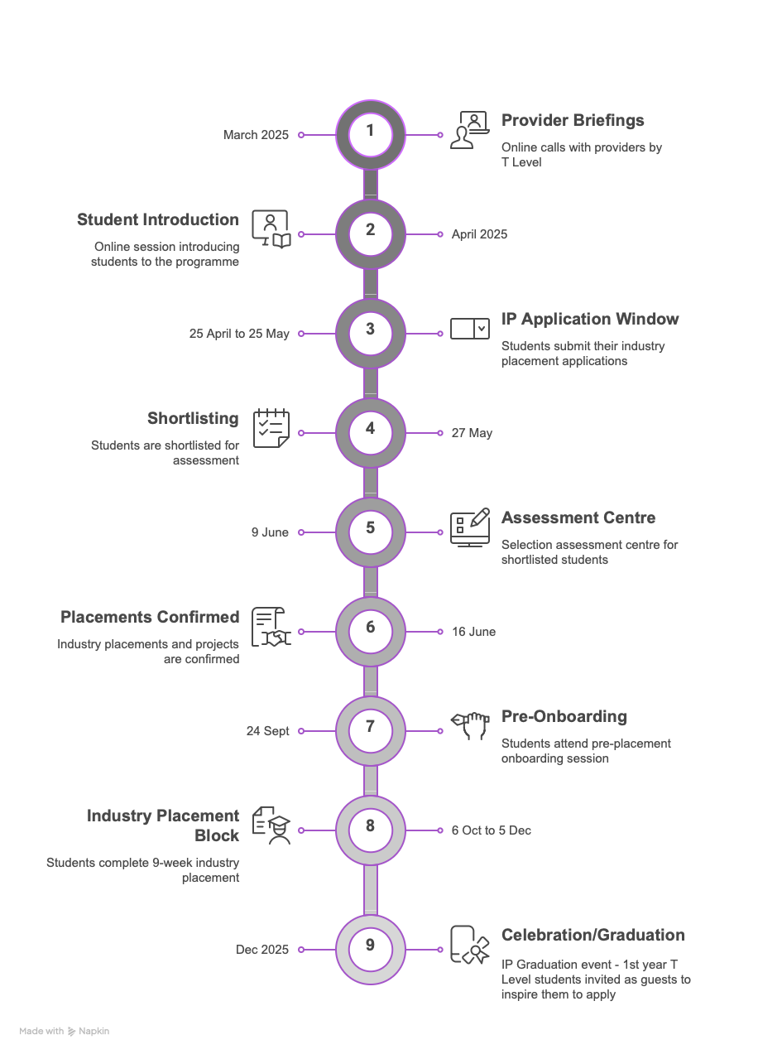

4. Impact and benefits
The Amazon T Level placement model has delivered measurable impact and far-reaching benefits for students, providers, and Amazon itself, both in immediate outcomes and longer-term cultural shifts.
For students, the placement offered far more than technical skills development. Students reported increased confidence, improved applications, and stronger interview performance.
As Natalie explained, “It was about saying yes to an opportunity that in theory could potentially change their own trajectories.” For many students, especially those from underrepresented backgrounds the experience expanded their ambition and confidence. Others gained a sense of professional pride that rippled through their peers and families. “It gave the students who are coming up through the school a sense of pride… that shared sense of accomplishment has made a significant impact.” Four of their six students successfully progressed into Amazon’s highly competitive degree apprenticeship programme.
The placements also exposed students to Amazon’s broader digital ecosystem. Will Knox reflected on the wider learning impact beyond the nine-week placement: “They (Amazon), sent in about 40 apprentices to run workshops… have engaged in numerous assemblies, open evenings… the promotion’s just been huge.” Even students not placed with Amazon benefited from new role models and increased awareness of digital careers.
For providers, the model acted as a catalyst for positive change and professional development. Natalie described how the partnership helped embed employer engagement into school culture: “We have seen the difference this level of employer engagement has had on our student’s aspirations and ambitions. They now have direct access to clear information of the recruitment process for a global company. Knowing how to submit stronger applications because of their enhanced understanding of how to write a winning CV, interview techniques and assessment centre expectations. It has made the whole school feel proud. Staff also gained new skills through the process, including experience in assessment centres and recruitment preparation. “We’ve learned alongside the students,”” said one.
The consortium model facilitated peer learning and practical support between schools. Will described sharing accounting curriculum resources and preparing for future T Level routes with support from more experienced colleagues: “That’s super useful when you’re developing a new course.”
For Amazon, the model helped to create a more inclusive and prepared early talent pipeline. Industry placements doubled as an extended interview for potential apprentices and offered a way to diversify recruitment. The visibility of Amazon’s programme increased dramatically. “My programme is now being talked about in Japan, in Europe, in the States,” said Jo Simovic. Will added that he now uses Amazon’s model to encourage other employers to engage: “Jo has taught us how she got the policy changes through her own leadership, and I can therefore help other employers explore that if helpful.”
Amazon, in turn, gained access to a motivated, diverse pool of students. The placements served as a pipeline into their apprenticeship programme, with a current conversion rate of 57%! Jo highlighted that the model is now being looked at by the business internationally.
This placement model has proven that when employers and providers work collaboratively, the benefits extend far beyond the workplace, building skills, aspiration, and lasting connections that support young people’s journeys into the world of work. In summary:

4.1. For Students
- Gained confidence, motivation, and clearer career direction.
- Developed real-world skills through structured, high-quality placements.
- Experienced an extended ‘live interview’ process, a dress-rehearsal for those who went on to apply for an Amazon higher or degree apprenticeship.
- Increased awareness of digital and tech career pathways.
- Built a sense of pride and accomplishment that spread through the wider school/college.
- Engaged in wider career activities like assembly talks and workshops run by Amazon apprentices.

4.2. For T Level providers
- Strengthened employer relationships and embedded deeper engagement in school/college culture.
- Staff gained exposure to employer practices like assessment centres and structured interviews.
- Improved internal processes around student preparation and progression tracking.
- Fostered professional networking and collaboration between providers via the consortium.
- Inspired other staff and students, even those not directly involved in placements.
- Boosted school/college reputation with parents, governors, and local communities.

4.3. For Amazon
- Built a diverse and motivated early talent pipeline aligned with its apprenticeship routes.
- Used placements as a strategic recruitment tool and development funnel.
- Shared their placement model with other employers, through the T Level Ambassador network, influencing wider sector practice.
- Strengthened internal alignment between recruitment, training, and outreach teams.

5. Challenges and lessons learned
Scaling a placement model like Amazon’s comes with multiple layers of challenge, each requiring careful coordination, leadership support, and adaptability across schools, colleges and employers.
One of the most persistent challenges has been curriculum alignment. Education providers often have tightly packed timetables and set assessment periods, which do not easily accommodate a nine-week block placement. Will’s dual role, as Head of Sixth Form and placement lead allowed for nimble decision-making and easy timetable adjustments. “For us, it hasn’t been a placement coordinator trying to agree arrangements… I can just make the changes,” he said, explaining that his authority over both curriculum and placement logistics which gave the school rare flexibility. However, he acknowledges this arrangement isn’t scalable long-term and will need some careful resource and process planning.
Teaching contact time is another area that can become challenging when employers set the placement timeline. Will Knox described the tension in their case: “Trying to maintain motivation for three students in a classroom while the others are on placement is hard.” The solution at Ada Lovelace was to continue with the planned teaching sessions and curriculum and to ‘shift responsibility’ onto students to catch up by utilising the online teaching resources. Natalie echoed the difficulty, noting that while teachers were initially unsure, they ultimately flexed delivery around the placement opportunity which was felt to be hugely beneficial for the students.
From the employer perspective, Amazon have worked hard with providers to make the links to the curriculum. Jo states “Ultimately, if the students are able to anchor their learning during the placement, that’s what’s going to get them jobs. Otherwise, it’s just the same curriculum they’d get on an A Level.”
The return to school after an extended and intensive period of industry placement presented a different kind of challenge. Will shared that some students came back with a greater sense of independence, which could occasionally clash with classroom norms. “They turn up on time for Amazon, but then struggle to adjust back to school expectations,” he observed. A brief period of recalibration and pastoral support helped to manage this transition.
From the employer side, scaling from one to multiple providers increased administrative complexity. Amazon initially ran placements with a single provider, which allowed for deep customisation and ease of coordination. However, expanding to multiple providers posed logistical and capacity challenges. Jo Simovic was candid: “This is just one part of my job; I can’t run this with eight different providers.” The consortium model became the solution: a collective agreement on learner journey design, communication protocols, application processes and review formats.
Cultural barriers within institutions also played a role as T Levels and industry placements are a different way of working with 16–18-year-olds. Some teaching staff struggled to comprehend this new approach to begin with, questioning: “What do you mean they’ve got to miss lessons?” This highlighted the importance of securing senior leadership team (SLT) buy-in. At Ada Lovelace, SLT were visible and involved, attending meetings with Amazon and supporting rapid decision-making. “You need the right staff to lead the relationships with employers,” Will emphasised, adding that experience beyond education was invaluable for appreciating the opportunity placements present. Natalie echoed this, noting that her school’s culture of putting students first made it easier to be flexible. “We had to work around the employer,” she said. “That’s just reality if you want opportunities like this.”
Another key learning was the need for agility and timeliness. Amazon (like most employers) moves at pace, and schools had to adapt. “If you’re told about an event next week… you’ve got to go,” said Will. “Otherwise, you won’t get the placements.” This required internal systems that empowered staff to act quickly and flexibly.
Finally, there was reflection on the need to remain open to other employer opportunities. Natalie shared a reflection: “I wouldn’t want anyone to be put off from working with us because we have a very good relationship with an employer like Amazon, we need employers of all types and sizes to work with education on industry placements so that we can match the right students to the right kind of employer.” The underlying message was clear strong partnerships are valuable but must not close the door to wider employer engagement.
Of course, no new project or large-scale collaboration is without its hurdles. What stands out in this case is the proactive, solution-focused mindset from all parties involved.

6. Summary of lessons learned from the consortia model
Taken together, these lessons suggest that successful industry placements depend not only on employer quality, but on provider adaptability, staff mindset, and a commitment to doing what works best for students.
- Employer-led models can work across multiple providers with the right structure, e.g., a consortium. Standardising processes, timelines and shared communications reduce workload and increase transparency. Weekly joint feedback sessions ensured consistency and encouraged peer learning among providers.
- Early and open communication and co-planning builds trust between education and industry partners – in this case, the development phase ahead of students on placement was approximately 12 months.
- Placement quality and experience improves when students are well-prepared and supported with employer feedback.
- Providers must adopt flexible curriculum approaches, including flexible scheduling and whole-school support to integrate placements effectively. Plus investment in digital content, self-directed learning, or flipped learning models.
- SLT backing and CPD for curriculum staff are essential to shift mindsets and integrate placements as core learning, not a bolt-on.
- Build a structured reboarding process, clarify expectations upfront, and leverage peer learning between placement returners and non-placement students.
- T Level providers need agile internal decision-making and staff empowerment to respond at pace.
- Inclusivity matters and value is found in balancing deep partnerships with openness to others.

7. Looking Ahead
Looking ahead, Amazon is keen to grow and strengthen the industry placement offer as they recognise T Level industry placements as a key strand of their early talent strategy, and as an incubator for their future apprenticeship applicants. They also want to inspire other employers to work creatively and develop partnerships with providers.
In 2025, Amazon plans to expand placements across Digital, Media, Finance and Business T Levels. Four new consortiums, one for each T Level have already been formed. The structure remains: jointly design the placement, agree on timelines, and co-deliver with clear employer-led standards.
There are plans to further develop and refine the placement offer by incorporating feedback mechanisms during recruitment and leveraging the policy flexibilities to ensure more learners from partner institutions benefit. Jo describes this model as not only efficient but inclusive: “If the college or school is part of our consortium, all of their students who choose to apply and are not successful for the full placement will be offered a three-week remote small group project to work on with us.”
By 2027, Amazon plan to expand to all corporate sites - Manchester, Bristol, Cambridge and are also looking to expand into operations and offer placements in Fulfilment Centres.
Amazon’s T Level industry placement model stands out not just for its scale, but for the care and intentionality behind it, from thoughtful day-to-day scheduling to meaningful learner engagement and real progression opportunities. It’s a vivid example of what becomes possible when a major employer leads with purpose and providers work in partnership, not competition.
This is more than a case study; it’s a call to action. For employers, it shows how to develop future talent in a way that is structured, inclusive, and strategically aligned. For providers, it demonstrates the power of openness, adaptability, and collective delivery.
At its heart, the Amazon model is built on trust, shared goals, and mutual respect. It charts a practical and inspiring course for any organisation serious about delivering impactful, high-quality T Level placements that genuinely prepare young people for the world of work.
For more information on the Amazon approach or to make contact visit: https://www.aboutamazon.co.uk/amazon-for-schools/online-hub-offerings/t-level-placements

