Building creative and flexible T Level industry placements

Introduction
T Level industry placement guidance allows a range of flexible models for good reason - not all employers or students are the same. Using different combinations helps unlock opportunities that wouldn’t otherwise be available. Here’s why you might want to build placements using different elements:
Benefits for employers | Benefits for providers | Benefits for students
- Reduced time commitment  - Remote participation  - Shared responsibility  - Specific business challenges solved | - Increased capacity  - Greater equity  - Wider curriculum fit  - Reciprocal partnerships | - Richer experience  - More inclusive  - Better engagement  - Career insight

Industry Placement requirements
The T Level Industry Placement Delivery Guidance is the key reference document for anyone involved in planning or delivering industry placements. It sets out the core expectations, flexibilities, and quality principles that ensure placements provide meaningful, real-world experience aligned to each student’s technical qualification.

Creative combinations: Building placements
Using the flexibilities set out in the T Level industry placement guidance allows providers to design placements that are both meaningful and manageable - tailored to the needs of students, employers, and local contexts. These flexibilities can support access, increase participation, and enable smaller or specialist employers to get involved where they otherwise might not.
Combining different approaches such as work tasters, remote hours, small team projects, or multiple employers opens up a wide range of creative delivery models. For example, students might begin with short tasters across different settings before settling into a main placement, or complete part of their hours through a provider-hosted project that leads into a live brief with an employer.
However, not all flexibilities can be layered on top of each other, and the total amount of remote working must always remain within permitted thresholds: up to 20% of total placement hours for most T Levels, or up to 50% for Digital T Levels. It’s important that each model remains aligned to the core principles of high-quality placements, ensuring that students apply their technical knowledge in real-world settings and are supported in their progression into skilled work.
Careful planning and collaboration with employers will help ensure that combinations are used effectively, ethically, and in a way that enhances the overall learning experience.
The delivery examples guidance document shows how different delivery approaches can be used—and combined—across a range of T Levels to create high-quality industry placements. We’ve also included three example placement models below, each with a simple visual to show how the different approaches add up to the required 315 hours.

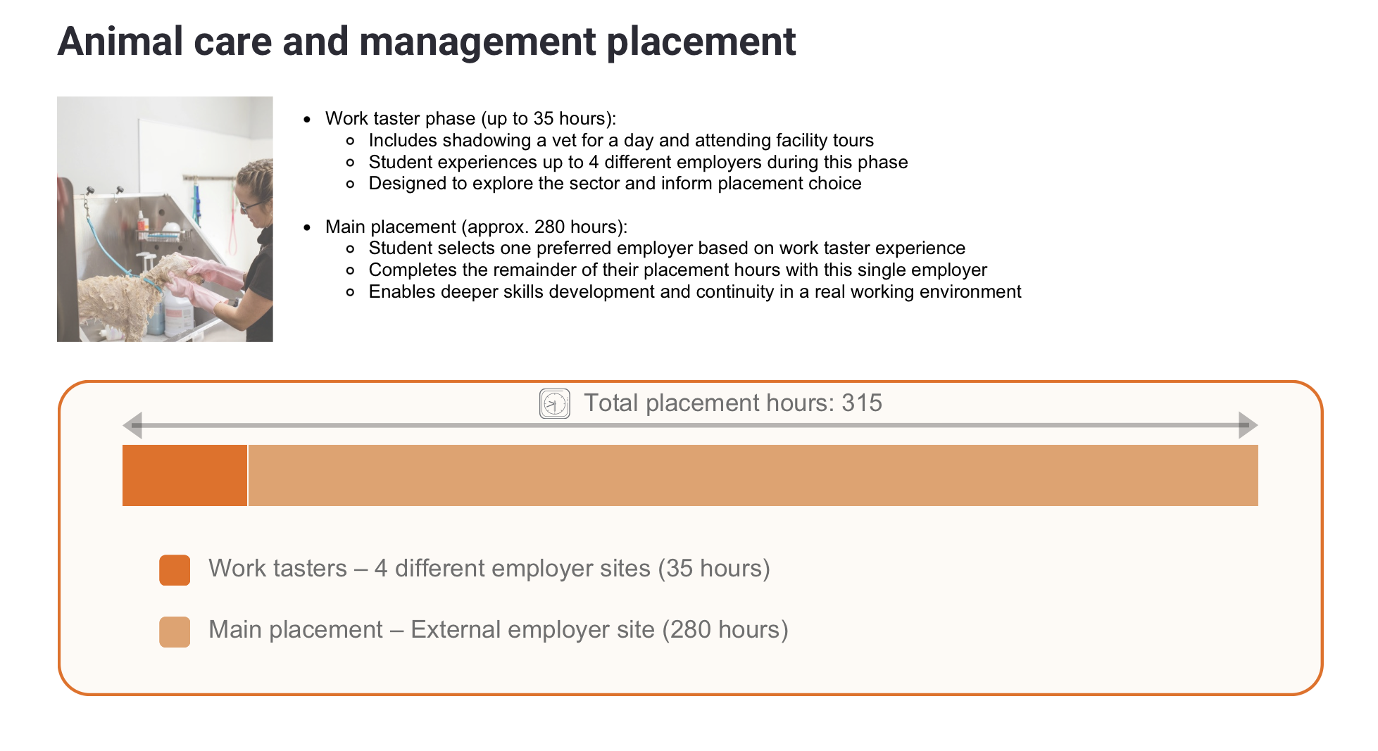
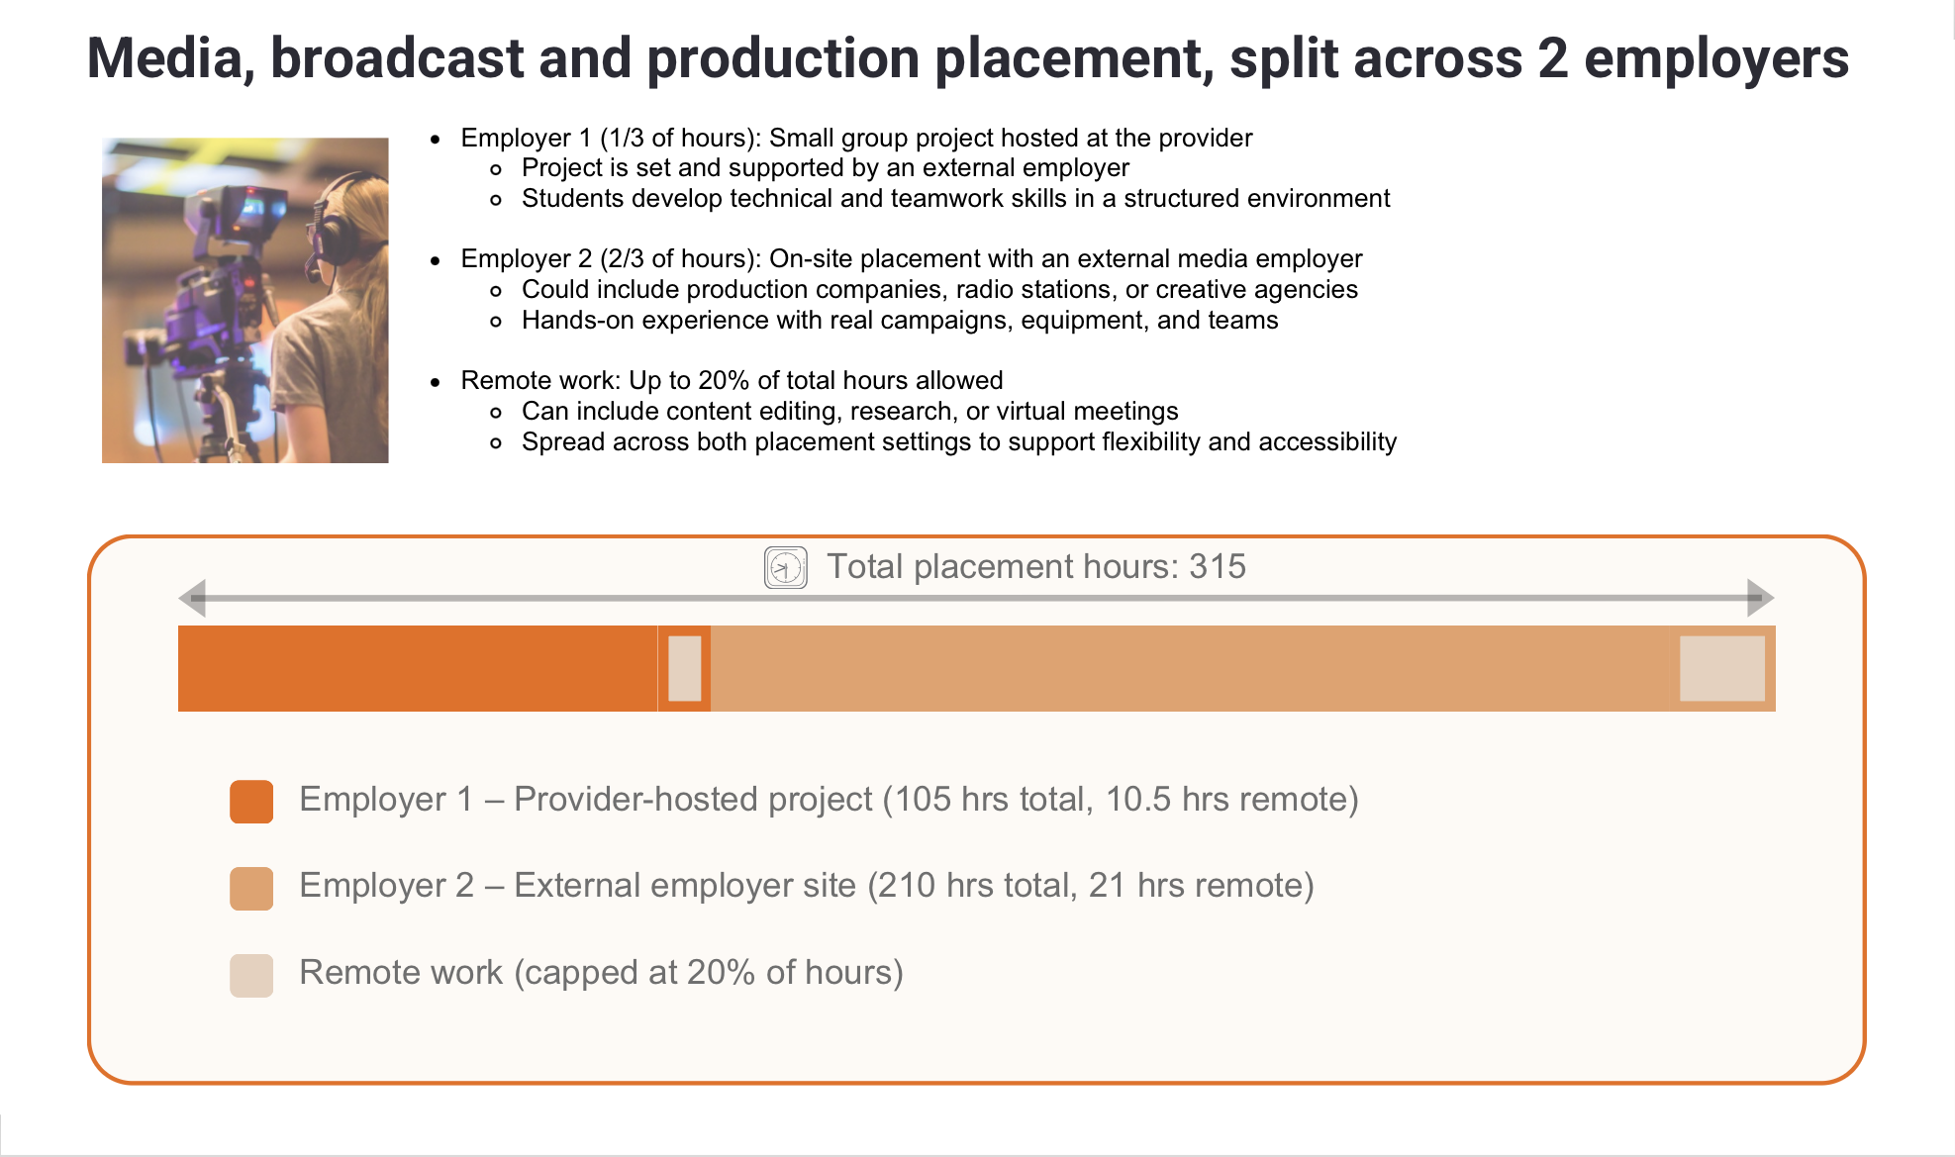
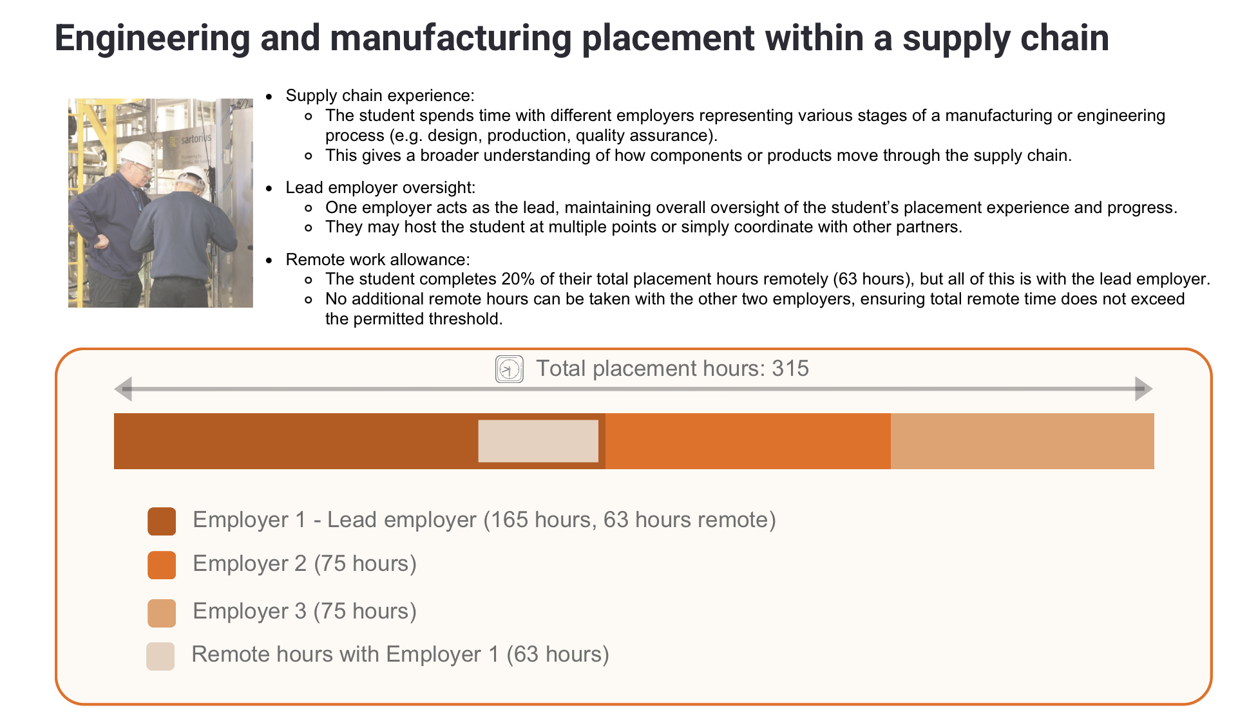

Risks and considerations when using placement flexibilities
While the flexibility within the T Level industry placement guidance allows for creative and inclusive models, it’s important to plan carefully to mitigate any unintended consequences. Below are some of the key risks and considerations to be aware of when designing flexible placements:
Overcomplication of models: Combining too many flexibilities can create overly complex placements that are difficult to manage or explain to employers and students. Simplicity and clarity should remain a priority.
Placement fragmentation: Spreading hours across multiple settings (e.g. tasters, projects, several employers) may reduce continuity for the student, limiting opportunities for deeper skill development and relationship building.
Supervision and oversight: Ensuring clear, consistent supervision across all elements of a flexible placement can be challenging – particularly if students are completing hours remotely or at multiple sites.
Remote work risks: While remote work offers convenience and accessibility, it may reduce exposure to workplace culture and direct employer interaction. It’s important that remote tasks are well-structured, purposeful, and regularly reviewed.
Misalignment with learning goals: Some flexible arrangements may fall short of student expectations – particularly where learners have a clear interest in a specific occupation – or may not provide enough opportunities to apply their technical knowledge meaningfully. It’s essential that placements remain aligned to the T Level’s learning outcomes and support each student’s progression.
Compliance and audit risk: When using blended models, there is a greater need to maintain accurate tracking and documentation to demonstrate compliance with guidance, remote hour limits, and supervision arrangements.
Employer confusion or uncertainty: If employers are unfamiliar with flexible models (e.g. small team projects or remote work), they may be hesitant to engage. Providers should invest in clear communication and supportive materials.

Helping employers say yes

There’s more than one way to get involved. These flexible approaches make it easier for employers of all sizes to offer meaningful T Level placement opportunities - even if a full placement isn’t possible right now.
“Not ready for a full placement? Start with a work taster.”
“Can’t host on-site? Remote projects count.”
“Got a real challenge to solve? Set up a team project.”
“Need help on something short-term? Share with another employer.”

