Map and identify employer opportunities
INTRODUCTION
It’s important to understand the local employer landscape for each individual T Level route you’re offering and identify individual employers who are well placed to support placements now and in the future.
This employer mapping template allows you to research, identify and create a list of ‘top target’ organisations to build relationships with:

BEFORE YOU BEGIN
Local Labour Market Information (LMI):
Start by understanding if the sectors you are delivering T Levels in are growing or declining by checking local labour market reports and data.
Here’s a good place to start: Local Enterprise Summary Reports - GOV.UK (www.gov.uk)
You can also use AI tools to find LMI data for your local area. Search using the prompt “Provide me with a list of local LMI reports and dashboards for <area>”. Local reports often mention organisations by name that are interested in growing their workforce and might be more open to offering industry placements, so add these to your list of potentials.

Other LMI considerations
- If the industry is growing or expecting large numbers of retirements in the coming years, you can use this insight when talking to employers to persuade them to offer industry placements.
Careerometer – LMI For All is a good free tool that shows workforce change nationally, with a focus on ‘replacement’ i.e. the percentage of skilled workers projected to retire over a specific period.
- If your LMI data shows that the industry T Level students will progress into is in decline locally, you should raise this with the Senior Leadership Team as your school or college may need to consider how to place students further afield.

RESEARCHING SUITABLE ORGANISATIONS
Here are eight ways for you to identify organisations that you could build relationships with.

- Search ‘news’ on work experience

To find organisations that are already providing experience to young people in your area, enter “<area> work experience” or “<area> internship” and select the news filter of your preferred search engine to uncover potential employers:



- Business directories

Many established local businesses are part of a business network, so it’s worth searching members of: Chambers of Commerce, FSB and BNI.
You can also use search engines or AI to find other business directories in your local area that align you to reputable businesses. These directories often provide details about the companies' size, industry, and contact information too.
You could target bigger businesses first, which are more likely to take several students on industry placements.

- Career development websites

There are several websites for 16–24-year-olds looking for experience in the workplace. You can use these sites to identify employers keen to offer opportunities to young people.
Start with: Jobs | Student Ladder
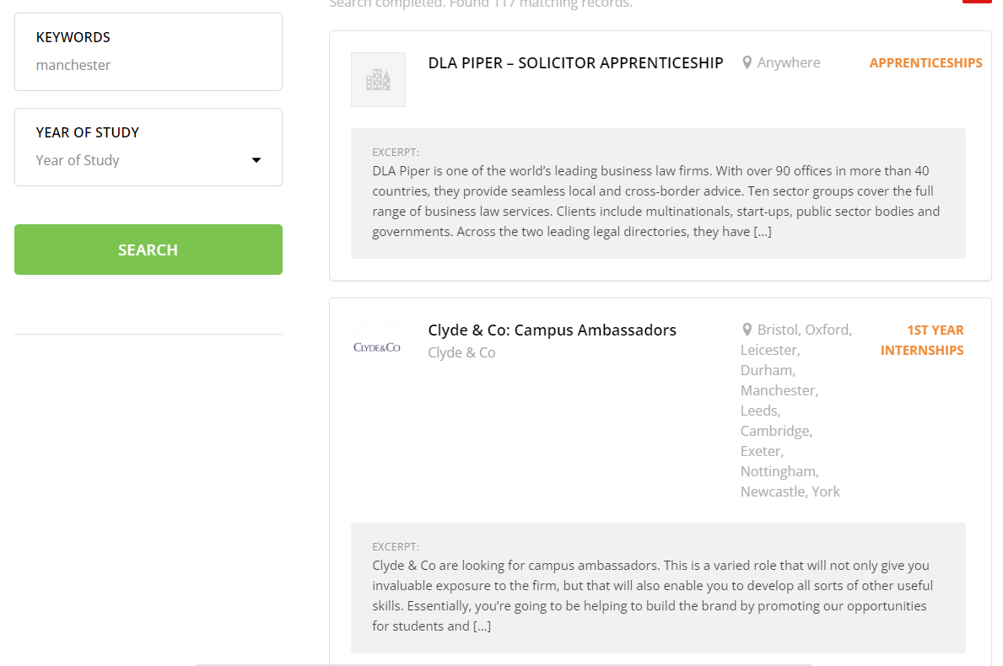

You can also use AI to search for additional work experience or internship listings in your area.

- Volunteering opportunities

Organisations searching for volunteers can also provide a nurturing environment for some of your learners.
Search for websites that showcase local volunteering opportunities, such as Council sites. This is a national example: Find an opportunity – Volunteering Matters
It’s also worth finding who are members of Community and Voluntary Organisations. These groups support local charities and social enterprises and will often list members that might support industry placement students.

- LinkedIn (and other online) professional communities

Search for professional communities and business groups in your area using online networking platforms such as LinkedIn, Meetup, or industry-specific forums.
On LinkedIn, you can search for a sector and filter by groups to find groups you might join.
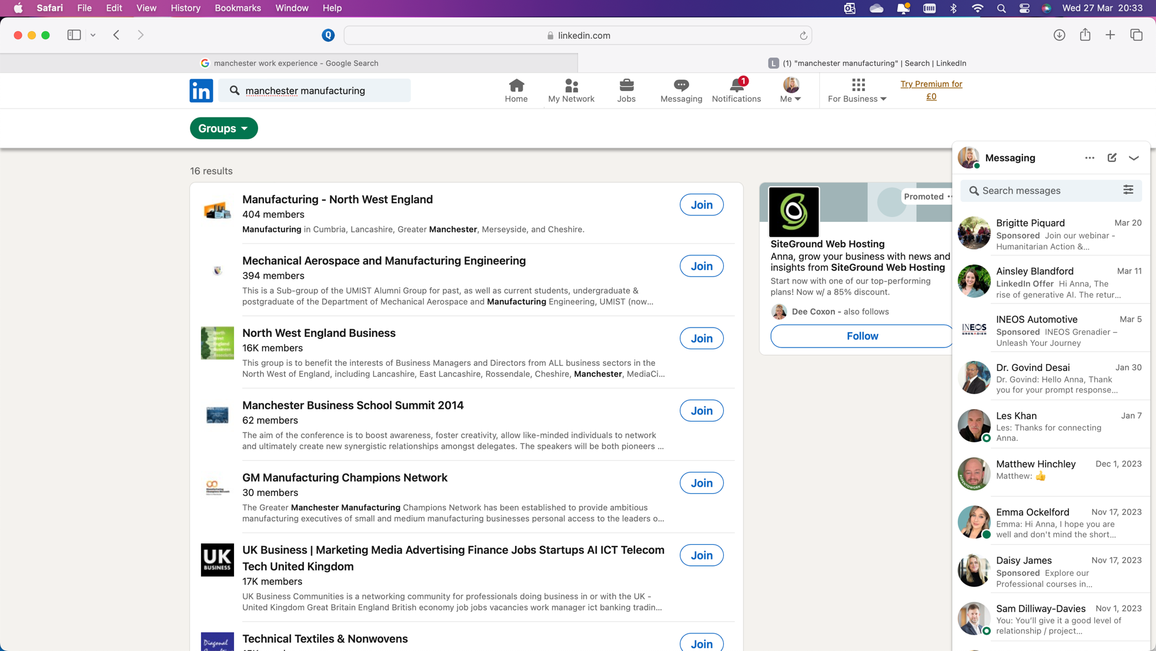

Joining these groups will also give you an insight into the challenges the sector has in your area and let you know about events and meetings you might attend.

- Online job platforms

Check online job platforms to see who is recruiting for entry-level jobs and apprenticeships in your area. You can search words like ‘junior’, ‘assistant’ or ‘trainee’ on websites like Indeed or Totaljobs.
You can also use specialist youth employment platforms like GetMyFirstJob and the Apprenticeship Service to see which local businesses are recruiting apprentices and are likely to be easier to engage in industry placements.

- Apprenticeship and T Level Ambassador Networks
Across the country there are regional Apprenticeship Ambassador Networks. These are networks of employers that are committed to promoting apprenticeships and technical education in schools. They almost always employ apprentices themselves, and therefore are likely to consider Industry Placements too. Plus, they have quarterly meetings, where it might be possible to talk about industry placements.
You can find details here: https://www.apprenticeships.gov.uk/influencers/yaan-regional-networks. Most of them have a website too which will have case studies of particular members you might choose to approach.
There is also a T Level Ambassador Network. You can email the DfE to ask them to connect you to employers offering industry placements in your area: https://employers.tlevels.gov.uk/hc/en-gb/articles/5163486794898-Becoming-a-T-Level-ambassador

- Think wider for hard to fill placements
If you're struggling to find industry-specific employers to host placements, think more broadly about where relevant experience can be gained. For instance, digital students don’t have to work in IT companies – valuable placements could be found in councils, the NHS or online retailers, supporting teams in software development, cyber security or web design.
Below is a detailed example of the kinds of roles and employers across different sectors that could host Legal T Level students. Use this list – and tools like AI – to help you generate similar ideas for your subject areas.

Example roles and employers by business sector

Business sectors | Roles | Typical employers
Business and Administration | Legal assistant, Contracts Manager, HR manager, Office Manager, Compliance officer, Contract Manager | Local councils, public sector bodies, multinational corporations, SME’s
Legal, Finance and Accounting | Solicitor, barrister, legal executive, risk analyst, finance officer, tax advisor, auditor | Law firms, insurance companies, regulatory bodies, accounting firms
Sales, Marketing and Procurement | Procurement manager, licencing specialist, commercial contracts advisor, sales contract manager, marketing officer | Retail chains, e-commerce platforms, advertising spaces, marketing firms, procurement consultancies
Health and Science | Health and safety officer, regulatory affairs specialist, data protection officer, medical compliance officer, school administrator | NHS, pharmaceutical companies, healthcare providers, medical device companies
Education and Training | Policy advisor, education compliance officer, school administrator | Colleges, universities, education charities, educational institutions
Digital, Technology and Data | GDPR officer, IT compliance manager, cybersecurity compliance analyst | Tech start-ups, software companies, telecoms providers, IT consultancies, cybersecurity firms
Construction and the Built Environment | Contract manager, environmental compliance manager, health and safety manager, procurement manager | Construction firms, estate agencies, housing associations, environment agencies, engineering companies
Transport and Logistics | Risk manager, procurement officer, transport safety manager, logistics manager | Logistics companies, airlines, public transport authorities, shipping companies
Creative and Design | Media rights advisor, ethics officer, entertainment lawyers, copyright compliance officer | Film studios, design agencies, media companies
Agriculture, Environment and Animal Care | Sustainability compliance officer | DEFRA, food productions companies, agricultural businesses, sustainability consultancies
Hospitality and Tourism | Risk manager, health and safety manager, tourism compliance officer | Hotel chains, event management companies, hospitality groups, travel agencies

AFTER YOUR RESEACH
Once you have used the above tools and tips to identify potential host employers, create a spreadsheet with the information you know about each:
- Company name
- Possible T Levels
- Size of business
- Local location
- Contact name
- Contact details
From this list, draw up your ‘top targets’ for each T Level route that you intend to build relationships with.
You can then carry out Internal Stakeholder mapping to see if your school or college might already have a relationship with any of these businesses and who is best to build on that relationship.
You should also use the Marketing Channels tool to plan how best to reach these organisations that you don’t have an existing relationship with.

Building relationships, especially with large organisations, takes a long time.
It isn’t always wise to jump straight into ‘will you offer industry placements’, you are likely to need to build the relationship slowly, get to understand the business and where they might be able to support students and how your school or college can adapt its offer to their needs.

WHAT ELSE?
If you have a long list of top targets, that you want to shorten down, it can be helpful to consider how easy each business is to reach by public transport before making contact. You could prioritise the employers that are easy to get to first and are most closely aligned to the student’s course/intended career path.

