EMPLOYER MAPPING

INTRODUCTION
It’s important to understand the local employer landscape for each individual T Level route you’re offering and identify individual employers who are well placed to support placements now and in the future.
This employer mapping template allows you to research, identify and create a list of ‘top target’ organisations to build relationships with:

BEFORE YOU BEGIN
Local Labour Market Information (LMI):
Start by understanding if the sectors you are delivering T Levels in are growing or declining by checking local labour market reports and data.
Here’s a good place to start: Local Enterprise Summary Reports - GOV.UK (www.gov.uk)
You can also use AI tools to find LMI data for your local area. Search using the prompt “Provide me with a list of local LMI reports and dashboards for <area>”. Local reports often mention organisations by name that are interested in growing their workforce and might be more open to offering industry placements, so add these to your list of potentials.

Other LMI considerations
- If the industry is growing or expecting large numbers of retirements in the coming years, you can use this insight when talking to employers to persuade them to offer industry placements.
Careerometer – LMI For All is a good free tool that shows workforce change nationally, with a focus on ‘replacement’ i.e. the percentage of skilled workers projected to retire over a specific period.
- If your LMI data shows that the industry T Level students will progress into is in decline locally, you should raise this with the Senior Leadership Team as your school or college may need to consider how to place students further afield.

RESEARCHING SUITABLE ORGANISATIONS
Here are eight ways for you to identify organisations that you could build relationships with.

- Search ‘news’ on work experience

To find organisations that are already providing experience to young people in your area, enter “<area> work experience” or “<area> internship” and select the news filter of your preferred search engine to uncover potential employers:



- Business Directories

Many established local businesses are part of a business network, so it’s worth searching members of: Chambers of Commerce, FSB and BNI.
You can also use search engines or AI to find other business directories in your local area that align you to reputable businesses. These directories often provide details about the companies' size, industry, and contact information too.
You could target bigger businesses first, that are more likely to take several students on industry placements.

- Career development websites

There are several websites for 16–24-year-olds looking for experience in the workplace. You can use these sites to identify employers keen to offer opportunities to young people.
Start with: Jobs | Student Ladder
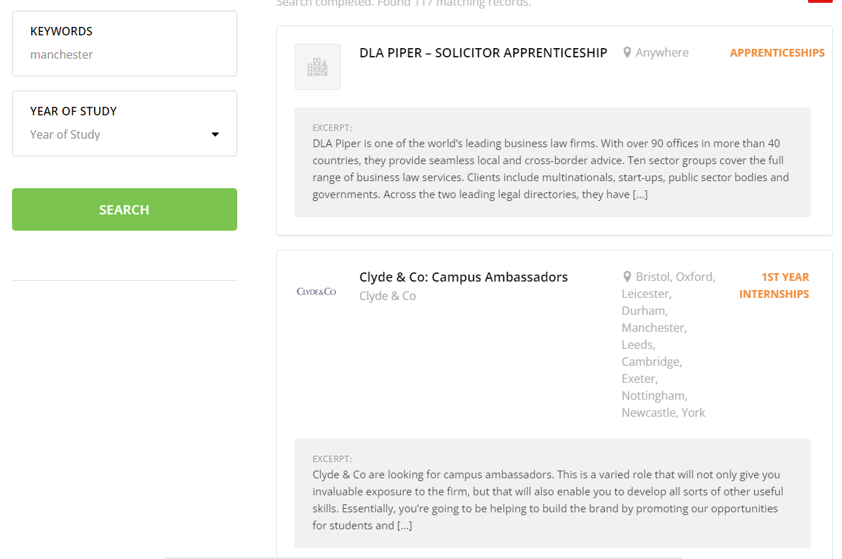

You can also use AI to search for additional work experience or internship listings in your area.

- Volunteering opportunities

Organisations searching for volunteers can also provide a nurturing environment for some of your learners.
Search for websites that showcase local volunteering opportunities, such as Council sites. This is a national example: Find an opportunity – Volunteering Matters
It’s also worth finding who are members of Community and Voluntary Organisations. These groups support local charities and social enterprises and will often list members that might support industry placement students.

- LinkedIn (and other online) Professional Communities

Search for professional communities and business groups in your area using online networking platforms such as LinkedIn, Meetup, or industry-specific forums.
On LinkedIn, you can search for a sector and filter by groups to find groups you might join.
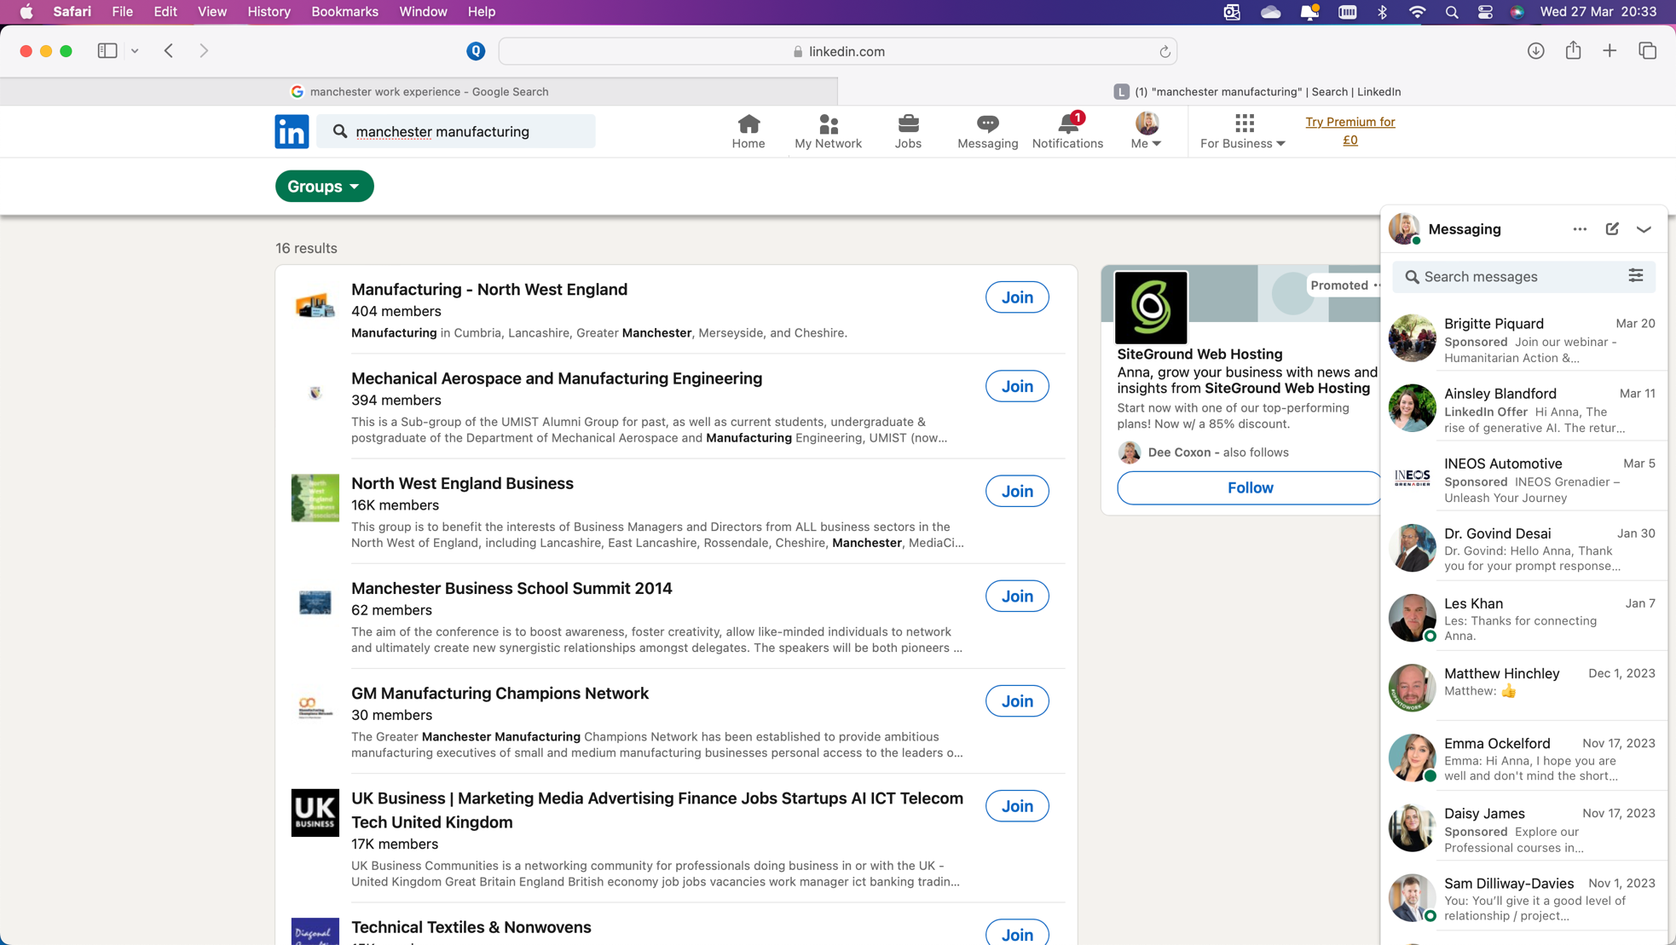

Joining these groups will also give you an insight into the challenges the sector has in your area and let you know about events and meetings you might attend.

- Online Job Platforms

Check online job platforms to see who is recruiting for entry-level jobs and apprenticeships in your area. You can search words like ‘junior’, ‘assistant’ or ‘trainee’ on websites like Indeed or Totaljobs.
You can also use specialist youth employment platforms like GetMyFirstJob and the Apprenticeship Service to see which local business are recruiting apprentices and are likely to be easier to engage on industry placements.

- Apprenticeship and T Level Ambassador Networks
Across the country there are regional Apprenticeship Ambassador Networks. These are networks of employers that are committed to promoting apprenticeships and technical education in schools. They almost always employ apprentices themselves, and therefore are likely to consider Industry Placements too. Plus, they have quarterly meetings, where it might be possible to talk about industry placements.
You can find details here: https://www.apprenticeships.gov.uk/influencers/yaan-regional-networks. Most of them have a website too which will have case studies of particular members you might choose to approach.
There is also a T Level Ambassador Network. You can email the DfE to ask them to connect you to employers offering industry placements in your area: https://employers.tlevels.gov.uk/hc/en-gb/articles/5163486794898-Becoming-a-T-Level-ambassador

- Employability Programmes
Investigate local employability programs or initiatives that connect young individuals with work experience opportunities too. Organisations like The Prince's Trust or local Bootcamp providers will have links with employers giving opportunities to young people.

AFTER YOUR RESEACH
Once you have used the above tools and tips to identify potential host employers, create a spreadsheet with the information you know about each:
- Company name
- Possible T Levels
- Size of business
- Local location
- Contact name
- Contact details
From this list, draw up your ‘top targets’ for each T Level route that you intend to build relationships with.

You can then carry out Internal Stakeholder mapping to see if your school or college might already have a relationship with any of these businesses and who is best to build on that relationship.
You should also use the Marketing Channels tool to plan how best to reach these organisations that you don’t have existing relationship with.

Building relationships, especially with large organisations, takes a long-time.
It isn’t always wise to jump straight into ‘will you offer industry placements’, you are likely to need to build the relationship slowly, get to understand the business and where they might be able to support students and how your school or college can adapt its offer to their needs.

WHAT ELSE?
If you have a long list of top targets, that you want to shorten down, it can be helpful to consider how easy each business is to reach by public transport before making contact. You could prioritise the employers that are easy to get to first.

